The impact of macroeconomic scenarios on recurrent delinquency: a stress testing framework of multi-state models for mortgages
Cecilia Bocchio, Jonathan Crook, Galina Andreeva
Business School, University of Edinburgh, 29 Buccleuch Place, Edinburgh EH8 9JS, UK
Abstract
Transition probabilities between delinquency states play a key role in determining the risk profile of a lending portfolio. Stress testing and IFRS9 are topics widely discussed by academics and practitioners. In this paper, we combine dynamic multi-state models and macroeconomic scenarios to estimate a stress testing model that forecasts delinquency states and transition probabilities at the borrower level for a mortgage portfolio. For the first time, a delinquency multi-state model is estimated for residential mortgages. We analyse and control for repeated events, an aspect previously not considered in credit risk multi-state models. Furthermore, we enhance the existing methodology by estimating scenario-specific forecasts beyond the lag of time-dependent covariates. We find that the number of previous transitions have a significant impact on the level of the transition probabilities, that severe economic conditions affect younger vintages the most, and that the relative impact of the stress scenario differs by attributes observed at origination.
JEL Classification: G21, C41, G17, G32.
Keywords: multi-state models, stress testing, retail credit risk, mortgages.
1 Introduction
The implementation of IFRS9¹ brought a substantial change in the way banks calculate their provisions. For the first time, financial institutions needed to consider not only past and current information but also forward-looking components when building their impairment reports. Expectations became a key element. Moreover, stress testing under IFRS9 resulted in a new challenge for banks as forecasts of the staging criteria²should contemplate alterna tive scenarios. To calculate stage allocation distributions and expected credit losses, a lender needs to know the time an account is expected to keep the contractual repayments up to date before missing any payment that could ultimately lead to default. This expectation may not only be influenced by the borrower’s behaviour but also by the economic environment. The existing practice of estimating losses for just one state (90 days past due or 3 months in arrears) is no longer sufficient. There is a need for more nuanced insights into movements of the account between different numbers of days past due. For these reasons, transition between delinquency states matter. These transitions can occur more than once throughout the life of a loan, and the methodology followed to estimate them needs to take this into
¹International Financial Reporting Standard 9.
²Impairments are recognised under three stages. Stage 1 for financial assets not experiencing a significant increase in credit risk (SICR) since initial recognition. Stage 2 for financial assets experiencing SICR since initial recognition, and Stage 3 for credit-impaired financial assets. 12-month expected credit losses (ECL) are recognised under stage 1 and lifetime ECL under stages 2 and 3.
1

consideration. In the last two decades, a large body of the literature has concentrated on the application of survival (or single-event) analysis to estimate credit risk metrics such as transitions into default (Banasik et al., 1999; Bellotti and Crook, 2009, 2013a,b; Malik and Thomas, 2012; Djeundje and Crook, 2019; Calabrese and Crook, 2020) or recovery (Zhang and Thomas, 2012)³. Even though their contribution was to build the first set of applications of survival analysis in credit risk modelling, more complex specifications are needed to rep resent the actual dynamics of multi-state events. A borrower is subject to transit alternative paths before defaulting, and anticipating these “pre-default” movements is crucial for risk management. This complexity can be captured by multi-state (or intensity) models which are able to characterise a subject experiencing (or not) different types of events across time.
This paper makes the following three contributions to knowledge. First, we apply a multi state delinquency model to a residential mortgages portfolio with the purpose of estimating and predicting six alternative transition probabilities between delinquency states. There is some research that has analysed transitions towards default and cure states for mortgages such as Kelly and O’Malley (2016); however, this paper uses very few states. The events we analysed in this study have only been modelled for credit cards (Leow and Crook, 2014; Djeundje and Crook, 2018). Second, we connect the concept of multiple transition intensi ties to the estimation of account-level transition probabilities while contemplating repeated events and discontinuous risk intervals. This is the first paper in which recurrent delinquency is estimated for a mortgage portfolio using intensity processes. Third, the incorporation of macroeconomic scenarios into the estimation enabled us to enhance the existing methodol ogy permitting us to forecast scenario-conditional transition probabilities and delinquency states beyond the lag of time-varying covariates making this type of model suitable for both stress testing and IFRS9. Banks have found it challenging to predict provisions as they are required to do under the new Standard and this paper enhances the available methodology still further compared with the existing literature. Overall, we bring a complete solution that overcomes Cope et al. (2020) statement that the state transition model approach is ‘complex to estimate and execute forecasts’.
Research regarding default probability in mortgage portfolios has a long history. One of the first studies was developed by Kau et al. (1994) who indicated that the rationale behind the decision to enter into default is driven by house prices falling well below the value of the mortgage’s termination option. Since the publication of Basel II in 2004, credit scoring has gained significant attention in default risk modelling, specially for mortgages as they are one of the lending products from which there is more for lenders to gain from implementing IRB models. In recent years, there has been an increasing amount of literature on the estimation of default probabilities for mortgages based on survival analysis. These studies have introduced different characteristics to better represent movements into default. For example, Beran and Dja¨ıdja (2007) built a mixture exponential model with immunity to analyse extreme censoring in default risk finding that numerous mortgages may actually not be subject to default. McDonald et al. (2010) created a pricing model for UK mortgages incorporating
³More examples of seminal papers in this area can be found in Dirick et al. (2017). 2

default probabilities based on Cox’s model which used application and macroeconomic data. They also performed Monte Carlo simulations to produce a distribution of cash flow forecasts for different economic scenarios. Park (2016) developed a competing risks survival model to analyse the probability of default or prepayment for uninsured, FHA-insured and privately insured US mortgages finding that adverse selection was present. Even though application and behavioural information was included in the estimation, macroeconomic data was not considered. Kiefer and Larson (2015) also examined the association between defaults and insured mortgages but concentrated their analysis on mortgages financed by a mortgage insurance or a second mortgage. Calabrese and Crook (2020) incorporated spillover effects in a survival model that also allowed for variations in the coefficient estimates, both over time and over space.
The application of survival analysis for mortgages is not circumscribed to transitions into default or default probabilities. Competing risks survival models have been applied to post-default mortgage data to analyse loss given default. Wood and Powell (2017) applied the Fine and Gray competing risk regression to estimate the probability of possession and the probability of cure using the LTV and the applicant’s age at origination.
Multi-state models are not yet widely explored in credit risk modelling. The first em pirical analysis was developed on corporate credit rating migrations (Lando and Skødeberg, 2002; Schuermann et al., 2003; Duffie et al., 2007; Duffie, 2011). Only in the past decade have studies directly analysed multiple delinquency events and their respective transition prob abilities using intensity models for retail lending portfolios. Schechtman (2013) compared empirical transition matrices between delinquency states for consumer credit applying cohort and survival approaches. Leow and Crook (2014) developed the first multi-state delinquency model for credit cards using account-specific application and behavioural data while consid ering six plausible types of events. Djeundje and Crook (2018) enhanced the methodology by incorporating macroeconomic indicators, flexible baseline hazards and random effects to control for repeated events. Kelly and O’Malley (2016) used a portfolio of Irish residential mortgages to built a two-state model considering movements into and out of default. The results were then translated into transition probabilities assuming time homogeneity.
On the other hand, recurrent events within the survival analysis framework have exten sively been analysed in medical studies (e.g. Wei and Glidden (1997); Guo et al. (2008); Sagara et al. (2014); Ullah et al. (2014); Amorim and Cai (2015)); however, researchers have not treated this aspect in much detail in the context of credit risk. By applying random effects into the intensity processes, only Djeundje and Crook (2018) analysed a credit cards portfolio considering the inherent dependency between recurrent delinquency events, finding these random effects ‘strongly’ significant; however, the authors did not expand on the rela tive impact recurrent events have on the transition probabilities. Previous studies have also failed to incorporate the effect of macroeconomics scenarios in multi-state intensity processes. Single-event models (Bellotti and Crook, 2009, 2013a,b; Djeundje and Crook, 2019; Calabrese and Crook, 2020) and multi-state models (Kelly and O’Malley, 2016; Djeundje and Crook, 2018) applied to credit risk have successfully incorporated macroeconomic data in their estimations but no study dealt with the incorporation of scenarios to build forward-looking intensity processes in a multi-state framework. Bellotti and Crook (2013a,b) simulated se vere macroeconomic conditions to forecast time to default for a credit cards portfolio using survival analysis but the forecast horizon was restricted to the lag of the time-dependent covariates.
An understanding of the dynamics of transitions between delinquency states is highly important. The sub-prime financial crisis shed light on how much an economy depends on the banking system, and that its soundness is heavily determined by the risk profile of the lending portfolios. A major failure of risk assessment was to base it on a mortgage’s past performance without considering economic impacts (Hott, 2015). Therefore, the determi nation of delinquency transitions based on macroeconomic scenarios would help banks to better manage their credit risk, especially under severe economic conditions. Regulators are particularly concerned about the effect of adverse scenarios as ‘forecasts of significant losses can trigger remedial supervisory actions’ (Kupiec, 2018). Moreover, stress testing is expected to continue being a relevant topic, either because of regulator requirements that change from time to time or because it is considered a good risk management practice (Schuermann, 2014).
The remainder of this article is organised as follows. Section 2 presents the methodology to estimate transition probabilities for a mortgage portfolio using multi-state models and considering both recurrent events and discontinuous risk intervals. Section 3 relies on the estimation results to build scenario-conditional forecasts of transition probabilities. Finally, Section 4 concludes.
2 Modelling Recurrent Delinquency and Recovery Events
We aim to estimate and predict transition probabilities among different delinquency states for a UK mortgages portfolio applying multi-state (or intensity) models which rely on survival analysis but add the complexity of handling multiple types of failures or events. By delinquency state we refer to how many payments a borrower has missed by the con tractual due date. We are interested in analysing the time an individual spends in a given delinquency state before moving towards an alternative one, and to use this information to predict dynamic probabilities of movement among the states.
In survival analysis the focus is on the time to a single event, and the variable of interest is duration time reflecting the time a subject spends in a given state. Multi-state models are an extension of single-event models where different types of events are analysed (e.g. the same borrower can move from up to date to 1 payment down and then to 2 payments down). At the same time, repeated events can explicitly be considered. This feature is particularly important given that it avoids making the strong assumption that the attributes characterising the first event also characterise consecutive events of the same type. Ignoring recurrence when estimating delinquency or default risk leads to biased coefficient estimates as failure times within the same subject are correlated. Therefore, a methodology that handles this absence of independence is needed. Finally, when considering multiple events,
4

the objective is to analyse and understand the different paths an individual might undergo before reaching a certain state. It is then possible to build transition probabilities to predict future movements or migrations.
We define T to be a non-negative random variable which represents the survival time and we assume that T is continuous. We consider those individuals who have not experienced the event of interest by time t. Specifically, we are interested in knowing the probability that the event will occur in some small interval [t, t + dt) provided that it did not happen before t. This probability is given by α(t)dt, where α(t) is a hazard function defined as
The most common survival model, known as the proportional hazard model, was intro duced by Cox (1972) which states that the hazard function is related to a vector of covariates in the following way:
α(t) = α₀(t) exp(β⁰x(t)) (2)
where α₀(t) is the (unspecified) baseline hazard function, exp(β⁰x(t)) is a relative risk func tion, and β = (β₁, . . . , β_{m})⁰is a vector of m coefficients that shows the effects of the covariates x(t) which may or may not vary over time t.
2.1 Transition Intensities
Cox’s model can be extended to the multi-state framework. The generalisation of the multiplicative intensity function considering multiple events and time-varying covariates is
α_{hji}(t) = Y_{hi}(t)α_{hj0}(t) exp(β⁰_{hj}Z_{i}(t)) (3)
where Y_{hi}(t) is the at-risk indicator process that assumes value 1 if the individual i is in state h at time t and 0 otherwise, α_{hj0}(t) is the (unspecified) non-negative baseline transition intensity from state h to state j and exp(β⁰_{hj}Z_{i}(t)) is the relative risk function with unknown regressors β_{hj} for the individual-specific covariates Z_{i}(t) (see Andersen et al. (1993); Aalen et al. (2008)).
Transition intensities can be defined in different ways depending on the underlying pop ulation and the characteristics of the events. In this study we analyse transitions (or mi grations) among alternative delinquency states considering that the subjects might transit the same path more than once. There exists several Cox-based models for repeated events (Kelly and Lim, 2000; Thenmozhi et al., 2019), e.g. Andersen-Gill (AG) counting process (Andersen and Gill, 1982), Prentice-Williams-Peterson gap time (PWP-GP) and total time (PWP-CP) models (Prentice et al., 1981), Wei-Lin-Weissfeld (WLW) and Lei-Wei-Amato (LWA) marginal models (Wei et al., 1989; Lee et al., 1992), and Cox frailty model. Addi tionally, there are four components to be considered when analysing recurrent events (Kelly and Lim, 2000): (i) the definition of the risk interval, (ii) common versus event-specific baseline hazards, (iii) the definition of the risk sets, and (iv) within-subject correlation.
5

A risk interval is defined as the period of time during which an individual may experience the event. There are three alternative definitions:
• Counting process: the risk interval depends on previous events. In order to experience the kth event, first the subject has to experience the (k-1)th event.
• Total time: the risk interval for the kth event is independent of the risk interval of any other event. This means the analysis time starts at zero and finishes at the time the event is observed.
• Gap time: the risk interval measures the time from the previous event, re-setting the clock after each event.
The determination of the baseline hazard is constrained to the selection of the risk set as it is possible to differentiate among restricted, unrestricted and semi-restricted risk sets. In the first case, the risk set for the kth event will be based on the information provided by all the subjects that experience (k-1) events. In the second case, overlaps are allowed and two individuals can contribute to the same risk interval regardless of whether one subject is at risk of the kth event and the other subject is at risk of the nth event. The assumption of restricted risk sets implies the distinction of event-specific baseline hazards (stratification). On the other hand, a common baseline hazard is estimated under an unrestricted risk set. Semi restricted risk sets are characterised by event-specific baseline hazards but allow subjects to be at risk of the kth event even if they experience less than (k-1) events.
There exist two methods to handle within-subject correlation. Variance-corrected ap proaches which estimate the model and correct the variance to take into consideration the dependency in the observations, and second, frailty or random effects which introduce a random variable to account for correlation between repeated events for the same subject by accounting for unmeasured heterogeneity not captured by covariates.
For the purpose of this study, we have selected two model specifications under the count ing process framework, the Andersen-Gill (AG) counting process model and the PWP-CP model. The AG model follows the structure presented in Equation (3) and it is characterised by an unrestricted risk set with a common baseline hazard for repeated events, and the risk interval is described by a counting process. The standard approach assumes independence between repeated events observed for the same subject but this assumption is relaxed by incorporating the number of previous occurrences of the event for that subject (Kelly and Lim, 2000). Therefore, information regarding the times an account has been at risk of mov ing out of a given state is also considered. The PWP-CP differs from the AG model in the determination of the risk set which is a restricted one leading to event-specific baseline hazards, α_{hj0k}(t).
α_{hjik}(t) = Y_{hi}(t)α_{hj0k}(t) exp(β⁰_{hj}Z_{i}(t)) (4)
where k is the number of previously experienced events by time t.
Finally, the Efron approximation is used to account for tied events as it considers the differing composition of the risk set at each time t (Box-Steffensmeier and Jones, 2004),
6

and robust standard errors were considered in the estimation process. Censoring is assumed non-informative and time is treated as continuous.
In line with Leow and Crook (2014) and Djeundje and Crook (2018), four delinquency states are defined:
• State 0 = Performing, i.e. the borrower is up to date.
• State 1 = One month in arrears, i.e. the borrower is 30 days past due. • State 2 = Two months in arrears, i.e. the borrower is 60 days past due.
• State 3 = Three months in arrears, i.e. the borrower is 90 days past due. This is also the default definition and assumed sink state from which there is no recovery.
Throughout the life of the mortgage, a borrower can transit between different states. Figure 1 depicts transitions among the delinquency states defined above where the default definition is considered an absorbing state. The jumps are those possible in a one-month period, which results in six possible types of one-month transitions h → j: 0 → 1, 1 → 2, 2 → 3, 2 → 1, 1 → 0 and 2 → 0.
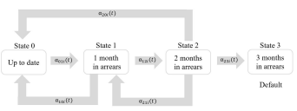Figure 1: One-month transitions between delinquency states
The intensity processes are structured such that they account not only for repeated events but also for discontinuous risk intervals. This means that an individual can transit from state h to state j more than once (repeated events) and it is possible that a subject is not at risk of moving into the state j for a given period of time (discontinuous risk interval).
2.2 Data
Data on 67,827 mortgages originated from June 2006 to December 2015 from a UK financial institution was used in this study. The dataset consists of both application data and monthly records of behavioural data. For each account, information from the origination date is available. Two independent samples were created: a training sample consisting of data observed between June 2006 and December 2011, and a test sample containing information relating to accounts originated from January 2012. All the estimations are developed on the training sample and validated on the testing sample.
7
Macroeconomic variables for the UK economy are also analysed as potential covariates of the intensity processes given that when the economy deteriorates borrowers find it more difficult to keep their financial commitments up to date (Crook and Banasik, 2012). The pool of potential candidates is selected based on economic theory and have extensively been used in the literature (Bellotti and Crook, 2009, 2013a,b; Leow and Crook, 2016; Djeundje and Crook, 2018). The following 6 macroeconomic variables are included in the analysis:
• Unemployment rate. In a downturn, the percentage of unemployed individuals in creases worsening the repayment affordability as an account holder could be unem ployed and unable to repay as scheduled. Consequently, it is expected to see higher delinquency rates when the unemployment rises.
• Consumer Price Index. An increase in consumer prices can be seen as a deterioration of the purchasing power making debt repayments more difficult to afford. On the other hand, inflation might be caused by economic growth if the aggregate demand rises faster than the aggregate supply in which case it would have a positive impact on repayments.
• House Price Index. The valuation of the property (the collateral) is reflected in the reported LTV, an indicator used by lenders to define the portfolio’s risk profile. An increment of the property value is translated into lower LTVs and, therefore, into a less risky mortgage. This is the case as higher valuations are seen as a rise of the capital value (equity) which the borrowers are less keen to lose, generating extra incentives to repay the mortgage and greater collateral for a bank to take over if the mortgage is not repaid.
• 5-year Mortgage Rate. Increases in the mortgage rate make payment commitments more expensive, affecting the individual’s ability to repay a debt. Moreover, banks tend to offer higher interest rates to customers that are considered riskier.
• Industrial Production Index. This index compiles information regarding the volume of production for several industries⁴. We used it as a proxy for the GDP (Gross Domestic Product) which is only available on a quarterly frequency. Positive changes represent economic growth; therefore, it is expected a reduction in transitions towards delinquency and an increase in recovery rates when the index of production improves.
• Consumer Confidence Index. This index provides an indication of expected future developments in households’ consumption and saving, based upon answers regarding their expected financial situation, their sentiment about the general economic situation, unemployment and capability of savings. An increase in the index implies optimistic expectations regarding the economy which can be translated into better recovery rates and lower levels of missed payments.
⁴Manufacturing, mining and quarrying, energy supply, and water and waste management. 8

• FTSE-100. This index is a share index of the largest 100 companies listed in the London Stock Exchange that summarises the financial market state for the UK. Pos itive variations of the FTSE-100 are associated with better financial conditions and, therefore, with lower delinquency and default rates.
The complete list of variables considered is detailed in Table 1.
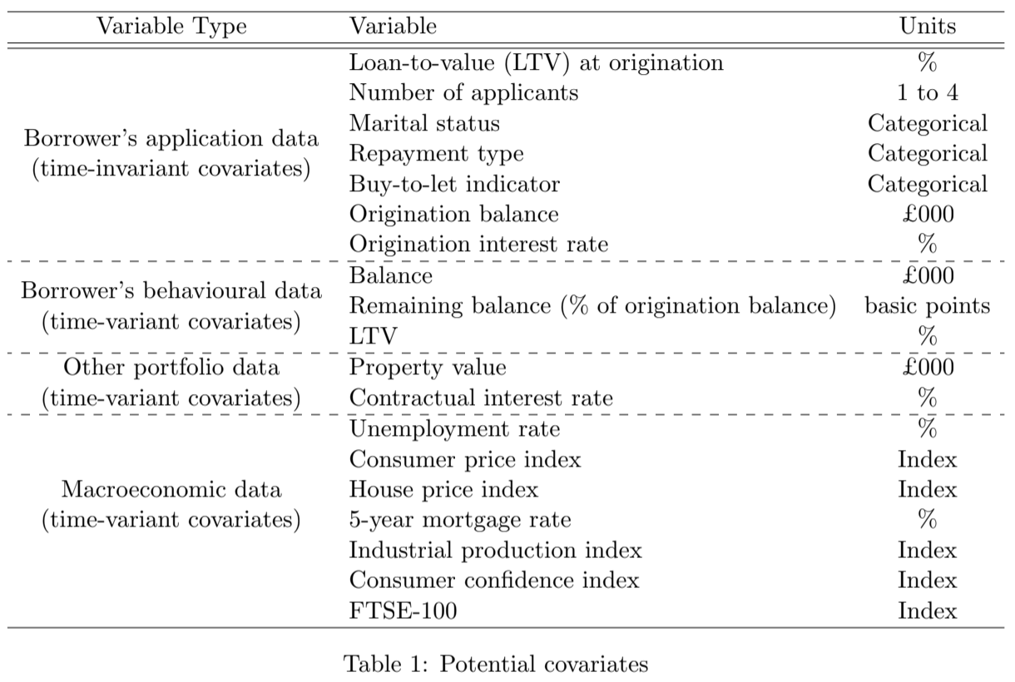
2.3 Estimation Results
To account for recurrent events, we define a strata as the number of previous events experienced by the borrower at each duration time t. The low number of events in higher strata needs to be taken into consideration when estimating the transition intensities as the reduced number of events of a given strata might bring instability in the coefficient esti mates (Amorim and Cai, 2015). There are at least three data manipulations that can be performed to mitigate this problem (Therneau and Hamilton, 1997). First, we could leave the information as it is and accept this instability for higher risk intervals. Second, we could disregard the data with low events per strata. Third, we could combine the events in higher risk intervals into one strata. The last option has been selected to estimate the transition intensities as it avoids excluding data from the sample while bringing more robustness into the coefficient estimates. Table 2 presents the number of accounts by strata after group ing. For example, we observe 2,269 accounts experiencing one payment down just once and 441 accounts experiencing this event at least three times. The majority of the events are concentrated in movements out of state 0 where we observe accounts “failing” several times throughout the sample horizon. Moreover, the assumption of considering 3 months in arrears
9

as an absorbing state is reflected in the definition of the strata as no account has previously being in state 3. This is also consistent with the standard definition of default as 90 days past due.
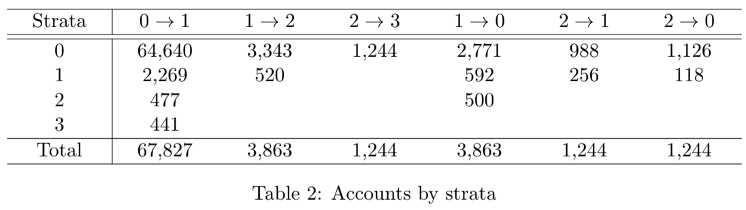
Table 3 presents the estimated parameters for the six intensity models under the AG and the PWP-CP models. For time-dependent variables the first, second, third and sixth lag were considered to allow for delayed effects on the transition intensities. Finally, transformations of the macroeconomic variables were also used (annual growth rates and first differences). As one of the purposes of this study is to build out-of-time forecasts of transition probabilities, only model specifications with significant coefficient estimates are considered. This implies using different combinations of covariates to explain the dynamics behind each intensity process. We performed a pre-assessment based on univariate analysis to select a first pool of potential explanatory variables, and we then applied a stepwise process to select the final covariates.
1

*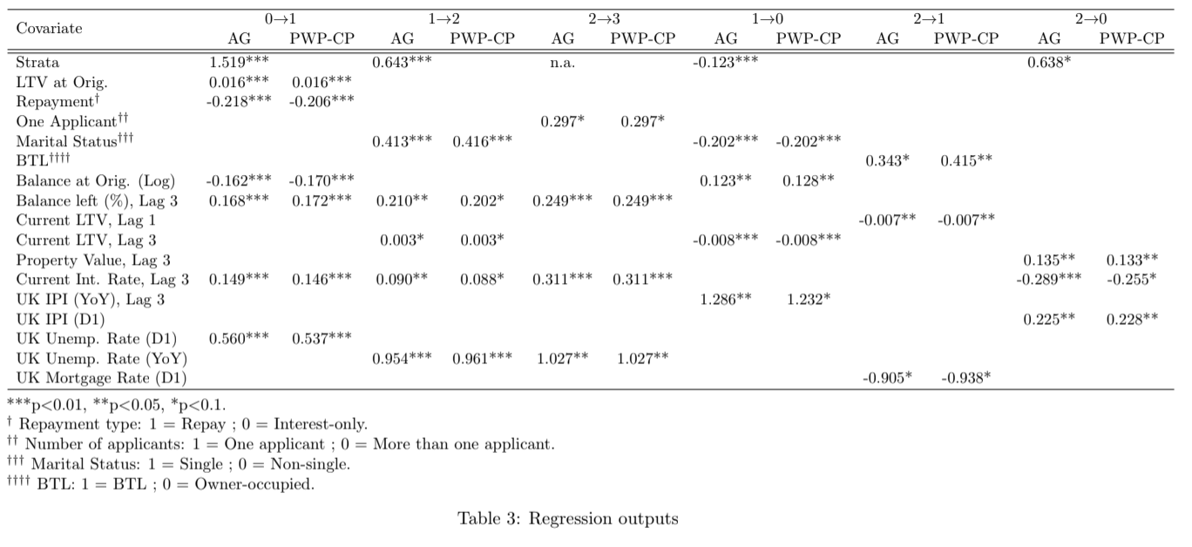
9
11

The coefficient estimates are similar under both model specifications showing that the marginal effect of both the account-specific metrics and the macroeconomic environment is not impacted by the number of previous experienced events. The strata (or number of previous events) is an explicit covariate of the AG model and it is significant in each estimation, except for transitions 2 → 1. Only the transition 1 → 0 shows a negative coefficient estimate implying that the chances of recovering from one payment down decreases if the account has experienced this event in the past. On the other hand, accounts that have previously been in the delinquent state face an increased risk of missing one payment. This risk is relatively large for movements out of state 0 as having transited once in the past increases the intensity rate by 356.8% (exp(1.519) − 1).
Accounts with high LTV are more likely to miss one payment throughout the life of the contract. The LTV represents the proportion of exposure that is collateralised against the property and it is a key element to be considered in any delinquency or loss model for a retail mortgage portfolio. The LTV at origination is determined by the bank’s risk appetite as it describes how much risk the financial institution is willing to take while the behavioural or current LTV is affected by the payments made by the borrower and by the property’s revaluation. Accounts with low LTV are considered less risky as they have lower incentives to default given they would face a higher financial loss. Similarly, delinquent accounts with high current LTV are less prone to recover. These relationships are analogous to those of Kelly and O’Malley (2016).
The higher the percentage of outstanding balance the higher the intensity rate of accounts moving into delinquency and into default, implying borrowers tend to miss payments in early stages of the repayment schedule. Moreover, accounts with large absolute value of outstanding exposures at the origination date of the contract are less likely to miss a payment as it is expected low-risk accounts will have access to larger lending. Beran and Dja¨ıdja (2007) found the opposite relationship in their survival model, concluding that large mortgages are at higher risk of default.
Repayment mortgages show lower transition rates towards delinquency (state 1) com pared to interest-only (IO) accounts. Under an interest-only scheme, the borrower commits to regular payments covering only the interest on the principal. This means that the balance does not change over time and the borrower has to pay it back at the end of the contract (or re-negotiate new terms, if possible). Repayment mortgages consist of regular payments covering not only interest but also a proportion of the outstanding principal. IO accounts are more likely to default at the end of the contract when they need to make the final capital payment than throughout the life of the loan when the contractual payments are relatively low (compared to a repayment mortgage).
Banks charge higher interest rates to riskier accounts and this is reflected in the positive sign on the interest rate obtained for the transition towards delinquency and default. At the same time, increases in interest rates are translated into higher costs for borrowers under a flexible interest rate contract meaning higher chances of missing a payment. Overall, mortgage accounts with single borrowers or one applicant are more likely to miss two or three
12

payments, while married borrowers (or in partnership) have better chances of recovering. Increases in delinquency and default rates are expected during downturns. For instance, poor macroeconomic conditions are reflected in a higher unemployment rate and in reductions of the GDP growth. In economic recessions, individuals experience more difficulties to keep their finances up to date resulting in an overall increase of missed payments. The opposite is expected under a benign economy, in which access to lending is easier and individuals have more chances of making repayments. A good economic environment helps borrowers in the up to date state to stay in that position while delinquent accounts have better opportunities to recover. On the macroeconomic side, the change in the unemployment rate helps to explain transitions towards delinquency and default. As an economy deteriorates, the percentage of unemployed individuals increases worsening the ability to repay. Consequently, we expect to see higher delinquency rates when the unemployment rate rises. The industrial production index and the 5-year mortgage rate help to explain recovery movements, showing expectations aligned with those discussed in Section 2.2.
2.4 Transition Probabilities
The intensity processes described by Equation (3) and Equation (4) represent the instan taneous risk of moving from one delinquency state to another one. However, practitioners and regulators are more interested in understanding the dynamics of the delinquent subjects. To do so, the results presented for each intensity process can be translated into account-specific transition probability matrices. These matrices show the probabilities P_{hji}(s, t) of moving from any state h to any state j between any two points in time s and t, where s < t. Specifically, for each borrower i and duration times s and t, it is possible to compute
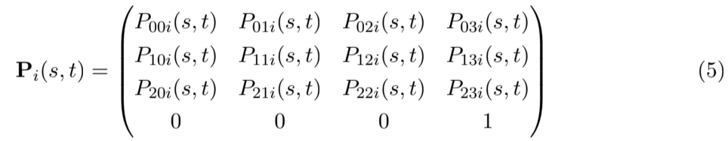
where each row sums to 1 and the last row shows state 3 (the default state) as an absorbing state.
These transition probabilities are characterised by a non-homogeneous Markov process and can be estimated using the Aalen-Johansen estimator (Aalen and Johansen, 1978), also known as the product-integral estimator:

where A_{i}(t), known as the generator matrix, contains subject-specific cumulative transition intensities. The elements of A_{i}(t) are given by
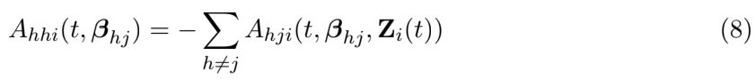
The estimator of the cumulative hazard function is
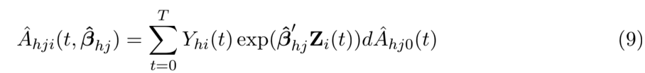
The estimated cumulative baseline hazards obtained from the Andersen-Gill model, _{(A}ˆhj0(t)), and from the PWP-CP model, (Aˆ_{hj0k}(t)), are depicted in Figure 2. The AG cumulative baseline hazards represented by the black dashed lines are common to all sub jects regardless the number of previous events. On the other hand, the PWP-CP cumulative baseline hazards are stratified by the number of previous k events. The curve for the first strata uses information from all the accounts that are at risk of experiencing the event for the first time while, for instance, the third strata uses information of accounts that have ex perienced the events twice and are at risk for the third time. As the clock continues ticking between events, the cumulative baseline hazards for the different risk intervals are “shifted” towards the right given that an account has to first experience the event before being part of a higher strata. The baseline cumulative hazards for movements towards delinquency are higher the higher the number of repeated events (see panels (a) and (c)). This means that those accounts that have already missed one or two payment in the past have a higher prob ability of doing it again. On the opposite side, accounts that have recovered in the past are likely to recover again (see panels (b), (d) and (e)). Moreover, borrowers are more likely to show a recovery if they miss one or two payments for the first time; however, this probability decreases if the account recurrently enters into a delinquency state (see panels (b), (d) and (e)) implying that even though the subject might have been able to totally or partially pay back the amount due, she struggles to repeat this action.
The common AG cumulative baseline hazard is generally aligned with the results obtained for the first strata (k = 0) of the PWP-CP model. Given that default is assumed to be absorbent, the cumulative baseline hazard under both approaches is the same. In all cases, we observe that accounts in state 1 are more prone to recover than to move into state 2. At the same time, those borrowers that miss two payments are also more likely to recover than to move into default.
14
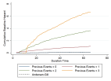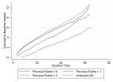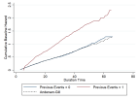(a) Intensity 0→1 (b) Intensity 1→0 (c) Intensity 1→2 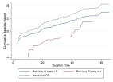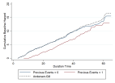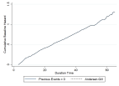(d) Intensity 2→0 (e) Intensity 2→1 (f) Intensity 2→3
Figure 2: Cumulative baseline hazards
Figure 3 presents the estimated cumulative hazard for transitions 0 → 1 (i.e. Aˆ_{01i(t, β}ˆ₀₁)) under both model specifications and for two selected accounts experiencing repeated events. Account 1 moved from state 0 to state 1 at duration times t = 12 and t = 21, and moved back to state 0 at times t = 13 and t = 22, while account 2 transitioned at times t = 50 and t = 58 returning to state 0 at times t = 51 and t = 59. These “jumps” are represented by the discontinuity in the cumulative hazards. The discontinuous risk interval appears because the subject is no longer at risk of making the transition 0 → 1 at those specific duration times. Figure 3 shows that every time an account misses one payment, the slope of the estimated cumulative hazard significantly increases, especially if the event is observed in early months since origination. Moreover, the estimated impact is larger when we stratified the baseline hazard by the number of previous events (panel (b)).
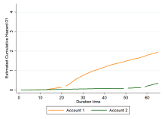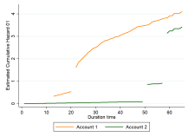(a) Andersen-Gill (b) PWP-CP
Figure 3: Estimated cumulative hazard, Aˆ_{01i(t, β}ˆ₀₁). Example
15

Next we translate the estimated cumulative intensities into account-specific transition probabilities. In order to bound these probabilities to the space [0, 1], the Aalen-Johansen estimator (Equation (6)) can only be applied to constant or increasing cumulative hazards. The characteristics behind the results obtained from the PWP-CP model (stratified hazards with lower cumulative baseline hazards for recurrent recovery events - see panels (b), (d) and (e) of Figure 2) imply we face a limitation to obtain the corresponding transition probabilities. However, this model specification sheds light on the impact that recurrent events have on the instantaneous risk of transitioning.
In the remainder of this study, we concentrate on results obtained from the AG model. Figure 4 plots the distribution of 3-month predicted transition probabilities considering the population observed after 12 months since origination. We may conclude from the figure that, given the characteristics of this portfolio, if a subject is in the up to date state, then there are high chances she will stay in state 0 after 3 months as the vast majority of the population shows a probability of remaining in state 0 is above 98%. Moreover, delinquent accounts showing 1 missed payment are more likely to recover within the next 3 months than to miss another payment. However, the distributions of predicted transition probabilities for subjects experiencing 60 days overdue are skewed more to the higher probabilities for the jump to default than the distribution of probabilities showing movement to being just one payment behind.
16
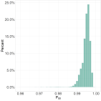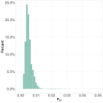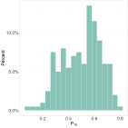_{(a) P}ˆ_{00(12m, 15m)} _{(b) P}ˆ_{01(12m, 15m)} _{(c) P}ˆ₁₀(12m, 15m) 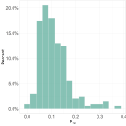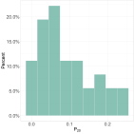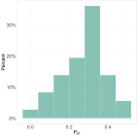_{(d) P}ˆ_{12(12m, 15m)} _{(e) P}ˆ_{20(12m, 15m)} _{(f) P}ˆ₂₁(12m, 15m) 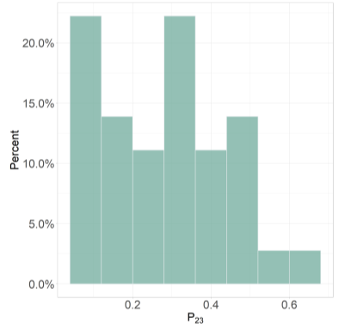
_{(g) P}ˆ₂₃(12m, 15m)
Figure 4: Estimated transition probabilities P^{ˆ}(12m, 15m). Distribution
We assess the accuracy of the model by applying the methodology developed by Leow and Crook (2014) to test the results obtained through the estimation process of the transition intensities. The coefficient estimates from the AG model are applied to the accounts observed in the test sample and transitions probabilities Pˆ_{hji}(s, t) are computed for each account. These probabilities are then used to predict transitions from state h to state j. Finally, the predictions are compared against actuals (observed transitions) to validate the estimation results.
The first step is to define a time horizon as the probabilities can be computed for any combination of duration times s and t. For this exercise, we are interested on three predic
17

_{tions: P}ˆ_{hji(12m, 13m), P}ˆ_{hji(12m, 15m) and P}ˆ_{hji}(12m, 18m). The aim is to study different time lengths, e.g. predictions 1, 3 and 6 months apart from the starting point⁵. The second step is to compute cut-off values (c_{hj} ) to predict whether a transition takes place. These cut offs are selected such that the proportion of accounts observed to go through the transition h → j in the training sample is the same proportion predicted to transit in the test sample. For each individual i, the prediction to move to state j at time t given an initial state h at time s is defined as:
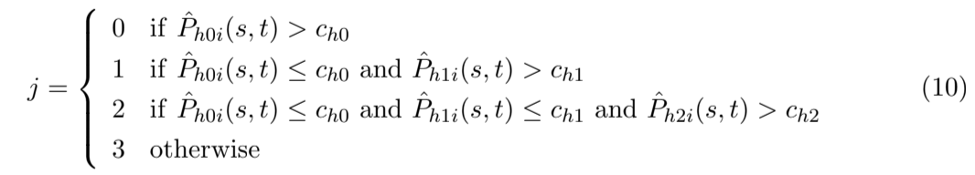
This methodology possesses the disadvantage of disregarding the natural competing risk of the states, where the order of selecting the accounts to move to any delinquency state has an impact on the final results. For example, those accounts first selected to be in state 0 can no longer be selected to be in state 1 at time t. Instead of comparing all the estimated transition probabilities at the same time, a step-process is specified. Given that this method focuses on observed proportions of accounts undergoing the different states, it ensures predictions among all the states, and therefore it was selected for this analysis⁶.
Table 4 presents the proportion of accounts that are predicted to be in state j at time t after applying the cut-offs defined by Equation (10) relative to the observed accounts in state j, i.e. ^{predicted accounts in state j}
_{observed accounts in state j}. Predictions for the up to date portfolio are very accurate across the three windows since an accuracy ratio above 99% was obtained. On the other hand, the test sample has few cases in the delinquency states at s = 12 (less than 0.5% of the portfolio); therefore, it is reasonable to observe less accuracy in the results for the under performing accounts. Except for transitions towards state 2 at times t = 13 and t = 15, the model tends to overestimate the number of accounts missing payments, especially for the defaulted population 3 and 6 months after the starting reference date where the predicted number of accounts in state 3 is 6 times and 2.7 times higher the number of observed accounts.
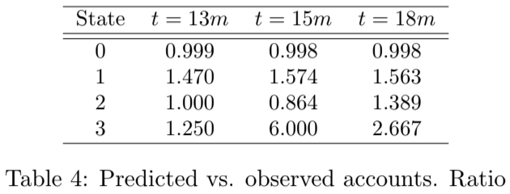
3 Scenario-Conditional Transition Probabilities
Scenario-conditional forecasts for the six transition intensities are made using the pa rameter estimates obtained from the AG model. This implies that each component of Ta
⁵Note that any starting duration time could have been selected.
⁶Refer to Djeundje and Crook (2018) for an alternative approach to define the cuf-off values.

ble 3 needs to be projected across a pre-defined horizon window. There are three types of covariates for which we need forecasts: application variables, behavioural variables and macroeconomic variables. Application variables are, by definition, static across time while the macroeconomic scenarios were obtained from the Bank of England⁷. A challenge is then to consistently forecast the account-level behavioural data considering that the economy and the delinquency state of the account at each unobserved future time t would have an impact on the account’s behaviour. We present a method to do this in Section 3.2 below.
3.1 Macroeconomic Scenarios
Every year, UK the Prudential Regulation Authority (PRA) publishes two stress testing scenarios (one baseline and one severe) that UK financial institutions are meant to use for the Internal Capital Adequacy Assessment Process (ICAAP). The scenarios are given such that consistency in the correlation among the different macroeconomic factors is retained. The PRA provides macroeconomic scenarios on a quarterly frequency. However, the transition intensities in our paper are estimated and projected on a monthly frequency as movements across delinquency states occur from one month to another. This implies that an interpola tion process to obtain monthly macroeconomic series is necessary. A simple approach could be assuming a constant growth rate for the months belonging to the same quarter; neverthe less, this process would dismiss any volatility within a given quarter. To avoid this problem, a natural cubic spline interpolation was implemented by assuming the information provided by the PRA matches the quarter-end values.
Based on the results presented in Table 3 the list of macroeconomic factors determining the alternative transition intensities are the house price index (HPI) used to estimate the borrower’s property value, the unemployment rate, the industrial production index and the 5-year mortgage rate. Given that the PRA only provides scenario-specific forecasts for the HPI and the unemployment rate, it was necessary to extend the PRA’s assumptions to obtain scenario-specific forecasts for the industrial production index and for the mortgage rate. To do so, the PRA’s available information was used as a proxy to expand the scenarios. We performed regression analyses to select the combination of PRA’s variables that better represent the movements of the target variables based on in-sample fit and we applied the estimated coefficient estimates to the selected explanatory variables to obtain estimated baseline and stressed values for the industrial production index and mortgage rate⁸.
The macroeconomic series used to forecast the transition probabilities under the alter native scenarios are presented in Figure 5.
⁷https://www.bankofengland.co.uk/stress-testing/2016/stress-test-scenarios-2016
⁸Refer to Section A.1 in the Appendix for more details relating this methodology.

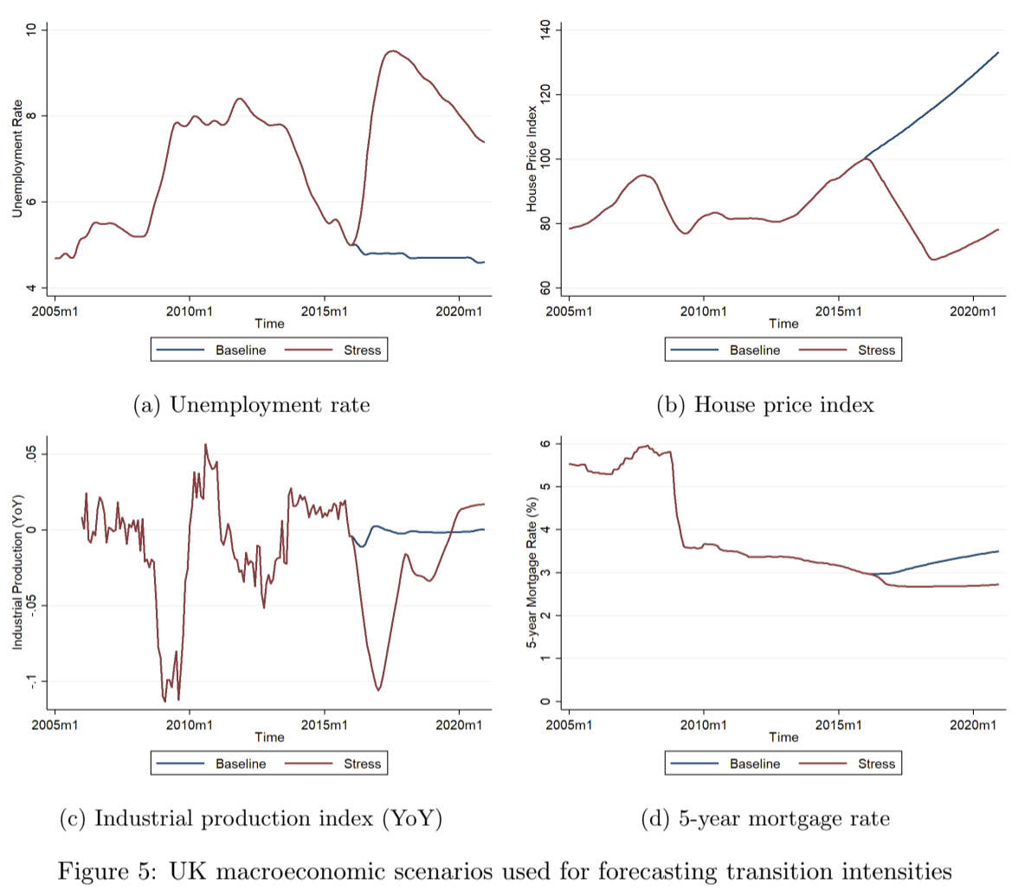
3.2 Forecasting Scenario-Conditional Transition Intensities and Transition Prob abilities
The UK mortgage data show account-level application and monthly behavioural informa tion until December 2015 for accounts originated between June 2006 and December 2015. A two-year forecast starting in January 2016 was chosen to allow for enough spread between the baseline and stress scenarios. All non-defaulted accounts originated between July 2014 and June 2015, and still open as at December 2015 were selected to produce the forecasts. The selection of alternative origination dates implies that different duration times are considered at the starting point (i.e. at January 2016).
The first step to forecast transition probabilities is to produce scenario-conditional cumu lative hazard functions. For each scenario scene, the cumulative hazard is estimated following Equation (11).
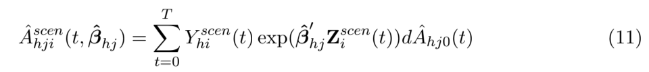
The cumulative baseline hazard (Aˆ_{hj0}(t)) is not risk interval-specific meaning that each

borrower receives the same specification regardless of how many times she has experienced the event of interest. However, this variance-corrected approach uses the risk interval information to account for dependency on repeated events for the same subject implying that we need to know how many times an account has transited by any future time t⁹. A one-step process was developed:
1. Select all non-defaulted accounts as of the latest available reporting date and allocate them to the corresponding risk set based on the current delinquency state and the number of previous observed events.
2. For each account, estimate the cumulative intensity since the origination date (in sample estimation).
3. For each account and for each macroeconomic scenario, forecast the six transition intensities one month out-of-time, i.e. from t to t + 1.
4. For each account and for each macroeconomic scenario, estimate the one-month tran sition probability using the Aalen-Johansen estimator:
5. Based on the transition probabilities estimated in step 4, decide whether each account undergoes the transition h → j. A series of cut-off values was defined by applying Equation (10) to each single 1-month transition using the training and test samples. This meant obtaining different cut-off values for different duration times. Because the cut-off values were determined in-sample, these are not scenario-dependent. The comparison between the estimated Pˆ^{scen}
_{i}(t, t + 1) and the cut-off values determines if a
transition takes place between t and t + 1. The estimated delinquency status obtained at this stage becomes the starting point for forecasting the transition in the following _{month, i.e. for P}ˆ^{scen}
_{i}(t + 1, t + 2).
6. Based on the delinquency status estimated in step 5, determine the current value for the behavioural variables.
7. Re-set the at-risk indicator Y_{hi}(t) based on the results from step 5 and repeat from step 3 until reaching the end of the forecasting window.
The steps listed above involve different levels of sophistication. The challenge appears in the forecast of the behavioural variables as the application variables remain constant across time and the macroeconomic scenarios are given by the series depicted in Figure 5. The time-varying portfolio data needed for the estimation process are account-level information for the exposure (or balance), the property value (to determine the current LTV) and the interest rates at each future time t. As the behavioural data used in the estimation processes
⁹The strata is a component of Z^{scen}
_{i} (t) in Equation 11.

are lagged, we first make the decision of whether the account experiences a transition and we then estimate the current value of the behavioural information based on this decision. Balance: if the account is selected to be performing (i.e. the account is selected to be in state 0) the balance is amortised following the expected contractual repayment: 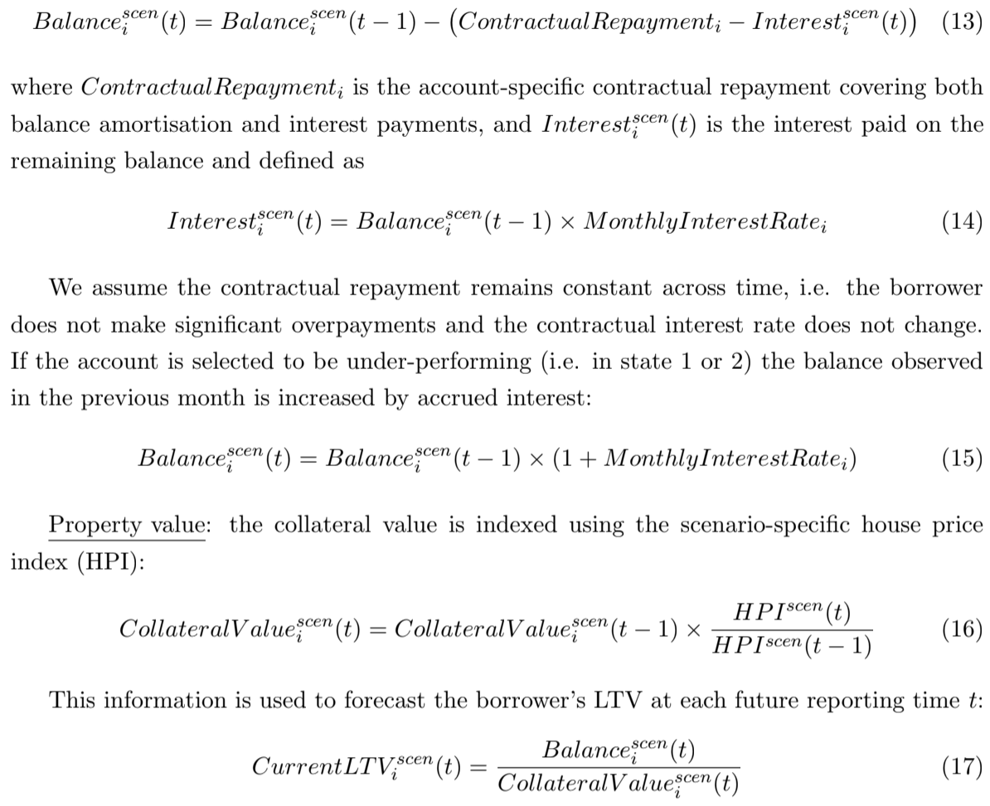

Contractual interest rate: assumed fixed throughout the life of the mortgage. As the vast majority of the portfolio does not show missed payments, the remainder of this analysis is concentrated on transitions out of state 0. Figure 6 presents the average relative spread between stress and baseline cumulative hazards for transitions 0 → 1 by origination vintage¹⁰. Panel (a) shows that while the spread follows a similar shape across all origination vintages, the level of the peak is significantly different. By December 2016 the average cumulative hazard under stress is 12.1% higher than the cumulative hazard under baseline for the 2015m6 vintage, while for the 2014m7 vintage this spread is approximately 7.5%. This implies that the relative risk of moving into one payment down under stress decreases the longer the account has been on book.
r

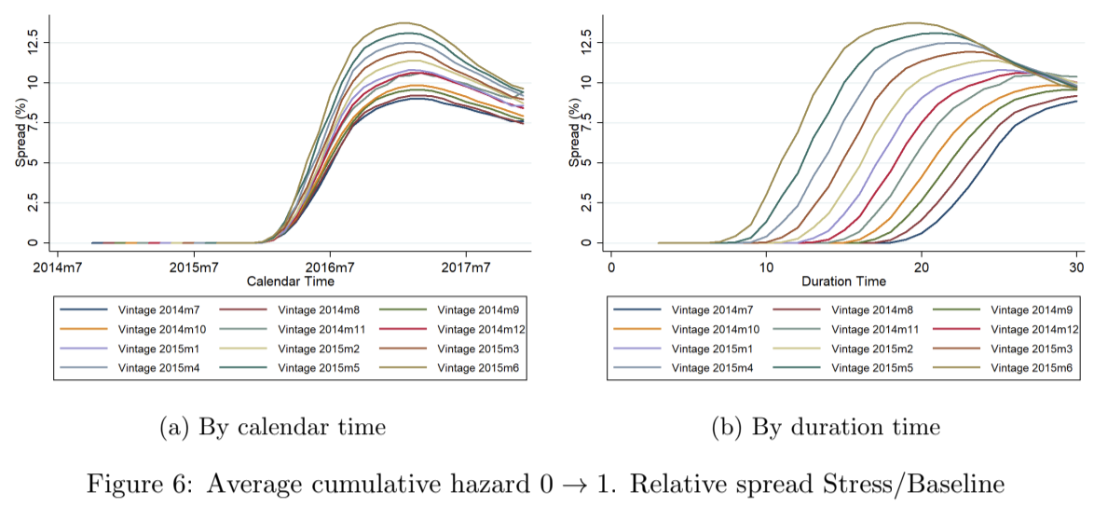
Figure 7 presents the average transition probabilities for both baseline and stress scenar ios. In line with economic theory, the probability of staying in state 0 is lower under stressed conditions. Similarly, movements into delinquency are more likely in a downturn.
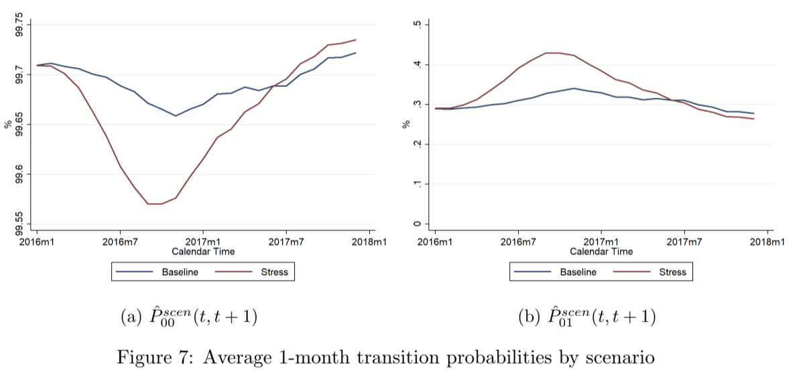
The scenario-conditional transition probabilities also differ by segments. Interest-only accounts and single applicants show a higher risk of entering into delinquency than repayment and multiple/married applicants. This line of reasoning is also reflected in the analysis by scenario. Figure 8 shows average transition probabilities Pˆscen
₀₁ (t) by scenario and origination
segments. While the spread between stress and baseline figures for a given segment is similar, the level of the transition probability is significantly different. For example, by October 2016, _{the average stressed P}ˆscen
₀₁ (t) is 0.38% for IO accounts and 0.45% for repayment accounts,
while the spread between stress and baseline for both segments remain around 28.4% (panel (b)). Similarly, single applicants face an average transition probability of 0.47% in October 2016 while married applicants have a lower probability of 0.40% but in both cases the spread between stress and baseline scenarios is similar (panel (c)).

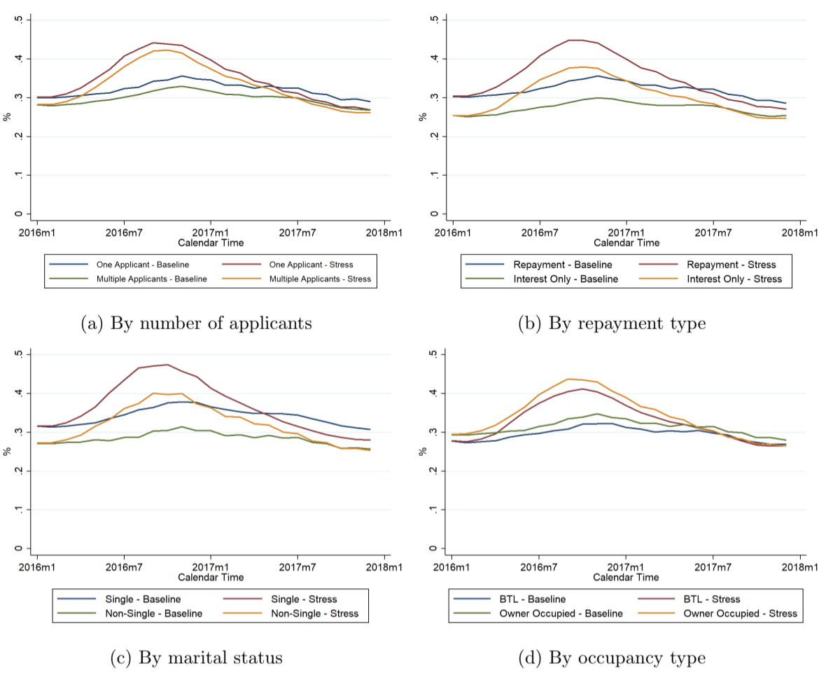Figure 8: Average 1-month transition probabilities Pˆscen
₀₁ (t, t + 1) by scenario and segment
It is possible to apply the Aalen-Johansen estimator to obtain transition probabilities between any duration times under each macroeconomic scenario by applying Equation (18)
Figure 9 presents the average 1-, 3- and 6-month transition probabilities where, consid ering the up to date book as the starting state, we plot the probability of being in state 0 (panel (a)) or in state 1 (panel (b)) 1, 3 and 6 months after. Because these are forward transition probabilities, we expect to observe the peak of the stressed scenario at different calendar times. For instance, Pˆscen
₀₁ (t, t + 1) incorporates transition intensity information of
_{the following month while P}ˆscen
₀₁ (t, t + 6) considers transition intensity information of the
next 6 months. Furthermore, the results show that also the level of the average transition probabilities change together with the forecast time horizon as it is more probable that an account that is in state 0 at any time t will stay in the same state the following month, but it

has more chances of moving towards delinquency in the next 6 months (under any scenario).

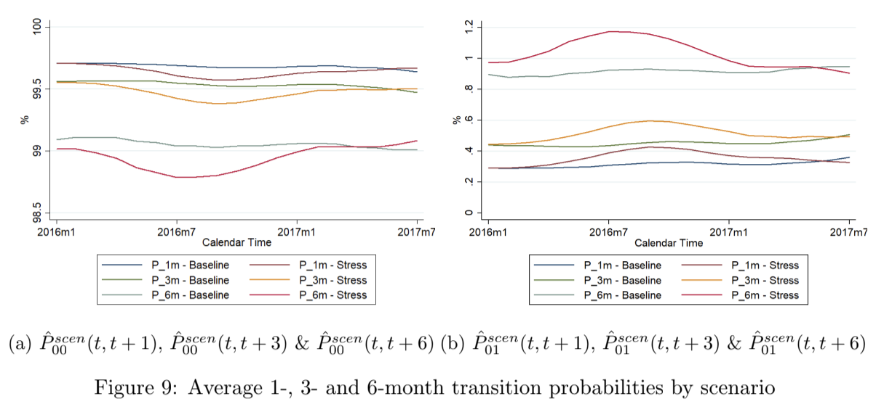
4 Conclusions
The literature studying the applications of survival models and intensity models to credit risk portfolios has increased rapidly in recent years. At the same time, stress testing analysis is a vitally important activity for banks to protect depositors and the wider public from losses in the event of severe but plausible adverse economic events. Banks need to provide stress testing results to regulators on a regular basis and carry out stress tests to compute economic capital. This study presents a new approach to forecast delinquency states and transition probabilities among alternative macroeconomic scenarios based on a dynamic multi-state model.
The contribution of this research is threefold. First, we estimate a delinquency multi-state model for residential mortgages. Previous studies have focused on similar specifications for credit cards (Leow and Crook, 2014; Djeundje and Crook, 2018) but this is the first study to consider six plausible types of transitions for a mortgage lending portfolio (Kelly and O’Malley (2016) based their study on movements into and out of default only). Our estima tion process considered both account-specific data (application and behavioural information) and macroeconomic series. The sign obtained for the coefficient estimates were aligned with expectations and economic intuition.
Second, the estimation and forecast of transition probabilities accounted for recurrent events. We considered both an Andersen-Gill model and a PWP-CP model with event specific baseline hazards. To the best of our knowledge, only Djeundje and Crook (2018) controlled by repeated events using a multi-state frailty model for credit cards. By imple menting the AG model we found that the number of times an account has experienced the event is significant, while the estimation of the PWP-CP model explicitly showed the impact on stratified risks. We also presented how recurrent events have a direct impact on the level of the cumulative intensities.
Third, this study adds to the existing literature on stress testing given that scenario conditional transition probabilities based on dynamic multi-state models were not analysed

before. The methodology we propose allows us to forecast delinquency states and transition probabilities consistent with changes in the underlying economic conditions and considering alternative macroeconomic scenarios. By forecasting each component of the intensity pro cesses we were able to predict transition probabilities for any future and unobserved time, i.e. beyond the lag of the time-varying covariates. We conclude that stress scenarios have a larger impact on younger vintages than on older vintages suggesting that more recent bor rowers are more likely to become delinquent under severe economic conditions. Moreover, the relative impact of the scenario also differs by origination characteristics such as the number of applicants, the repayment type or the occupancy type. We also found that both the level of the transition probabilities and their spread between stress and baseline scenarios change depending on the selected horizon (t, t + τ ].
26

A Appendix
A.1 Paths for Industrial Production Index and 5-year Mortgage Rate
We ran an exhaustive regression analysis on the year-on-year growth of the industrial production index and on the 5-year mortgage considering the variables listed in Table 5 and Table 6. This process implied analysing the combination of all potential covariates using up to three explanatory variables and considering both contemporaneous and lagged effects. Once all these regressions were obtained, we kept those with significant coefficient estimates at the 5% level that also showed the expected sign based on economic intuition. To avoid multicollinearity, combinations of covariates with a correlation above |0.75| were disregarded. As several models satisfy these constraints, we then selected the specification with the highest Adjusted R²
_{RMSE} ratio as it represents the model with best in-sample fit.
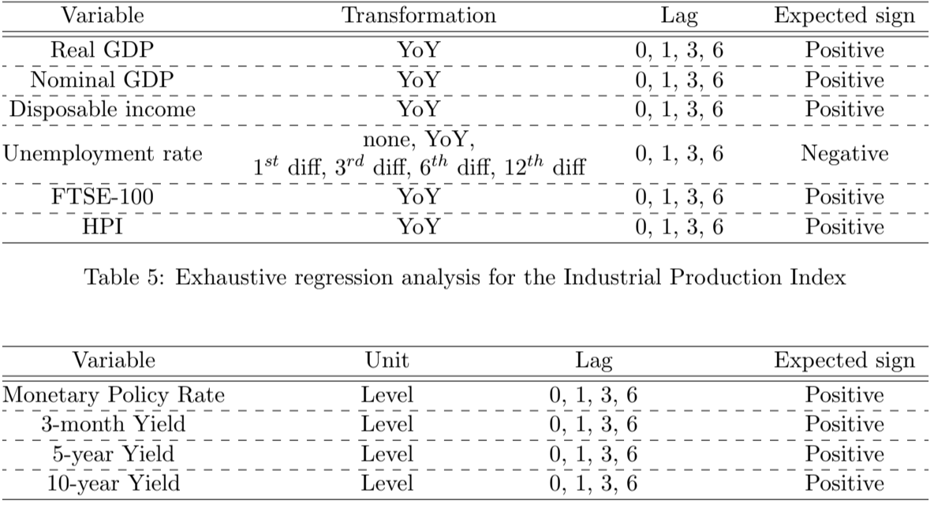
Table 6: Exhaustive regression analysis for the 5-year mortgage rate
Table 7 and Table 8 present the top ten models based on in-sample fit. The specifications highlighted in grey were selected.

References
Aalen, O., Borgan, O., and Gjessing, H. (2008). Survival and event history analysis: a process point of view. Springer Science & Business Media.
Aalen, O. O. and Johansen, S. (1978). An empirical transition matrix for non-homogeneous Markov chains based on censored observations. Scandinavian Journal of Statistics, 5(3):141–150.
Amorim, L. D. and Cai, J. (2015). Modelling recurrent events: a tutorial for analysis in epidemiology. International Journal of Epidemiology, 44(1):324–333.
Andersen, P. K., Borgan, O., Gill, R. D., and Keiding, N. (1993). Statistical models based on counting processes. Springer-Verlag New York, Inc.
Andersen, P. K. and Gill, R. D. (1982). Cox’s regression model for counting processes: a large sample study. The Annals of Statistics, pages 1100–1120.
Banasik, J., Crook, J. N., and Thomas, L. C. (1999). Not if but when will borrowers default. Journal of the Operational Research Society, 50(12):1185–1190.
Bellotti, T. and Crook, J. (2009). Credit scoring with macroeconomic variables using survival analysis. Journal of the Operational Research Society, 60(12):1699–1707.
Bellotti, T. and Crook, J. (2013a). Forecasting and stress testing credit card default using dynamic models. International Journal of Forecasting, 29(4):563–574.
Bellotti, T. and Crook, J. (2013b). Retail credit stress testing using a discrete hazard model with macroeconomic factors. Journal of the Operational Research Society, 65(3):340–350.
Beran, J. and Dja¨ıdja, A.-Y. K. (2007). Credit risk modeling based on survival analysis with immunes. Statistical Methodology, 4(3):251–276.
Box-Steffensmeier, J. M. and Jones, B. S. (2004). Event history modeling: A guide for social scientists. Cambridge University Press.
Calabrese, R. and Crook, J. (2020). Spatial contagion in mortgage defaults: A spatial dynamic survival model with time and space varying coefficients. European Journal of Operational Research, 287(2):749–761.
Cope, D. P., Hsu, C., Lively, C., Morgan, J., Schuermann, T., and Sekeris, E. (2020). Stress testing for commercial, investment and custody banks. Handbook of Financial Stress Testing, Forthcoming.
Cox, D. R. (1972). Regression models and life tables (with discussion). Journal of the Royal Statistical Society, 34(2):187–220.
Crook, J. and Banasik, J. (2012). Forecasting and explaining aggregate consumer credit delinquency behaviour. International Journal of Forecasting, 28(1):145–160.
30
Dirick, L., Claeskens, G., and Baesens, B. (2017). Time to default in credit scoring us ing survival analysis: a benchmark study. Journal of the Operational Research Society, 68(6):652–665.
Djeundje, V. B. and Crook, J. (2018). Incorporating heterogeneity and macroeconomic vari ables into multi-state delinquency models for credit cards. European Journal of Operational Research, 271(2):697–709.
Djeundje, V. B. and Crook, J. (2019). Dynamic survival models with varying coefficients for credit risks. European Journal of Operational Research, 275(1):319–333.
Duffie, D. (2011). Measuring corporate default risk. Oxford University Press.
Duffie, D., Saita, L., and Wang, K. (2007). Multi-period corporate default prediction with stochastic covariates. Journal of Financial Economics, 83(3):635–665.
Guo, Z., Gill, T. M., and Allore, H. G. (2008). Modeling repeated time-to-event health con ditions with discontinuous risk intervals: an example of a longitudinal study of functional disability among older persons. Methods of Information in Medicine, 47(2):107.
Hott, C. (2015). A model of mortgage losses and its applications for macroprudential instru ments. Journal of Financial Stability, 16:183–194.
Kau, J. B., Keenan, D. C., and Kim, T. (1994). Default probabilities for mortgages. Journal of Urban Economics, 35(3):278–296.
Kelly, P. J. and Lim, L. L.-Y. (2000). Survival analysis for recurrent event data: an applica tion to childhood infectious diseases. Statistics in Medicine, 19(1):13–33.
Kelly, R. and O’Malley, T. (2016). The good, the bad and the impaired: A credit risk model of the Irish mortgage market. Journal of Financial Stability, 22:1–9.
Kiefer, N. M. and Larson, C. E. (2015). Counting processes for retail default modeling. Journal of Credit Risk, 11(3):45–72.
Kupiec, P. H. (2018). On the accuracy of alternative approaches for calibrating bank stress test models. Journal of Financial Stability, 38:132–146.
Lando, D. and Skødeberg, T. M. (2002). Analyzing rating transitions and rating drift with continuous observations. Journal of Banking & Finance, 26(2):423–444.
Lee, E. W., Wei, L., Amato, D. A., and Leurgans, S. (1992). Cox-type regression analysis for large numbers of small groups of correlated failure time observations. In Survival analysis: state of the art, pages 237–247. Springer.
Leow, M. and Crook, J. (2014). Intensity models and transition probabilities for credit card loan delinquencies. European Journal of Operational Research, 236(2):685–694.

Leow, M. and Crook, J. (2016). The stability of survival model parameter estimates for predicting the probability of default: Empirical evidence over the credit crisis. European Journal of Operational Research, 249(2):457–464.
Malik, M. and Thomas, L. C. (2012). Transition matrix models of consumer credit ratings. International Journal of Forecasting, 28(1):261–272.
McDonald, R. A., Matuszyk, A., and Thomas, L. C. (2010). Application of survival analysis to cash flow modelling for mortgage products. Operational Research Society, 23(1):1–14.
Park, K. A. (2016). FHA loan performance and adverse selection in mortgage insurance. Journal of Housing Economics, 34:82–97.
Prentice, R. L., Williams, B. J., and Peterson, A. V. (1981). On the regression analysis of multivariate failure time data. Biometrika, 68(2):373–379.
Sagara, I., Giorgi, R., Doumbo, O. K., Piarroux, R., and Gaudart, J. (2014). Modelling recurrent events: comparison of statistical models with continuous and discontinuous risk intervals on recurrent malaria episodes data. Malaria Journal, 13(1):293.
Schechtman, R. (2013). Default matrices: A complete measurement of banks consumer credit delinquency. Journal of Financial Stability, 9(4):460–474.
Schuermann, T. (2014). Stress testing banks. International Journal of Forecasting, 30(3):717– 728.
Schuermann, T., Jafry, Y., et al. (2003). Measurement and estimation of credit migration matrices. Center for Financial Institutions Working Papers, 3(8).
Thenmozhi, M., Jeyaseelan, V., Jeyaseelan, L., Isaac, R., and Vedantam, R. (2019). Survival analysis in longitudinal studies for recurrent events: Applications and challenges. Clinical Epidemiology and Global Health, 7(2):253–260.
Therneau, T. M. and Hamilton, S. A. (1997). rhDNase as an example of recurrent event analysis. Statistics in Medicine, 16(18):2029–2047.
Ullah, S., Gabbett, T. J., and Finch, C. F. (2014). Statistical modelling for recurrent events: an application to sports injuries. British Journal of Sports Medicine, 48(17):1287–1293.
Wei, L. and Glidden, D. V. (1997). An overview of statistical methods for multiple failure time data in clinical trials. Statistics in Medicine, 16(8):833–839.
Wei, L.-J., Lin, D. Y., and Weissfeld, L. (1989). Regression analysis of multivariate in complete failure time data by modeling marginal distributions. Journal of the American statistical association, 84(408):1065–1073.
Wood, R. and Powell, D. (2017). Addressing probationary period within a competing risks survival model for retail mortgage loss given default. Journal of Credit Risk, 13(3).

Zhang, J. and Thomas, L. C. (2012). Comparisons of linear regression and survival analysis using single and mixture distributions approaches in modelling LGD. International Journal of Forecasting, 28(1):204–215.

