Super-App environments: value and implications in consumer lending services
Alejandro Correa-Bahnsen¹, David Zarruk¹, Luisa Roa¹, Jaime Acevedo-Viloria¹, Ana Quintero¹, and Fernando Cortés-Tejada²
¹Rappi, Cl. 93 #19-75, Bogotá, Colombia.
²Pontificia Universidad Católica del Perú, Av. Universitaria 1801, San Miguel, Lima, Perú.
Abstract
In this paper we present the impact of alternative data that originates from an app-based marketplace, in contrast to traditional bureau data, upon credit scoring models. These alter native data sources have shown themselves to be immensely powerful in predicting borrower behavior in segments traditionally unrserved by banks and financial institutions. Our re sults, validated across two countries, show that these new sources of data are particularly useful for predicting financial behavior in low-wealth and young individuals, who are also the most likely to engage with alternative lenders. Furthermore, using the TreeSHAP method for Stochastic Gradient Boosting interpretation, our results also revealed interesting non-linear trends in the variables originating from the app, which would not normally be available to traditional banks. Our results represent an opportunity for technology companies to dis rupt traditional banking by correctly identifying alternative data sources and handling this new information properly. At the same time alternative data must be carefully validated to overcome regulatory hurdles across diverse jurisdictions.
Keywords: Fintech; Super-App; Credit Scoring; Income Estimation; Financial Inclusion; Alternative Data
1 Introduction
Super-Apps are mobile applications intended for satisfy a large number of day-to-day consumer needs, from banking needs to delivery of goods, shopping and transport. Given the wide range of services, Super-Apps capture data from the different interactions and transactions of their users, which will better understand the needs, profiles and interactions of users. This is particularly beneficial for financial services since they can complement the financial history of users, which is the source with which traditional entities usually evaluate individuals. In fact, 2 billion adults are unbanked, which implies that traditional entities do not offer them services since there is not enough information to evaluate them.
Data originating from non-financial sources is defined as alternative data (Siddiqi, 2017) has been shown to generate value for different tasks in the credit origination process and especially to promote financial inclusion. However, at the best of our knowledge, little has been investigated on the value generated by the alternative data of a super-app, specifically in credit rsik assessment and income estimation problems. This presentation compiles three works carried out by the authors to understand the value and implications in consumer lending services.
1

2 Use cases
In this section, different works are presented that study the impact of alternative data on credit risk assessment and income estimation.
2.1 Credit risk assessment - Tabular features
In Roa, Correa-Bahnsen, Suarez, Cortés-Tejada, Luque and Bravo (2021a), the authors study how variables related to consumption and transactionality in a Super-App enhance credit risk assessment. To this end, the authors propose 4 groups of features that capture information from different processes in the Super-App. First, the generic features that are demographic attributes of the user, such as the age and type of cell phone they have, allow the user profile to be captured in a general way. Then, the delivery features are variable related to the consumption within the delivery functionalities such as food, groceries, e-commerce, among others. These variables allow to understand the consumption within the platform and different preferences and behavior. They also define the transportation features that are variables of the consumption of scooter, bike and ride services, this information allows you to know the mobility of the user and their preferences. Finally, they define the financial features that withdraw information from the transactionality in the fintech platform of the Super-App, for example the use of bank transfers or the virtual dual wallet. With this information, 3 types of XGBoost qualification models are defined, one that only considers financial data of the good credit, another with only features of the Super-App and a last one that combines the features, in order to see the earnings of each one . Additionally, the authors propose to evaluate these models on the complete sample of users and on three different segments in order to understand whether default prediction can be improved for certain populations. The segments are the device score, how new and costs is the cell; the wealth score, which is a proxy metric of the Super-App that provides a proxy for economic capacity; and the RFM (recency, frequency and monetary) segment, which is a segmentation based on the user consumption. The models are valued from a statistical point of view (AUC) and a financial point of view (Savings) where a cost sensitive approach Correa Bahnsen, Aouada and Ottersten (2014) is considered.
Overall, the authors find that the model that combines the features of burau and the Super App has the best performance in terms of AUC and savings for the different segments as shown in Figures 1a and 1b. In such a way that the transactional variables manages to retrieve insights that the bureau score fails to capture, this is specifically evident for the Wealth Score and RFM segments where the differences are more pronounced than in other segments. It is also noteworthy that it is identified that for users in the high segments there is a better performance, something intuitive as it is easier to identify behavior from good payers to bad payers. In addition, the authors use SHAP Lundberg and Lee (2017) to understand the effect of variables in the model without segments, the results are shown in Figure 2. Finding that the features associated with the payment method behavioral patterns were those that added more value to the accuracy of the default prediction. In this way, the more orders are paid with a credit card and there are fewer cancellations due to payment errors (insufficient line), the better payer the user will be.
2.2 Credit risk assessment - Graph features
Continuing with the problem of credit risk, in Roa, Rodríguez-Rey, Correa-Bahnsen and Valencia (2021b) it is studied how the data generated from different interactions within the Super-App can improve the evaluation. For this, the authors first define 5 types of networks: the graph based
2

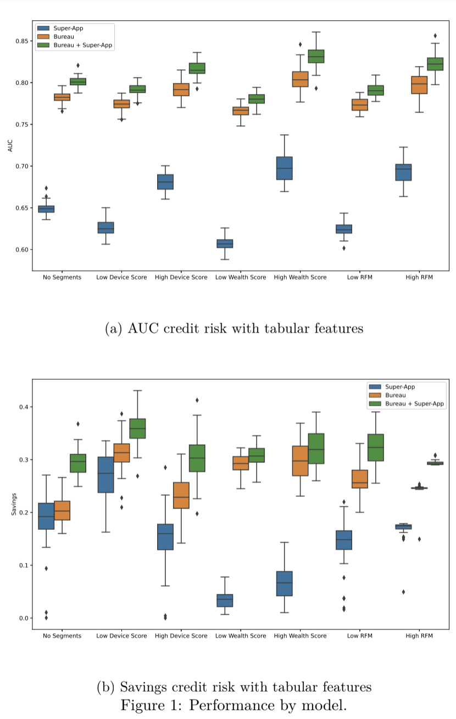

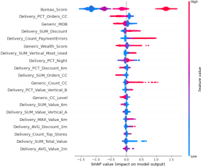
Figure 2: SHAP credit risk with tabular features
on the peer to peer transfers of the platform where users connect if there is any transfer between them; the credit card graph where you have the relationships users to their credit cards registered in the app; the devices graph where users are connected to the devices from which they have started session; the bin graph where the first six digits of the credit card are extracted and the relationships are used to bin; and finally, the geohash graph where users are related to geohash nodes that represent the delivery addresses. Starting from the graphs, graph based features are obtained, including degree centrality, Eigenvector centrality, Pagerank centrality, Louvain communities and the average of some features of direct neighbors. Also, more than 140 transactional features of the app are built that are the input for a first XGBoost classifier model that they call base model, then 5 hybrid models are defined in which the transactional features and the features of each graph are combined and finally they define a model that considers the features of all graphs.
The authors find that the models that consider the variables based on the graphs of credit cards, devices and bines allow to improve the average AUC of the models as shown in Figure 4, specifically the network of bins offers the highest prediction to while capturing information from users with similar financial profiles. It is also noteworthy that the model with the best performance is that it combines all variables and particularly for this the authors use SHAP to obtain the importance feature. Figure 5 shows that of the 20 most important variables 9 are graph-based and it is particularly relevant that the centrality in the bin graph has a high predictive value. Likewise, variables of the P2P and credit card graphs that add neighbor variables indicate that the context of the users with whom they are related allows the payment behavior to be deduced. For example, the more canceled orders the user’s neighbors have on the p2p network, the lower the probability of default.
2.3 Income estimation - Tabular features
For the income estimation problem, in Suarez, Raful, Luque, Valencia and Correa-Bahnsen (2021) the authors use transactional variables to see the effect on the estimation and how they can improve traditional calculations. The authors define four groups of alternative data variables in the Super
4
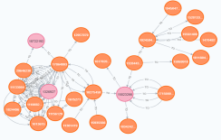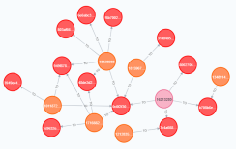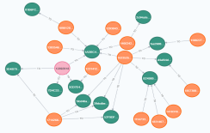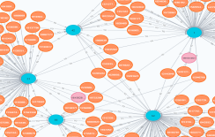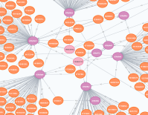
Figure 3: Graphs

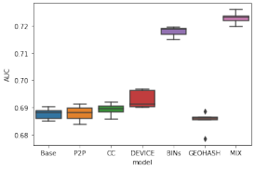
Figure 4: AUC credit risk with graph-based features
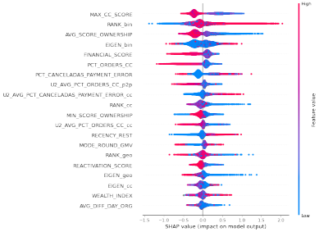Figure 5: SHAP credit risk with graph-based features
6

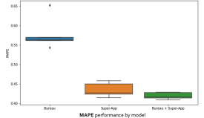
Figure 6: MAPE income estimation
App: personal information, consumption patterns, payment information and financial features. In the first group demographic characteristics are considered, in the second consumption patterns are retrieved from the vertical delivery within the Super-App, in the next group it is considered variable related to payment methods and finally in the last group transactionality in the financial services. In this work, 3 models are also considered, one of which only has bureau features, another only features Super-App features and finally a model that combines the two data sources.
The results show that the information from the Super-App alone generates more information than the variables from bureau. In Figure 6 it is evident that the MAPE is reduced by more than one percentage point when comparing the models of bureau variables and variables of the Super App. In addition to feature importance, Figure 7, it identifies that Users with high estimated income have high consumption in exclusive restaurants, high delivery consumption, high amount of money debited through financial services and high-level or premium credit cards registered. Users with low estimated income have high use of discounts in orders and low tipping value in orders.
3 Conclusion
This work presents how the alternative data generated by a super app generates value in different use cases during the origination process. First, for the credit risk problem, it is presented how the transactional and behavioral data allow to improve the evaluation of certain customer segments. Identifying variables such as credit card use and relevant tip amounts to identify good and bad payers. Furthermore, it was presented how the networks generated by users and different entities also improve the task of identifying the creditworthiness of a user. In particular, the BINs graph manage to group users with a similar financial profile as these are the first six digits of the credit cards they use, consequently a proxy for the economic capacity to pay a loan is captured. Finally, it is also presented how the alternative transactional data also improves the estimation of the income of the users since the users consume with respect to their economic capacity.
Based on the above, it is identified that the data generated by the Super-App is valuable for financial inclusion as well as the strengthening of origination processes. For this reason, regulators should promote the use of this type of information to improve access to credit and also generate regulations that guarantee its use. Finally, institutions that use this data have a competitive advantage since they can create comprehensive profiles of their clients in such a way that these are not only evaluated with the credit history but also with the interactions of the platform itself.

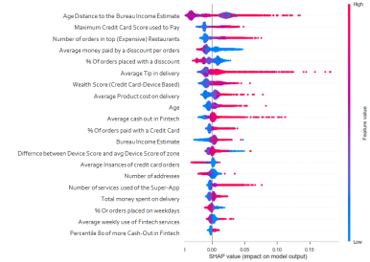Figure 7: SHAP income estimation
References
Correa Bahnsen, A., Aouada, D., Ottersten, B., 2014. Example-Dependent Cost-Sensitive Logistic Regression for Credit Scoring, in: 2014 13th International Conference on Machine Learning and Applications, IEEE, Detroit, USA. pp. 263–269.
Lundberg, S.M., Lee, S.I., 2017. A unified approach to interpreting model predictions, in: Guyon, I., Luxburg, U.V., Bengio, S., Wallach, H., Fergus, R., Vishwanathan, S., Garnett, R. (Eds.), Advances in Neural Information Processing Systems 30. Curran Associates, Inc., pp. 4765– 4774.
Roa, L., Correa-Bahnsen, A., Suarez, G., Cortés-Tejada, F., Luque, M.A., Bravo, C., 2021a. Super-app behavioral patterns in credit risk models: Financial, statistical and regulatory implications. Expert Systems with Applications 169, 114486. URL: http://dx.doi.org/ 10.1016/j.eswa.2020.114486, doi:10.1016/j.eswa.2020.114486.
Roa, L., Rodríguez-Rey, A., Correa-Bahnsen, A., Valencia, C., 2021b. Supporting financial inclu sion with graph machine learning and super-app alternative data. arXiv:2102.09974. Siddiqi, N., 2017. Intelligent Credit Scoring. John Wiley & Sons, Inc.
Suarez, G., Raful, J., Luque, M.A., Valencia, C.F., Correa-Bahnsen, A., 2021. Enhancing user’ s income estimation with super-app alternative data. arXiv:2104.05831.

8

