Assessment of Survival Analysis Approaches to IFRS9 Implementation for Retail Portfolios
Andrea Lunelli, Konstantinos Bousoulas, Ansgar Wenzel, Sylvain Willart¹ Advanzia Bank S.A.
Abstract
Since the 2008 financial crisis, regulators focused on ensuring adequate capital provisions are available for banks and other financial institutions to account for a potential new crisis (Basel III and EU CRR regula tions). With the introduction of IFRS9, banks are required to estimate Expected Credit Losses (ECL) for their credit portfolios. This is typically done by computing Probability of Default (PD), Exposure at Default (EAD), Loss Given Default (LGD), and applying a forward-looking adjustment. These can be calculated either on a portfolio level, intermediate aggregate, or individual loan level. Each of these approaches presents different advantages and challenges. For a retail bank like Advanzia, with many small consumer loans, individual calculations are the most challenging, but also potentially the most rewarding. In particular, individual PD modelling is performed traditionally using a logistic regression, that allows to estimate probability of default on a fixed performance window. This approach presented several challenges in the case where multiple different performance windows were necessary, or in the case where ‘lifetime’ probability of default calcu lations were involved as required by IFRS9. Modelling of LGD at individual level can also be performed using a logistic regression, but this presents other challenges such as handling the performance window considered for the recovery process, dealing with different lengths of available data at individual level, and with right-censored data from cases having only partial recovery status at the end of the performance win dow. Advanzia has implemented a survival analysis model framework for the estimation of PD and LGD resulting in a more accurate and stable estimation of ECL. Hazard rate based definitions were used for assessing worsening credit quality and allocation to stages. Both Proportional Hazards (PH), and Accel erated Failure Time (AFT) models were tested and compared to model time to default (PD models), or time to repayment (LGD models), facilitating the calculation of Life Time value expectations. Furthermore, macroeconomic indicators, treated as potential covariates affecting the baseline hazard, allowed to adjust for forward-looking economic shocks. We aim at sharing our experience and the modelling challenges we encountered following a survival approach to IFRS9 requirements on a portfolio of over one million credit cards. Finally, we will give an outlook to possible further improvements, focusing on portfolio optimisation and the use of machine learning algorithms for a better estimation of the survival models.
¹{andrea.lunelli, konstantinos.bousoulas, ansgar.wenzel, sylvain.willart}@advanzia.com
Contents
1 Introduction 2
2 Why Survival 3
3 Methodological Background: Survival Modelling 4
4 Issues Solved Using Survival 10
5 Challenges Encountered in Implementation 20
6 Results 23
7 Potential Improvements and Machine Learning 24
1 Introduction
1.1 Advanzia Bank S.A.
Founded in 2005 in Luxembourg, Advanzia Bank is a European digital bank specialising in credit cards and payment solutions. With 1.9 million credit card customers, the bank achieved a credit card turnover of EUR 3.5 billion in 2020. Advanzia is a leading credit card issuer in Germany and has a strong presence in Luxembourg, Austria, France and Spain. As well as issuing credit cards under its own brands, the bank also partners with over 240 companies, associations and financial institutions who use Advanzia co-branded credit cards to create competitive advantage. Advanzia currently employs more than 200 employees.
1.2 IFRS9 and Revolving Credit Cards
In the wake of the 2008 financial crisis, the International Accounting Standards Board (IASB) proposed an update to the International Accounting Standard (IAS) 39: the International Financial Reporting Standard (IFRS) 9 [2], published in 2014 for implementation in 2018. With this new approach, the accounting impair ment of any financial asset (within the scope of the IFRS9) is expressed by the expected credit loss (ECL), this being the projected present value of the estimated cash shortfalls over the expected life of the asset.
Expected credit loss is typically evaluated by computing, for each asset, the probability of default (PD), the exposure at default (EAD), and the loss given default (LGD), and applying a forward-looking adjustment. The formula used is simply
ECL = P D ∗ EAD ∗ LGD,
while the forward-looking adjustment can be applied either to the ECL or to each of its component separately.
The IFRS9 standard also differentiates between assets (and their ECL computation) based on a significant increase in credit risk (SICR). In practice, banks split their loan portfolio between stage 1, the loans in good standing, stage 2, the loans whose credit quality has degraded since origination and have triggered this SICR threshold, and stage 3, the already defaulted loans. In the case of SICR (stage 2) assets, the period over which the ECL has to be evaluated is the expected lifetime (ELT) of the loan:
“[2], 5.5.3: Subject to paragraphs 5.5.13–5.5.16, at each reporting date, an entity shall mea sure the loss allowance for a financial instrument at an amount equal to the lifetime expected credit losses if the credit risk on that financial instrument has increased significantly since initial recognition.”

The question of the expected lifetime of the asset is central for determining the cash shortfalls that have to be taken into account. It is well defined for loans who have an embedded maturity (typically mortgages, see [2], 5.5.19), but not so for credit card assets². In the case of credit cards, the ECL has to be computed over the lifetime of the loan, irrespective of the asset exhibiting a significant increase in credit risk. In essence, there is no fundamental difference in ECL computation between stage 1 and stage 2 assets in the context of credit cards. Therefore, owners of revolving credit card portfolios are left with the challenging task of computing the ELT of a product that, by definition, has none.
The importance of lifetime in the case of ECL computation for Advanzia’s revolving credit card portfolio has naturally led us to investigate the survival modelling approach.
2 Why Survival
Survival Analysis is a branch of statistics that deals with both the estimation and the analysis of time to event, where the event can be a biological death, a mechanical failure, or, in the case of credit risk, a loan default.
It is traditionally used in medicine, to analyse factors relating to the onset and time of death, or the onset of disease. It is also commonly used in actuarial science, for the computation of premiums for life insurance, but can be used in any application where there is a need to analyse the onset and time of a specific event.
2.1 One Model for Several Maturities and Usages
The main benefit of turning to survival models and methods is that they fit well with the concept and re quirements of both lifetime and lifetime risk required by IFRS9. Survival models can predict a probability of default at all desired performance windows, simultaneously. A single model result can be used to predict PD up to the expected lifetime for loans in IFRS9 stage 1, but also the full lifetime risk for loans that moved to IFRS9 stage 2.
Additionally, the same model can be used to compare the current PD with the one at initial recognition, at whatever time horizon the latter was estimated for. This can be used to determine significant increases in credit risk, for example.
Survival analysis also provides a methodology for estimating the expected lifetime, such as those used in the computation of lifetime risk for IFRS9 stage 2 loans. This is especially important for loans with no contractually defined maturity, such as credit lines or credit cards. The concept of median survival time is a well established estimator for the expected lifetime of an event, widely used in all applications of survival analysis, and will be presented in section 4.1.2.
2.2 Censored Data
Another advantage of survival models over more traditional logistic regression models is the handling of censored data. An individual is called right censored³ if its time to event is unknown, and we only know it survived up to some time C. A good example for this are loans that did not default yet.
²From [2], 5.5.20: “some financial instruments include both a loan and an undrawn commitment component and the entity’s con tractual ability to demand repayment and cancel the undrawn commitment does not limit the entity’s exposure to credit losses to the contractual notice period. For such financial instruments, and only those financial instruments, the entity shall measure expected credit losses over the period that the entity is exposed to credit risk and expected credit losses would not be mitigated by credit risk management actions, even if that period extends beyond the maximum contractual period.”
³The opposite case is that of left censored data, where an individual’s time to event is known to be before some time C, but the precise time is unknown. This should have no use in the context of credit risk, however.

For a model predicting an event over a fixed target performance window, one would have to exclude cases who do not have the desired maturity yet from the model development sample⁴.
However, survival models do not have a fixed performance window. All cases would contribute to the like lihood function and to the hazard estimation, up to their time to event T if available, or their censored time C. Therefore, it is not necessary to exclude any case from the development sample due to insufficient maturity. This allows us to have more data available to estimate the models, resulting in a better fit overall. It is especially advantageous for new products where data can be scarce in the beginning, such as a new market entry or for models with a long target performance window.
2.3 Multiple Events
In addition to PD, survival models can also be applied to other concepts that include one or more events over time. We had to deal with several issues with survival models related to the recovery and repayment of loans and we will present those in section 4.3.
2.4 Ease of Use
The most commonly used survival models, and in particular the Cox proportional hazards model presented in section 3.2.2, are a type of generalised linear models⁵. This means they are easy to understand and use in practice. Furthermore, all statistics and methods that can be used with linear models work with them as well. More importantly, as linear models they are normally easy to deploy in a production environment.
3 Methodological Background: Survival Modelling
This chapter contains a short introduction to survival analysis and survival models, taken from Moore [9] unless specified otherwise.
3.1 Survival Analysis
The main components of Survival Analysis are the survival and hazard functions. The survival function is defined as follows:
S(t) = P (T > t),
where T is a random variable denoting the time to death or event.
Effectively, S(t) is the probability of surviving at least up to time t, and is the inverse of F(t) = P (T≤ t), which is the distribution function of the lifetime random variable T.
The survival function has the following properties:
1. It is non-increasing: given u ≥ t, S(u) ≤ S(t),
2. For t = 0, S(t) = 1, so survival at the beginning is guaranteed and
3. For t → ∞, S(t) = 0, so the event is guaranteed to happen.
⁴For example, it is not possible to train a PD model with a 12-months performance window for the target on data that does not have 12 months of maturity yet, since the target cannot be defined.
⁵For an introduction to generalised linear models, see Peter McCullagh and John A. Nelder [10].
These properties ensure that the inverse of the survival function F(t) = 1 − S(t) is a proper cumulative distribution function, and so the distribution of the random variable T, the lifetime distribution, is well defined.
The third property makes sense for biological death. However, it is not fully appropriate for non-guaranteed events such as default, as some loans will be repaid, and will not default. This is not an issue in practice, as the requirement is up to infinity, whereas survival curves used for predictions will be cut at some specific time, such as the maturity of the loan.
The hazard function is defined as follows:
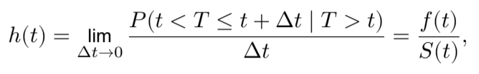
where f(t) = ^{d} _{dt}F(t) is the density function of the random variable T.
The hazard can be considered as the instantaneous risk that the event will happen at time t, provided that it did not happen before that time. It has the following properties:
1. It is non-negative: ℎ(t) ≥ 0 and
2. Its integral on the positive real numbers is infinite: ∫∞₀ ℎ(t) dt = ∞.
The latter property is related to the third property of the survival function.
A cumulative hazard function measures the accumulation of this instantaneous risk over time. It is a mono tonic function that diverges as t → ∞, and is defined as follows:
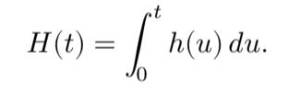

Knowing just one of S(t), h(t) and H(t) is sufficient to compute the other two, since the following holds⁶: 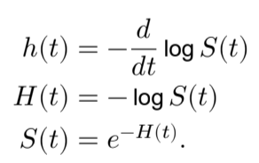
More often than not, the inverse of the survival function, i.e. the lifetime distribution function F(t) = 1−S(t), is just as important as the survival function itself. When analysing loan defaults within the context of credit risk, the lifetime distribution function matches well with the standard cumulative default rate. We will be exploring its use for the repayment of defaulted loans in section 4.3.
Since the survival function S(t) is an evolution of risk over time, the survival approach fits well with the con cept of lifetime risk as required by the IFRS9 standard [2]. The lifetime distribution function F(t) additionally provides a well known methodology to compute an expected lifetime, the median survival time.

⁶The first one is simply derived from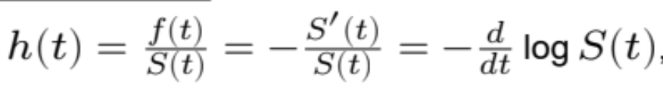 , and the two other relations follow.

3.2 Survival Models and Applications
3.2.1 Kaplan-Meier, Proportional Hazards, and Accelerated Failure Time
There are several methodologies for estimating and modelling survival and hazard curves directly from data. A purely non-parametric approach is known as the Kaplan-Meier estimator, and is computed as follows:
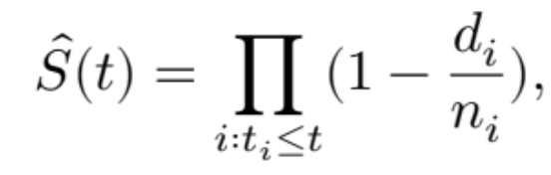
where t_{i} are (discrete) times where events actually happen, d_{i} are the number of events happening at such times t_{i}, and n_{i} are the number of cases at risk at time t_{i}, that is the count of those that survive up to that time. Note that:
• n_{i} includes the cases that died at time t, since they did survive up to that time. This ensures that d_{i} ≤ n_{i} for each t_{i}, and the estimator is essentially a cumulative product of the fraction of the surviving population at each time t_{i}.
• This estimator is already robust to right-censored data, where for some cases the event does not happen up to a known time C_{i}; those would enter the count for n_{i} only for t_{i} ≤ C_{i}, and not after.
The Kaplan-Meier estimator is the standard choice when computing average survival curves for a dataset. It can also be used to compute different survival curves based on values of some covariates, by segmenting the data. However, for a large number of covariates this estimator is not the best choice. This is because one would need a sufficient amount of data for each combination of covariates, in order to not overfit the model.
The most common approaches to modelling the survival (and hazard) curves with several covariates, are parametric and semi-parametric methods. Parametric methods seek to estimate two separate model com ponents at the same time⁷:
• A common baseline hazard function⁸, fitting some known probability distribution: ℎ₀(t) = ℎ(t ∣ δ),
where δ are the fit parameters for the probability distribution⁹.
• An individual risk parameter θ_{i}, resulting from a generalised linear model¹⁰ on the covariates X_{i}, with the natural logarithm as the link function:
θ_{i}= e^{eβ∗Xi} ,
where X_{i} are the covariates of the model for the individual i, and ^{β} is a vector of model coefficients.
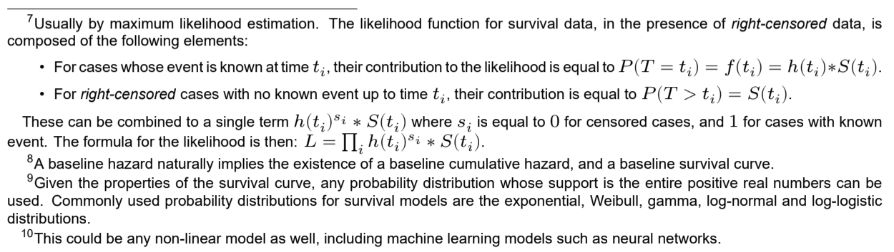

These models are broadly divided into proportional hazards (PH) models, and accelerated failure time (AFT) models. In PH models, the baseline hazard ℎ₀is multiplied by θ_{i}, to obtain a hazard curve for each individual case. In AFT models, t, the time parameter of the hazard function, is multiplied by θ_{i}. Intuitively, for higher values of θ_{i} the risk increases proportionally at a fixed time in a PH model. In an AFT model, instead, an individual would move faster on the baseline hazard¹¹. This is illustrated in the example figure 1 below.
Modelled hazard, cumulative hazard and survival functions for PH and AFT models are computed as follows: Table 1: Hazard, cumulative hazard and survival functions for PH and AFT models. 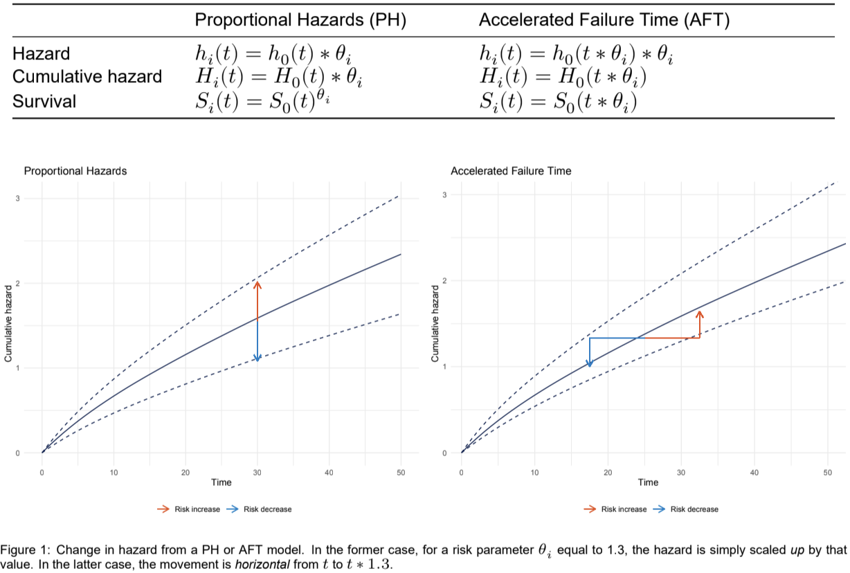
A proportional hazards model assumes that each covariate scales the baseline hazard in the same way at each point in time. For an accelerated failure time model, the assumption is that each covariate scales the time parameter of the baseline hazard function in the same way on the entire curve. Neither might be a perfect fit, but there are workarounds such as time-varying coefficients or stratified models, which will be presented in section 3.2.3.
3.2.2 Cox Proportional Hazards Models
As opposed to parametric methods, where both the linear model of the risk factor θ_{i} ^{and the lifetime distribu}tion parameters are estimated at the same time, a more common model methodology is the semi-parametric
¹¹Effectively, in PH models, the baseline hazard is scaled on the y axis, whereas in AFT models the scaling is performed on the t, or time, axis.

Cox proportional hazards model [see 4]. This approach broadly falls within the class of PH models described above¹², but the baseline hazard is not estimated when fitting the model.
For a Cox proportional hazards model, the risk factor θ_{i} = e^{B∗Xi} is estimated independently from the baseline hazard, using a partial likelihood function¹³. This is effectively a generalised linear model that ranks individuals based on their expected time to event. It can be used for analysis and descriptive statistics, without estimating the baseline hazard.
For our purposes of predictive modelling, however, the baseline hazard is needed. It is estimated non parametrically after fitting the Cox model, using a similar formula to the Kaplan-Meier estimator¹⁴.
The main advantage of the this type of model is that it requires no assumption on the distribution of the lifetime variable. We do not have to chose a statistical distribution, and instead the shape of the hazard function is determined entirely by the data. The main drawback, conversely, is that the hazard curve cannot be easily extrapolated beyond the time scope of the observed data.
For our implementation in the context of IFRS9 models, we have tested both AFT and PH models. We decided on the latter and more specifically on Cox models, since this choice makes more sense for modelling PD. This is because an individual with higher risk of default should have a higher hazard overall when compared to an individual with low risk of default, which is the assumption of a PH model. On the other hand, an AFT model assumes the event would happen for everyone but at a different time, which is not necessarily the case when the event is a loan default.
Another reason for this choice is the non-parametric estimation of the baseline hazard of Cox models. In most segments of our loans, the observed default hazard is close to zero for the first months, followed by a spike at the first possible time of default¹⁵ and then a drop to a lower level.
In other words, for those loans that do default, they tend to do it very quickly. This is shown below in figure 2. Instead of trying to fit some known (or custom) distribution to this very specific hazard, our preferred choice was to estimate it directly from the data.
3.2.3 Strata and Time-Varying Coefficients
To use PH models, and especially Cox models, it is necessary to ensure that the assumptions of proportional hazards are valid. This means that all individual hazards are multiples of a baseline hazard, and these multipliers can be computed as functions of the covariates.
These assumptions might not hold in practice, for example when considering a heterogeneous portfolio of loans. To avoid this problem several workarounds are possible. In particular, we have analysed the following:
¹²With one notable difference. There is a variation of parametric survival models that we did not test in the context of IFRS9, where the parameters of the statistical distribution are also allowed to vary with the covariates. These are also called dynamic survival models [see 5]. In this case, there is no fixed baseline hazard for the entire sample, but only a baseline family of hazards. This cannot be achieved with a Cox model. 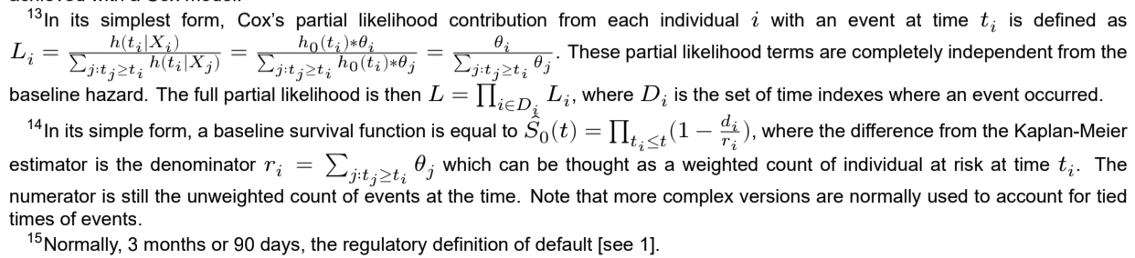
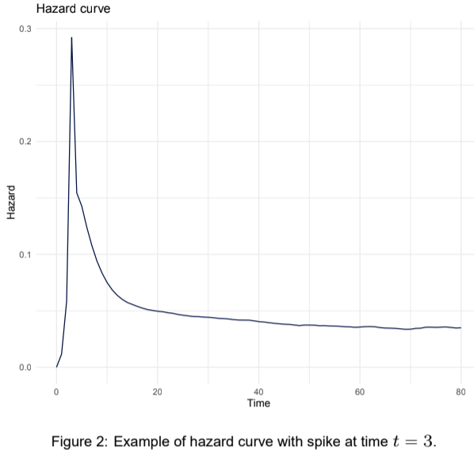

• Stratified models where the individuals i are grouped into segments s, each segment having its own separate baseline hazard. Effectively, the baseline hazard of the model becomes
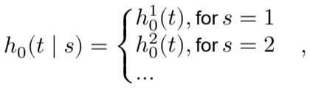
where s is a variable indicating the different segments. The segments should be chosen in order to have a homogeneous hazard function in each segment, and marked differences in hazard between segments. They should be chosen appropriately in order to avoid overfitting.
• Time-varying coefficients where the model coefficients are assumed to be a function of time with B = B(t). Deriving an exact, continuous functional relationship with time can overcomplicate the model. Therefore, an acceptable approximation is to estimate these coefficients as step-functions with regards to time. Time-varying coefficients can be used to ensure proportionality of hazards, in the (common) case of covariates having different impact over time. A simple example could be an application credit score, which would likely have a strong effect on the model for the first few months, but lower impact with passing time since it would become stale.
We have used both of these methods in our application of survival models to IFRS9. These will be described in section 5.
3.2.4 Goodness of Fit Measures
Since survival models are a type of generalised linear models, one can analyse the coefficients of a survival model using their estimated variances, or use some common information criteria¹⁶ to compare models and perform model selection.
For logistic regression models, one commonly used indicator of predictive performance is the AUC¹⁷, the area under the ROC curve¹⁸. An equivalent performance indicator for survival models is called the concor-
¹⁶In R, the Akaike information criterion, amongst other measures, is implemented for models from the survival package [14]. ¹⁷The Gini coefficient, also often used, is simply equal to 2 ∗ AUC− 1.
¹⁸The Receiver Operating Characteristic curve plots the relationship between True Positive Rate and False Positive Rate at all possible cut points of the model output. See [6] for additional details.

dance. This measures the ability of the model to correctly predict the order of time to event, but not if that predicted time to event is calibrated correctly¹⁹.
Given a pair of cases with times to event t₁ and t₂ respectively, and predicted linear outputs θ₁and θ₂, the pair is said to be concordant if t₁ < t₂ → θ₁ > θ₂, and discordant otherwise²⁰. The concordance measures the proportion of concordant pairs across all pairs of non-censored cases. Note that for a model with a fixed time to event for every individual, we can see that the concordance is effectively equivalent to the AUC. In fact, the concordance can be considered an extension of the AUC with no fixed performance window.
4 Issues Solved Using Survival
In this chapter, we will detail the main reasons why we have selected survival models for our new imple mentation of IFRS9.
4.1 Lifetime
4.1.1 Revolving Loans Have no Embedded ‘End of Life’
We implemented our previous modelling framework for IFRS9 using standard logistic regression. In that framework, a specific challenge we faced was the estimation of expected lifetime, for the recognition of stage 2 lifetime risk.
This is especially the case since our main product are revolving credit cards, which by definition do not have a contractual maturity. For a standard loan with a contractual maturity, this maturity serves as an upper limit to the expected lifetime of the loan, and all cases will in general either have defaulted or be paid in full before it.
In the case of a credit card or a credit line, an upper limit for the ELT simply does not exist. It is therefore important to estimate some reasonable average time period during which loans are exposing the bank to credit risk, since we cannot estimate a PD for infinite time²¹ t = ∞.
In order to estimate a lifetime for the portfolio (or for sub-portfolios), we must define an end of life event. Defaulted cases have a clear end of life in the default and termination. For the rest of the portfolio, one could define it, for example, by a full repayment event.
However, this is not always possible, for instance with revolving credit cards or credit lines. For those instru ments, full repayment of the balance is not guaranteed for all cases. Even if we consider only repayments against the current balance, and ignore any future drawdowns of the credit line, it is not guaranteed that every case will be repaid within a given time frame²².
Survival analysis offers us two potential methods to estimate an ELT for a portfolio. These are computation ally simple, so they can be applied to however many segments of a portfolio as necessary. In conjunction with survival models for PD, this allows us to re-estimate lifetime as often as necessary, without having to adjust the models. We will go more in detail in section 4.2.
¹⁹This is the same as the AUC, which measures the order of model output, and not for example the calibration of its predicted probabilities for a logistic regression.
²⁰The sign for t_{i} and θ_{i} are swapped, since a higher risk output from the model would result in a lower time to event, as shown in 3.2.1.
²¹In theory, this could be possible by fitting a parametric survival model for estimation of PD, either an AFT or a PH model. That way, the expected survival curve for each case could be extended to infinity. However, due to the basic properties of the survival function, lim_{t→∞} S(t) = 0, which implies PD = 1 for the entire portfolio, a result that does not seem appropriate.
²²In our particular case, for a segment of one of our portfolios, a significant portion of the cases would take at least 3 years to repay in full the initial balance, even ignoring future drawdowns of the credit line.
Using multiple end of life events, such as default and repayment (or repayment against current balance), one can fit and extrapolate a survival curve for the survival of the loan. If any only if this survival curve reaches zero within a finite time frame²³, or in other words
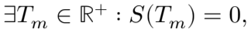
one can use this time T_{m} as an upper limit for an estimator of the expected lifetime. However, repayment against current balance might not be acceptable as an end of life event in the case of loans with the possibility of further drawdowns of a credit line in the future. Furthermore, without any accepted regulatory guidelines for the computation of ELT, one would be faced with the issue of computing an average lifetime using only the default event as an end of life.
In this situation, the above method is not applicable, since ideally, an entire portfolio of loans should not default entirely within a finite time frame. Even if we could estimate such an end time, it would be the point in time at which the survival curve associated to default reaches 0, i.e. the entire portfolio defaults. Using it as an ELT for PD models seems dangerous, since it would just result in PD = 1 for almost every case anyway.
4.1.2 Median Survival Time: a Solution with an Additional Challenge
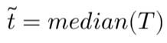
As a potential solution, survival analysis offers us a widely accepted methodology to calculate an expected lifetime. This is the median survival time, simply defined as the median²⁴ of the survival lifetime distribution²⁵ F(t):

Using median survival time would still not help us in the case of a survival curve based only on the default event. This is for the same reason why the previous methodology cannot not be applied: such a survival curve would not reach zero in a finite time, and the median survival time would give us unreasonable values for the ELT.
As an example, fitting a gamma distribution to the average survival curve of a segment of a portfolio, we calculated a median survival time of roughly 3,000 years.
As a workaround, we applied the following approach:
1) We cut the survival curve within a reasonable time frame T_{cut}, and then scaled the distribution so that F(T_{cut}) = 1 (and S(T_{cut}) = 0).
2) On this scaled and zoomed survival curve, we computed the median survival time t ̃_{, which returned a} more appropriate value for the ELT. Naturally, this value will be dependent on the choice of T_{cut}: 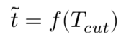
However, we have observed it to be rather stable, for reasonable values²⁶ of the parameter T_{cut}. An example of this process is shown in figure 3.
²³Note how this condition is guaranteed for loans with contractual maturity.
²⁴The median is used instead of the average, as the latter is often skewed in the case of outliers.
²⁵Alternatively, it is the time t ̃_{s.t. S( t} ̃_{) = 0.5} ̃ .
²⁶This is not the case for large values of T_{cut}, since for T_{cut} → ∞ we would end up with the full survival curve, which had a median survival time of 3,000 years.
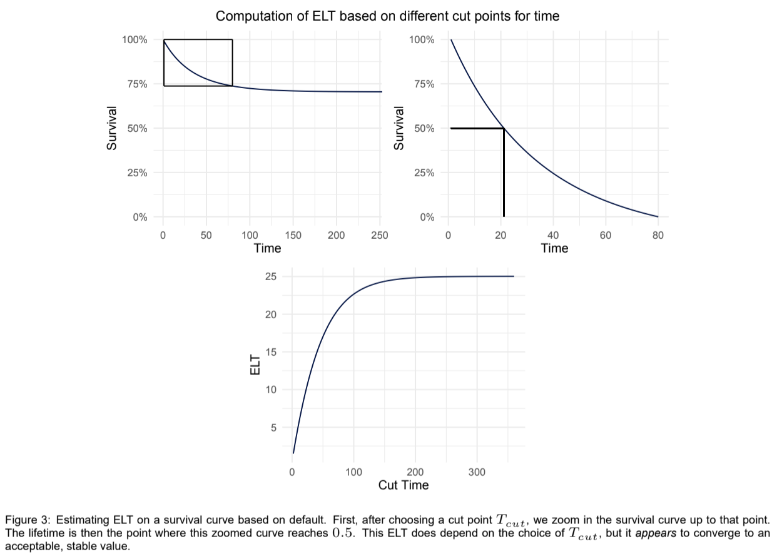
Ultimately, this methodology using median survival time provided us with a reasonable value for the ELT used in PD models, but is still open for improvements. Using it on our portfolio, we estimated an ELT slightly longer than the one calculated with our previous methodology, which was using default and repayments against current balance as end of life events.
4.2 SICR
Within the context of IFRS9, loans that show a significant increase in credit risk are to be classified as stage 2 loans and it is necessary to recognize their lifetime ECL. This SICR should be understood as an increase in credit risk compared to the risk at onboarding, or origination, of each loan. There is an additional re quirement²⁷ that institutions should attempt to identify these significant increases before a missed payment happens.
We can achieve this by comparing expected PD at origination with an updated PD, normally resulting from a model. This would then trigger a SICR event when the latter is significantly higher than the former²⁸.
For this comparison to make sense, both probabilities should be predicted over the same performance window. It would make little sense for example, to compare an expected PD at onboarding estimated over 12 months, with a current PD over 24 months.
²⁷[2], B5.5.2 of the IFRS 9 standard specifies that “Lifetime expected credit losses are generally expected to be recognised before a financial instrument becomes past due. Typically, credit risk increases significantly before a financial instrument becomes past due or other lagging borrower-specific factors (for example, a modification or restructuring) are observed”.
²⁸There is no standard regulatory definition for significantly higher that we know of. One possible approach would be to use the confidence interval of the predicted model PD.
Therefore, one would need to have an IFRS9 PD model that can return expected PD with the same perfor mance window of the risk calculated at origination²⁹.
At the same time, to compute the ECL for each loan, it is also necessary to estimate a PD over 12 months for cases in stage 1, or a lifetime PD for cases in stage 2.
To calculate individual level PD with traditional logistic regression models, one would need a large number of models with different performance windows. At the very least, this would include:
• A model for the comparison with probability of default at initial recognition in the context of SICR.
• At least one model for stage 1, for a 12-months PD estimation. Potentially more, in the case of models with ELT under 12 months.
• As many models as there are segments of loans with different ELT, for stage 2 estimation of lifetime PD.
Model management of these separate models is certainly challenging. Additionally, since these models all have a fixed performance window, one would have to re-estimate all the models in case of an update of the ELT parameter. This is because their performance window would be changing, and therefore the target definition of the models would change with it.
Alternatively, one could have a single model that predicts PD at some fixed performance window, together with some methodology to adjust the resulting probabilities to different performance windows as needed. For example, one could estimate a PD over 24 months as a specific power of the one at 12 months³⁰, PD₂₄ = PD^{f(t)}₁₂.
Essentially, this is what survival models do³¹. By using survival PD models, we are able to compute all probabilities at different times, for stage 1, stage 2 and comparison with that at origination, from just one single model result.
Formally, let ELT₁be the expected lifetime for cases in stage 1, ELT₂ the expected lifetime for cases in stage 2 and T_{O} the performance window used to compute PD at origination. Then table 2 holds.
Table 2: Different probabilities of default for IFRS9, taken from a survival model.
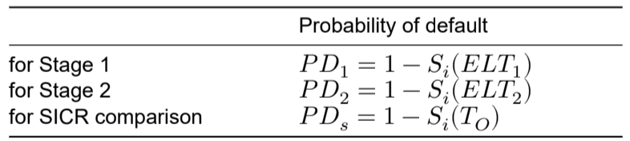
All of those probabilities are the output of the same survival function, which is the result of just one survival model computed with the covariates X_{i}.
With this model, even in case of a change in the ELT parameter, nothing would have to be changed in the model itself. One would have to adjust the model only if its baseline hazard was not representative of the average hazard of the portfolio any longer.
²⁹A common approach is to compute 12-months PD for the risk at onboarding.
³⁰An adjustment such as PD^{θ}₁₂, rather than PD₁₂ ∗ θ, will ensure that the result is still within [0, 1] irrespective of θ.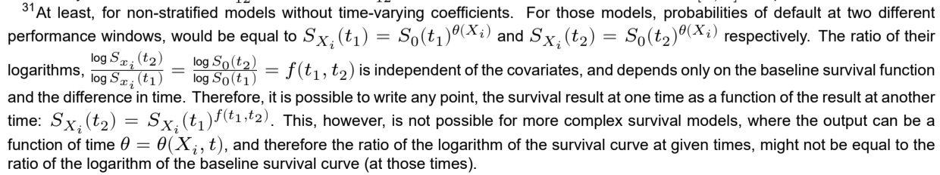
Depending on the model choice, it might even be possible to employ just one model for the computation of all probabilities involved in the computation of SICR. One could use such a single model to estimate both PD at origination and PD based on current covariates X_{i}, instead of having two separate ones. In this case, the comparison of probabilities of default for triggering a SICR would be much simpler.
This is possible because the IFRS9 standard requires ECL to be recognised right after origination, so that loans at origination have to be included in the model development sample as well. The expected PD at origination would then be:
where X_{i,O} are the covariates at the time of origination.
In this case, the comparison of probabilities of default in order to trigger a SICR can be expressed as follows:
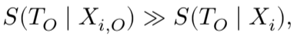
for some appropriate definition of ≫. Note that the order is inverted, since the survival function is the inverse of the probability of default³².
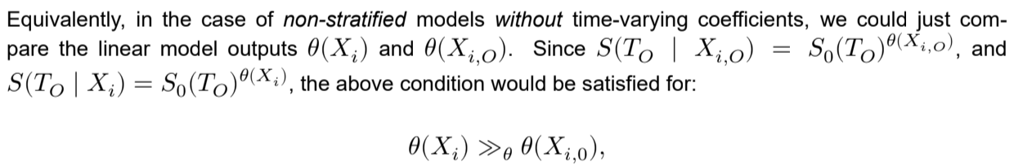
where ≫_{θ}has a slightly different definition than above, since the scaling would be different. Thus, the performance window for the comparison T_{O} would be meaningless in this case. An example of this can be seen in figure 4.
Note however that this might not be the case for stratified models where the baseline hazard is allowed to be different for different segments of the portfolio, if and only if a loan is allowed to move to a different strata after origination. For example, if a case is currently in strata B but was in strata A at origination, the current survival function would be equal to S(T_{O} ∣ X_{i}) = S_{0,B}(T_{O})^{θ(X}_{i}⁾and the one at origination S(T_{O} ∣ X_{i,0}) = S_{0,A}(T_{O})^{θ(X}_{i,0}⁾. Given that the baseline survival functions is different from the one at origination, the above comparison does not hold.
In conclusion, one could employ just one PD model in the context of IFRS9, to both compute the condition for a SICR and to calculate ECL independently of stage and ELT. This would work especially well for smaller portfolios where data is scarce. For more complex portfolios, it might be better to use a stratified model or a model employing time-varying coefficients. However, even in this case, it would still reduce the effort of model management significantly.
4.3 Loss Given Default
Another component of the calculation of IFRS9 ECL is the loss given default. LGD is the expected percent age loss on a defaulted loan, calculated as LGD = 1 − RR, where RR is the recovery rate. It is often estimated as an average at portfolio or portfolio segments level. However, one could attempt to model it using a logistic regression model, provided that there is sufficient data for it.
³²And thus it is the probability of survival instead.
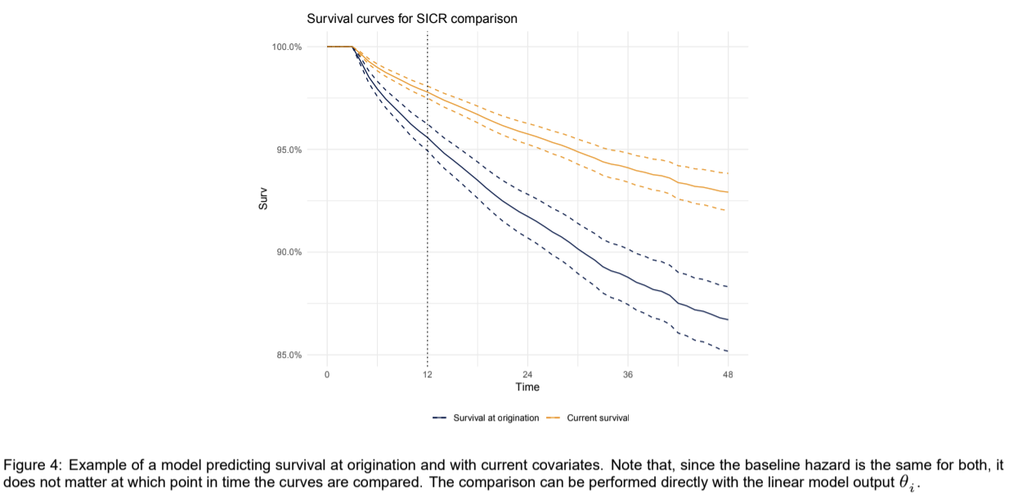
4.3.1 Challenges of LGD Modelling
There are some challenges in applying a logistic regression to model LGD. One such challenge is the defi nition of the model target. A logistic regression normally requires a binary target, but there is no guarantee that all cases in default will result in a final recovery of either 0% or 100%. In fact, in our experience that is very unlikely.
If the distribution of recovery rates at the end of the expected recovery performance window is mostly bimodal around two extreme values, we could simply consider any recovery rate above a threshold (such as 50%) to be a model target of 1. An example of this case is shown in figure 5.
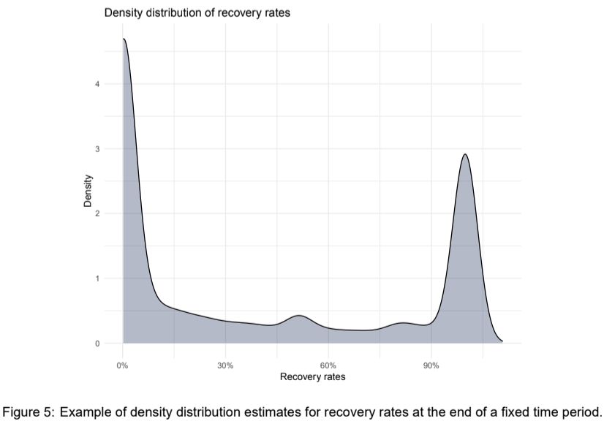
Even in this very favourable case, we would still assign the same model target to loans with significantly different recovery rates. For example, if we employ a threshold for the target of 50%, a case with 60% recovery would have the same target as a case with 90% recovery.

A more elegant solution that is often used, is a two-stages modelling approach. One could employ a classifi cation model for binary cases with recovery equal to 0 or 1, and a regression model for cases with recovery in (0, 1). See for example Yao, Crook, and Andreeva [18].
Other major challenges are related to the model performance window and to the length of the expected recovery period for defaulted cases. In the case of consumer credit this is a process that can span several years, if not more than a decade for legal credit collection cases³³.
In the ideal case, to model the value of LGD at the expected recovery period one would use said period as a performance window for the model. However, given that this period can be equal to several years, all recently defaulted cases without sufficient maturity would have to be excluded from the development sample of the model. With new products it is possible that no case has reached the desired performance window yet, and there would be no data at all to fit a model³⁴. Effectively, recovery data is often heavily censored, as discussed in section 2.2.
As a solution to this problem, an artificial limit of the performance window for the model estimation to a fraction of the full expected recovery period can be used. This is followed by a scaling of the model output in order to simulate the full recovery for the longer period. To perform this scaling, we would have to start from the extrapolation of the average recovery curve up to the desired time window, then compute an adjustment factor from it³⁵. However, one should take extra care with the extrapolation itself, with sufficient constraints in order to not overestimate or significantly underestimate long-term recovery rates.
By increasing the performance window and extrapolating from a longer recovery curve, we would likely have a better fit for the LGD model. However, this would come at the expense of available data to estimate the model and so could result in a model with a worse calibration.
4.3.2 LGD as a Survival Framework: When Claims Die Out
Most of the issues affecting LGD models are the same as those affecting PD models (see section 2) and can be solved by using survival methods in a similar manner.
After successfully applying survival models to the PD calculation for IFRS9, we were analysing the proper model methodology to apply to LGD, where intuitively survival models could also be used. This intuition was later confirmed when we stumbled upon the paper from Witzany, Rychnovský, and Charamza [16].
To model the defaulted loan recovery process with a survival process, one could consider the EAD as the initial living population. Each successive unitary recovery payment would then be considered a death event for the initial amount. Finally, at the end of the available time window for each case, one would recognize a censored event with weight equal to the remaining unpaid amount. For example, an initial EAD of 1,000€ would be considered as a population of 1,000 individuals, a successive payment of 100€ as 100 individual death events and at the end of the recovery period, a remaining, non-recovered, amount of 350€ would be considered as 350 individuals with censored time to event.
With this, we can use weighted survival methods to calculate hazard and survival functions for the recovery process of the defaulted loan portfolio. The implementation of weighted survival we used³⁶ considers the
³³This depends significantly on the applicable legislation. In the German market, the credit collection process can span more than 20 years in court. However, for example in the French market, credit collection cases in court will be dropped after 10 years. ³⁴In the case of Advanzia Bank, as the company was incorporated in 2006 with only the German market and given that the average expected recovery period as suggested by our credit collection partners is at least 20 years for said market, we would not have enough data to fit a model with a performance window of 20 years. 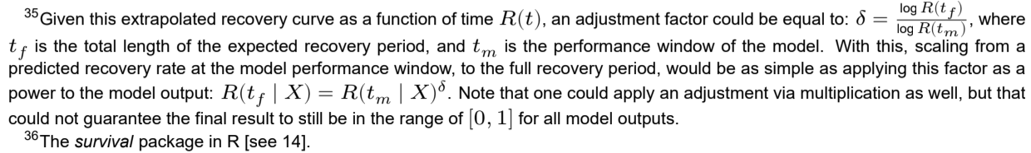
weights as count of events at each given time, which matches the desired behaviour previously described³⁷. Figure 6 shows a Kaplan-Meier estimator for such a survival recovery curve.
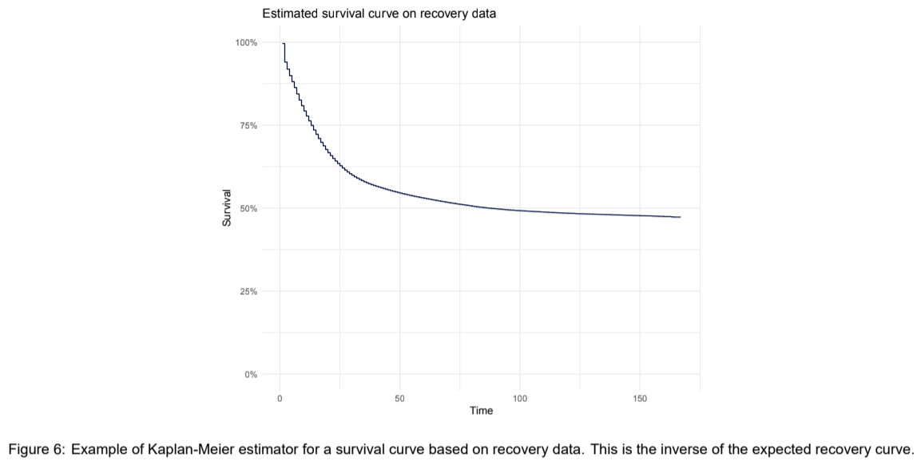
With this approach, the inverse of the survival function is equivalent to the well-known expected recovery curve and the hazard function would be an instantaneous relative rate of recovery for the remaining unpaid amount at each time. Finally, the survival function itself at a time t is equivalent to the LGD given an expected period of recovery equal to t.
Practically, if we have a survival model predicting the survival function for each individual case as S_{Xi}(t) with an expected duration of the recovery process equal to T_{R}, the loss for a case is simply equal to LGD = S_{Xi}(T_{R}).
Using survival models allows us to correct most of the issues described in section 4.3.1. Firstly, with survival models, the issue of target definition would simply disappear, since it is a well defined event itself.
More importantly, with the implicit handling of censored data in survival methods, there is no need to decide on a recovery performance window for the model. Thus, there is no need to discard any data point for the model development phase. This means that we can include all defaulted cases in the model, irrespective of maturity.
This also allows the model to react more quickly to changes to the recovery process, since we can now include the most recently defaulted cases as well. These recent cases contribute to the estimation of the survival function for at least the first data points, which are often the most important³⁸.
Depending on the scope of application, several types of survival models can be employed for the calculation of LGD under IFRS9. In the simplest of cases, one can compute a Kaplan-Meier estimator of the survival curve for some simple subgroups of the portfolio, resulting in an average LGD for each of those subgroups. Alternatively, one can employ semi-parametric models such as the Cox model, or even fully parametric
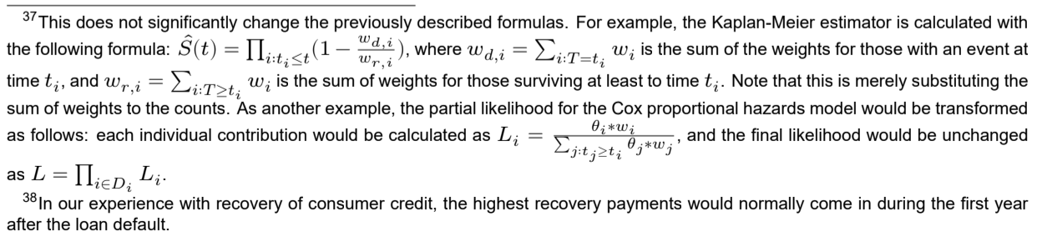
models such as proportional hazards or accelerated failure time models, in order to estimate LGD at an individual case level.
In case there is enough data to estimate a full survival curve up to the end of the expected recovery period, it is usually better to use a Cox model. Such a model can accommodate different shapes of recovery curves that might not be simple to fit via a known distribution.
If sufficient data is not available, such as in our case, parametric models could be used instead. This still leaves open the issue of fitting the correct distribution to the recovery process, in order to not overestimate or significantly underestimate recovery rates. In our specific case, the generalised Gamma distribution pro duces a good fit, however many distributions are available and one can also employ a custom distribution³⁹. An example of such a fit is shown in figure 7.
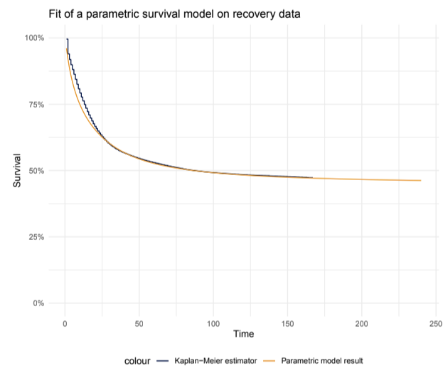
Figure 7: Example of fit of a parametric survival model to recovery data. While the fit is not good for t ≤ 30, it matches almost perfectly afterwards and allows for a reasonable extrapolation.
4.4 Forward Looking Macroeconomic Adjustment
The IFRS9 standard requires a forward-looking computation of ECL that includes scenarios based on ex ternal factors⁴⁰, such as influential macroeconomic leading indicators.
A simple approach that works with any type of model is to simply include a selection of macroeconomic indicators in the covariates of a model in order to incorporate these external factors. These factors have to be properly aligned so that they reflect their value at the model estimation date⁴¹ for each case.
This is conceptually the most correct method of integrating external factors, on the other hand it can cause issues of deployment if these macroeconomic indicators are not easily available (and regularly updated) in one’s data environment. Additionally, having external covariates included directly in the model does not allow for any expert judgement adjustment or Margin of Conservativism (MOC).
³⁹If not enough data is available, one could perhaps use an equivalent market-average recovery curve to define a custom distribution. The recovery curve is the inverse of the survival curve, or R(t) = 1 − S(t), but that is also the inverse of the cumulative distribution function of the time to event F(t) = 1 − S(t) = R(t). Therefore, one can simply take a market average recovery curve as an incomplete cumulative distribution function. While incomplete, this is still properly defined up to the desired recovery period, and therefore can be used to fit parametric survival models if the time to event in the data does not extend beyond the maximum time of this market average curve.
⁴⁰[2], 5.5.4: ECL is required to be assessed “considering all reasonable and supportable information, including that which is forward looking”.
⁴¹Or, the date when the covariates were calculated for each specific case. To obtain a more heterogeneous model development sample, it is often the case that this date is sampled randomly within some time period.

Due to availability of macroeconomic indicators and the need for MOC, we chose to compute a fixed adjust ment to the model outputs periodically instead⁴².
In the case of survival models, survival curves are an evolution of risk over time, but are not time series. This makes it challenging to estimate their sensitivity to macro-economic time series data. Our approach described in this section is to analyse the fluctuations of the hazard curve over calendar time vintages in order to turn that into a time series. This can be then used as the target of a time series model that includes external regressors.
While there are several approaches to estimating a macroeconomic adjustment to a model results, here we will explore one that we analysed, and ultimately implemented, within the framework of survival analysis. This method is analysed in the context of a Cox proportional hazards model, but can similarly work for a parametric PH model, since these are the types of models we employed in our framework. Adjustments might be necessary when using AFT models.
Given a proportional hazards model, one would generally estimate the baseline hazard of the model on the development sample or on subgroups of the sample for stratified models. We can also estimate, for comparison purposes, a baseline hazard for subgroups of the development sample, split by some vintage grouping⁴³ of the model estimation date.
If the proportional hazard assumptions hold, one should be able to approximate each vintage group’s hazard by multiplying the model’s baseline hazard with an adjustment factor⁴⁴.
Provided that the development sample has a sufficiently diverse range of model estimation dates, this will result in a series of adjustment factors that one can use to approximate each vintage hazard starting from the baseline hazard.
Given that each of these factors is associated to calendar vintages, it is essentially a time series of adjust ment factors. An example of such a time series is shown in figure 8. 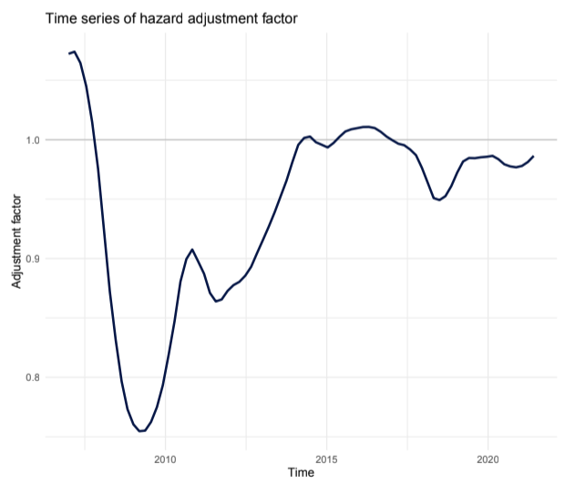
Figure 8: Example time series adjustment factor for the baseline hazard. Note how it is centered around 1, since it is to be taken as a multiplier for the baseline hazard, and lower values mean lower recoveries and therefore higher LGD. This appears to have a strong correlation with external factors such as unemployment rate.
Given a time series of adjustment factors, it seems natural to then apply a time series model with external regressors to estimate its future value v_{t} using external macroeconomic indicators. In particular, for our
⁴²Such as yearly or quarterly.
⁴³The sample could be split, for example, in yearly or quarterly vintages. Normally, they should be the same as the desired estimation period of the adjustment factor.
⁴⁴For a parametric model, one could instead estimate ratios between the parameters of the statistical distribution of hazard, estimated for each calendar vintage and for the entire development sample.

application, we used ARIMAX models⁴⁵.
Once forecasted, we can then apply the predicted adjustment factor v_{t} on the IFRS9 model results for a pre determined number of months⁴⁶ after which it would be re-estimated with new external factors. This method offers a conceptually similar effect to including external indicators as covariates directly in the model, and also allows us to apply expert based adjustments or MOC. Additionally, it allows us to change the time series model, for example by adding more external covariates, without adjusting the underlying survival model.
Since v_{t}is an adjustment to the baseline hazard, applying it to a survival model output is extremely simple:
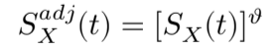
Altogether, this is a very simple method to perform a forward-looking adjustment based on macroeconomic indicators without including them in the underlying model directly.
5 Challenges Encountered in Implementation
5.1 When Hazards are Not Proportional
So far we have focused on the benefits of survival models in the context of the computation of ECL. Next, we are going to present some of the challenges that arose during the implementation of these models. Most of these issues are related to the assumptions of proportionality of hazards.
There are two main examples of broken proportionality of hazards that we have encountered when imple menting survival PD models. We have observed that, independent of the maturity of the loan, the hazard curve for our portfolio always shows a spike at roughly t = 3 or three months⁴⁷. It then quickly drops back down to a lower long-term level.
In other words, independent of the maturity, those loans that will default tend to do so as quickly as possible. However, the size of this spike in hazard, compared to the tail of the curve, does depend on maturity, as shown in figure 9.
In this plot, the hazard curves are already scaled down to match the tails of the curves, however, the spikes clearly do not match. If they were scaled to match the size of the spikes, then the rest of the hazard curves would now not match.
This means that it is not possible to get these hazard curves by simply multiplying a baseline hazard. Thus, the assumptions for a proportional hazards model are not satisfied⁴⁸.
Another example of broken PH assumptions surfaced with the estimation of PD for cases that are already past due. Here the shape of the baseline hazard curve is still somewhat comparable to the previous one,
⁴⁵Such as an ARIMAX model, or AutoRegressive Integrated Moving Average model with eXogenous variables. An AutoRegressive (AR) model is a type of time series model that estimates the relationship of a variable with its past values. A Moving Average (MR) model, instead, estimates the relationship of a variable with current and/or past white noise stochastic terms. The ARIMAX model combines both and also includes external covariates. It can be expressed as follows:
where B are the coefficients of the external covariates X_{t}, Φ_{i}, for i = 1, ..., p, are the coefficients of the past values of the dependent variable v_{t}and θ_{j}, for j = 1, ..., q, are the coefficients of the past values of the white noise time series z_{t}. The values p and q are called, respectively, the orders of the autoregressive and moving average components of the model. See Shumway and Stoffer [12] for additional details.
⁴⁶Based on the size of the calendar vintage groups used in the estimations and on the forecast interval of the prediction of the time series model.
⁴⁷Which the time it takes to reach 90 days past due, from a non-delinquent status.
⁴⁸Note that the same is true for accelerated failure time models; it is not possible to move from one hazard curve to the other by simply scaling the time axis.
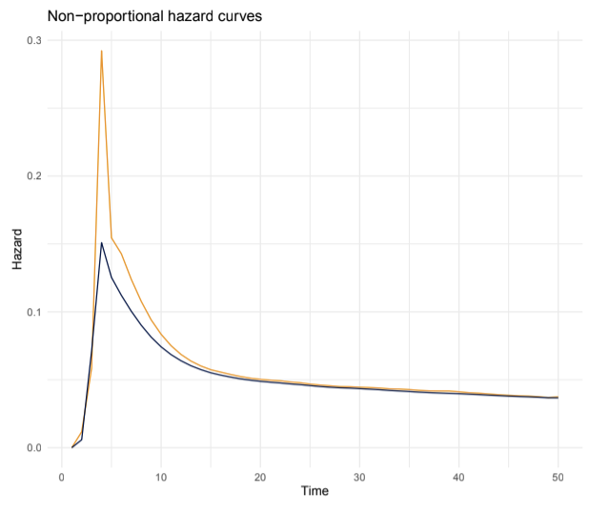
Figure 9: Example of hazard curves, rescaled to match the tails, which do not satisfy the proportional hazards assumption.
with a spike at the earliest possible time to default. However, since they are already past due, this spike happens earlier than for non-delinquent loans and precisely one month earlier for each month past due⁴⁹.
The size of the spike itself is also increasing with the number of months past due. That in itself is not an issue for PH models. However, the whole hazard curve is essentially shifted by one month. This clearly means it is not possible to obtain one from another via multiplication. Thus, again, the assumptions for PH models are breached⁵⁰. This is shown in figure 10.
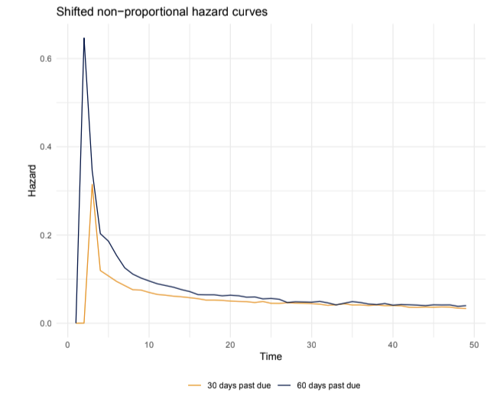
Figure 10: Example of hazard curves from past due cases. In this case, both the size and the position of the spike do not match.
⁴⁹Normally, a loan that is 30 days past due can reach default (90 days past due) in 60 days and not 90. ⁵⁰Here, it might make more sense to use accelerated failure time models. However, it should be noted that the curve is shifted on the time axis, and not scaled. There is a class of survival models called time shift models, which could be a good fit for this situation [see 15]. There, the model affects time additively: S_{i}(t) = S₀(t + θ_{i}). However we did not test them, since we were unable to find any implementation in R at the time we implemented survival models for IFRS9.

5.2 Stratified Models and Time-Varying Coefficients
As mentioned in previous sections, there are two methodologies that can be applied to survival models in order to satisfy the model assumptions regarding proportionality of hazards.
The first is using stratified survival models. These are obtained by dividing the portfolio into subgroups, or strata, in an attempt to obtain more homogeneous hazard within each subgroup. From the second case previously described, one could divide the portfolio in strata based on the number of months past due, for example.
After the sample has been divided, it is possible to estimate the model by allowing different baseline hazards for each strata⁵¹. At the same time, it is also possible to include the strata as an interaction term in the model, encoded in the form of binary variables⁵².
Stratified models are the simplest way in which one could enforce proportionality of hazards in the second example from section 5.1. It is, in fact, a method that we have employed in our implementation of survival models for IFRS9.
However, they might not work as well for the first example, since the size of the spike in hazards appears to be continuous with regards to maturity. Effectively, this means that the covariate maturity has an effect on the hazard curve that depends on time. This is the concept of time-varying coefficients in a survival model, where one estimates the coefficients for some of the covariates as functions of time.
In practice, to determine if a coefficient is a function of time, one can use a type of model residuals called the Schoenfeld residuals [for details see 13, ch. 4.6]. These are estimated separately for each coefficient of the model, and their average over time shows an evolution of the coefficients with regards to time. They can also be used to perform a statistical test⁵³ of the assumption of proportionality of hazards. Figure 11 shows an example of those residuals for one model coefficient. Note how there is a clear variation over time.
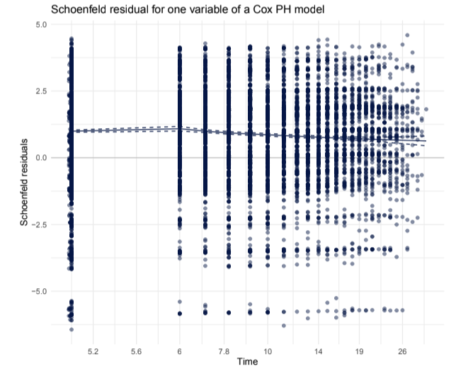
Figure 11: Example of Schoenfeld residuals over log(��), for one variable. The spline approximation can be used to estimate the evolution of this coefficient over time.
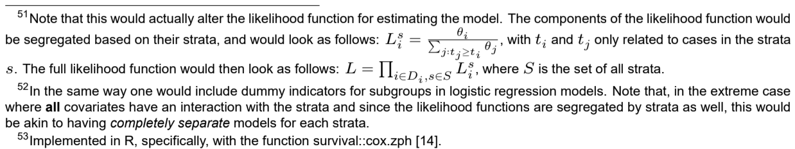

Ideally, one should specify directly in the model the functional form of this coefficient with regards to time. However, this is often impractical, especially when faced with multiple time-varying coefficients. A solution can be to approximate this continuous time-varying coefficients with step functions⁵⁴ with regards to time [see vignette of 14]. An example of such a step function is also shown in figure 12.
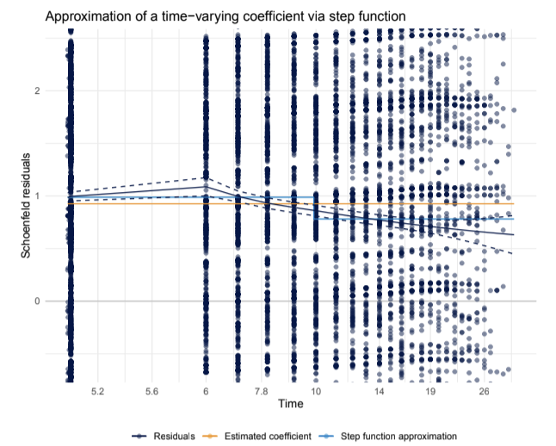
Figure 12: Example of approximation of a coefficient via step function. The estimated, constant coefficient of the model appears to be too low at the beginning, and too high at the end of the time period. A simple estimation with one single step around t = 10, appears to be a much better fit, being almost everywhere within the confidence interval of the spline approximation.
Those two methods to enforce proportionality of hazards are not mutually exclusive. In order to ensure a good fit, we have employed both of these methods for our IFRS9 PD and LGD models.
6 Results
In conclusion, we successfully implemented survival models in the context of IFRS9, for both PD and LGD models. We also included adjustments derived from external macro-economic indicators, using time-series ARIMAX models.
Both types of models we used were stratified models, and the data was split in strata based on the loan status, for example by their past due status for PD models. They also included time-varying coefficients, since we observed that covariates such as maturity and application credit scores vary with time.
Employing these models, we were effectively able to reduce the number of PD models to at best one stratified model per product, as opposed to a minimum of three models⁵⁵ per product that we would have had with logistic regression. In fact, in our previous IFRS9 framework, we had up to six models per product.
Naturally, having fewer models significantly simplified model management, back-testing, deploying and up dating. In addition, if we were to re-calibrate one of the new models, we can simply re-compute the baseline hazard on an updated sample without having to re-fit the model⁵⁶.
⁵⁴In practice, one would have to adjust the development sample of the model based on the extremes of the time intervals used in the step function approximation. For example, by having coefficients vary whether or not t ≤ 6, for all cases where the time to event T > 6, one would add an additional row to the sample with a synthetic censored target and time equal to 6. For any cases where the time to event (or censoring) is less or equal than 6, nothing would be changed. Then, one would add a grouping variable in the dataset, by identifying lines with time to event t_{i} ≤ 6 in one group, and the rest in another (all the newly added synthetic rows would be in the former). This grouping variable would then be added in the model as an interaction term with the desired coefficients to be approximated with this step function.
⁵⁵One for stage 1 PD up to 12 months, one for stage 2 lifetime PD, and one for a fixed time window, for the comparison with PD at origination for the purpose of determining Significant Increases in Credit Risk (SICR)
⁵⁶Provided that the model performance itself, measured by the concordance for example, has not declined significantly.
Lastly, survival analysis also provided us with a new acceptable methodology to compute an expected lifetime for our main product, for the computation of stage 2 PD.
As for (LGD) models, using survival analysis we were able to produce a model at individual loan level, even with our heavily censored dataset of recovery data. In particular, since defaulted loans in stage 3 have access to a completely different set of covariates, we implemented two survival models, one to be applied before a loan defaults (so stage 1 and 2), and one after.
In the previous IFRS9 framework, LGD was computed as an average for subgroups of the portfolio. By implementing individual level LGD models, we were able to provide a more precise estimation for ECL, in particular for stage 3 loans. We should note that this had the effect of slightly increasing the volatility of ECL for stage 3, since the model for LGD takes on covariates based on actual repayment behaviour whose values can change on a daily basis.
At the same time, having a more accurate ECL for defaulted loans ensures there are no hidden, unrecog nised losses in the portfolio, for example due to a cohort of defaulted loans that is much worse than the others. It also allows us to have a better estimation of the price for those defaulted loans, for example in the event of a sale of Non-Performing Loans (NPL).

7 Potential Improvements and Machine Learning
For our implementation of survival models in IFRS9, we have chosen to keep hazard modelling as simple as possible, using PH models, and for PD in particular we chose Cox models. Those models are a type of generalised linear models which are more widely known and accepted by auditors and regulators, compared to more modern and state of the art machine-learning models.
However, there is little doubt that we could have achieved additional performance and a better fit by using more complex machine-learning based approaches⁵⁷. To obtain a benchmark for the upper limit of model performance, we tested two different machine learning survival models. These are survival neural networks and survival random forests [see 7, 8]⁵⁸.
Both the semi-parametric Cox models, but also proportional hazards or accelerated failure time parametric models, are a type of generalised linear models fit using maximum likelihood. The baseline hazard is either estimated independent from the model itself, or is extracted from a fitted parametric distribution.
Intuitively, there is no need for the underlying model to be a linear model. Any non-linear model that can be fit via maximum likelihood and that outputs a risk value for each individual⁵⁹ can be used instead. For example, the likelihood function could be used in a gradient-descent algorithm (or one of its many evolutions), to fit a neural network in place of the linear model.
For a model based on the Cox partial likelihood, the baseline hazard would then be estimated after the fit, using the same formula as the standard Cox model. This type of model can have the same issues with regards to the PH assumptions presented in section 5.1, since the baseline hazard is still constant for all individuals in the development sample.
It is also possible to use a neural network for a parametric survival model instead. In this case, the pa rameters of the statistical distribution could also be part of the network output. Therefore, the shape of the baseline hazard would change with the covariates and instead of having the same baseline hazard for all individuals, one would have a family of baseline hazards. For such a model the workarounds discussed in section 5.2 might not be needed. This approach has not been tested yet in our framework and should be considered a potential future improvement.
⁵⁷For an introduction to these machine-learning approaches, see for example [3].
⁵⁸The survival random forest is implemented in R by using the packages ranger [17] and survival [14] together. For survival neural networks, no R implementation was found at the time this analysis was performed.
⁵⁹For parametric survival models, it should also return the parameters of the statistical distribution used.
Table 3: Increase in performance compared to a Cox model.

Survival models based on random forests, on the other hand, take a completely different approach. A decision tree is well known from statistics and can be thought of as a flowchart where the exact path is dependent on the sample considered, resulting in a single output value. This output value and, indeed, the tree itself is highly dependant on the training sample and chosen splitting variables. In other words, it is very likely to overfit. To overcome this limitation, we consider a majority vote of several trees, all of which are trained on a slightly different subset of the training data. This is known as a random forest⁶⁰, see Hastie, Tibshirani, and Friedman [6] for additional details.
In the same way, one could build a survival tree, where each terminal node returns not a value, but a full survival curve. Similarly to a decision tree, a single survival tree built this way would severely over fit, especially since the number of data points associated with each terminal node in the development sample is likely very small. Such a survival curve would be an irregular step function of time, and not a more continuous-like curve. However, averaging the resulting survival curves of a survival forest, does provide for proper estimation of calibrated survival curves, just as in the case of a standard random forest.
Using these type of models, we observed a significant increase mostly in the concordance, the survival equivalent of the AUC and a measure of model performance. In our analysis, using a survival forest had a higher uplift in concordance compared to the neural network approach. Table 3 shows the increase achieved with those models, compared to a standard Cox PH model.
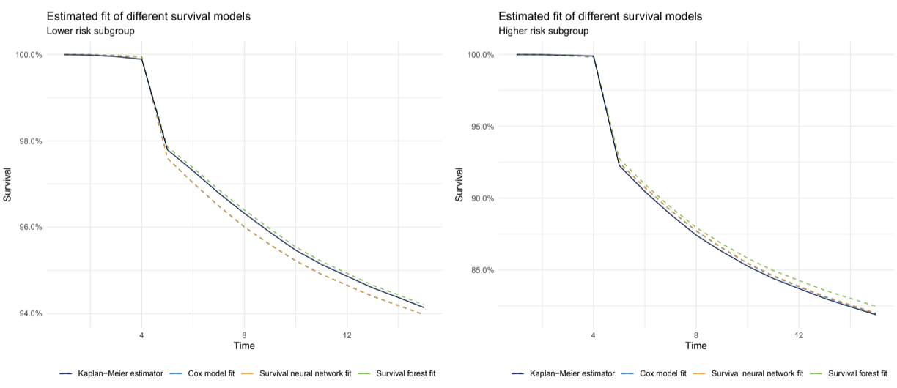
In conclusion, machine-learning based approaches to survival modelling show a significant increase in pre dictive performance compared to linear models. They can also remove the necessity for stratified models or time-varying coefficients, and should be considered as potential improvements over the standard linear model based survival models. However, special attention needs to be paid to the calibration of these mod els, as these classes of models have a tendency to overfit on the development data. This is especially true for survival models based on random forests⁶¹, and an example is shown in figure 13.

Figure 13: Example of predicted survival curves for three models, compared to the Kaplan-Meier estimator. These survival curves are predicted on two subgroups of the portfolio with different risk levels. The Cox model and neural network result in almost the same survival curve, which is a good fit for the higher risk subgroup but overestimates risk for the other one. The survival forest is the opposite, underestimating risk for the high risk subgroup instead.
⁶⁰To be precise, a decision tree has low bias and high variance. By combining large numbers in a random forest, the variance of the final model is lowered.
⁶¹Note that this appears to be an issue with survival forests specifically and not with traditional ones.
References
[1] European Banking Authority. Guidelines on the new Definition of Default. URL: https : / / www . eba . europa.eu/regulation-and-policy/credit-risk/guidelines-on-the-application-of-the-definition-of-default.
[2] International Accounting Standards Board. International Financial Reporting Standard (IFRS) 9. URL: https : / / www . ifrs . org / content / ifrs / home / issued - standards / list - of - standards / ifrs - 9 - financial - instruments.html/content/dam/ifrs/publications/html-standards/english/2021/issued/ifrs9.html.
[3] Scott V. Burger. Introduction to Machine Learning with R. O’Reilly Media, Inc., 2018. ISBN: 9781491976449.
[4] David R. Cox. “Regression Models and Life-Tables”. In: Journal of the Royal Statistical Society. Series B (Methodological) 34.2 (1972), pp. 187–220. ISSN: 00359246. URL: http:// www. jstor. org/ stable/ 2985181.
[5] Viani B. Djeundje and Jonathan Crook. “Dynamic survival models with varying coefficients for credit risks.” In: European Journal of Operational Research 275.1 (2019), pp. 319–333. ISSN: 0377-2217. DOI: https://doi.org/10.1016/j.ejor.2018.11.029. URL: https://www.sciencedirect.com/ science/article/pii/S0377221718309548.
[6] Trevor Hastie, Robert Tibshirani, and Jerome Friedman. The elements of statistical learning. Data mining, inference, and prediction. English. New York, NY: Springer, 2009, pp. xxii + 745. ISBN: 978-0- 387-84857-0; 978-0-387-84858-7. DOI: 10.1007/978-0-387-84858-7.
[7] Hemant Ishwaran et al. “Random survival forests”. In: The Annals of Applied Statistics 2.3 (Sept. 2008). ISSN: 1932-6157. DOI: 10.1214/08-aoas169. URL: http://dx.doi.org/10.1214/08-AOAS169.
[8] Håvard Kvamme, Ørnulf Borgan, and Ida Scheel. Time-to-Event Prediction with Neural Networks and Cox Regression. 2019. arXiv: 1907.00825 [stat.ML].
[9] Dirk Moore. Applied Survival Analysis Using R. 1st ed. Springer International Publishing, 2016. ISBN: 9783319312439.
[10] Peter McCullagh and John A. Nelder. Generalized Linear Models, Second Edition. Chapman and Hall/CRC Monographs on Statistics and Applied Probability Series. Chapman & Hall, 1989. ISBN: 9780412317606.
[11] R Core Team. R: A Language and Environment for Statistical Computing. R Foundation for Statistical Computing. Vienna, Austria, 2020. URL: https://www.R-project.org/.
[12] Robert H. Shumway and David S. Stoffer. Time Series Analysis and Its Applications (Springer Texts in Statistics). Berlin, Heidelberg: Springer-Verlag, 2005. ISBN: 0387989501.
[13] Terry M. Therneau and Patricia M. Grambsch. Modeling Survival Data: Extending the Cox Model. New York: Springer, 2000. ISBN: 0-387-98784-3.
[14] Terry M. Therneau. A Package for Survival Analysis in R. R package version 3.2-11. 2021. URL: https: //CRAN.R-project.org/package=survival.
[15] Andrew C. Titman. “Estimation of time-shift models with application to survival calibration in health technology assessment”. In: Statistics in Medicine 35.20 (2016), pp. 3645–3656. DOI: https : / / doi . org/ 10. 1002/ sim. 6951. eprint: https:// onlinelibrary. wiley. com/ doi/ pdf/ 10. 1002/ sim. 6951. URL: https://onlinelibrary.wiley.com/doi/abs/10.1002/sim.6951.
^{[16] Jiřı}́Witzany, Michael Rychnovský, and Pavel Charamza. Survival analysis in LGD modeling. eng. IES Working Paper 2/2010. Prague, 2010. URL: http://hdl.handle.net/10419/83464.
[17] Marvin N. Wright and Andreas Ziegler. “ranger: A Fast Implementation of Random Forests for High Dimensional Data in C++ and R”. In: Journal of Statistical Software 77.1 (2017), pp. 1–17. DOI: 10. 18637/jss.v077.i01.
[18] Xiao Yao, Jonathan Crook, and Galina Andreeva. “Enhancing Two-Stage Modelling Methodology for Loss Given Default with Support Vector Machines”. In: European Journal of Operational Research 263 (May 2017). DOI: 10.1016/j.ejor.2017.05.017.

