Assessing Disparate Impact for Machine Learning Credit Scoring Models: The Available Data Do Not Meet Analytical Requirements
Terry Woodford and Michael McBurnett
Equifax
Abstract
Generally, in lending, disparate impact is defined as a situation in which a lender applies a policy or practice equally to all applicants but it results in a disproportionate adverse impact on applicants from a protected class. Disparate impact has been evaluated in the context of logistic regression, but not in the context of AI and machine learning credit scoring models. This paper summarizes prior research and evaluates available data required to assess disparate impact in machine learning credit risk models.
The demographic ethnicity data used in the original analyses are commercially unavailable. Since the original analyses were reported in 2007 and 2010, proxy measures for certain protected classes have been publicized. In particular, in the United States, the Consumer Financial Protection Bureau (CFPB) in 2014 published a proxy for ethnicity, Bayesian Improved Surname Geocoding (BISG). This measure has been used by the CFPB in examinations of certain auto lending outcomes.
In this paper we examine the BISG proxy measure for ethnicity and compare it to commercially available inferred demographic data using a ~300 million record sample. Assuming that the inferred demographic data represent ground truth we show that the proxy measure falls short of allowing reliable inference. We conclude that the available data do not meet analytical requirements.
Introduction
Every day consumers of various ethnicities, races and backgrounds interact with lending institutions to receive a financial decision regarding whether that consumer will be able to obtain a loan for a vehicle, education, or a dream home. These are oftentimes life altering decisions that largely impact the consumer’s future. As standard across the industry, lenders make these decisions based in part on a consumer’s credit score. Consumers should expect that these institutions remain neutral regarding protected classes and abide by Fair Lending Laws and Regulations including but not limited to the Fair Credit Reporting Act (FCRA) and the Equal Credit Opportunity Act (ECOA).¹
Neutrality in lending implies, at least, that discrimination does not occur, and that lenders do not engage in disparate treatment, in which certain protected classes are disproportionately favored in lending decisions. In addition, lenders attempt to guard against disparate impact. Disparate impact is defined as “a creditor practice that is discriminatory in effect because it has a disproportionately negative impact on a prohibited basis, even though the creditor has no intent to discriminate and the practice appears neutral on its face, unless the creditor practice meets a ¹ FCRA: 15 U.S.C §1681 et seq., ECOA: 15 U.S.C §1691 et seq.,
legitimate business need that cannot reasonably be achieved as well by means that are less disparate in their impact.”²
In other words, disparate impact is said to occur when lending decisions appear to be neutral, but have a deleterious impact on a protected class, and there is no business justification for doing so. There is no better analytical measure of credit quality than credit scores, so the business need is met. However, it is possible that disparate impact on a protected class could be identified in credit scores, but empirical analysis will have to demonstrate it.
The only systematic analysis of disparate impact applied to credit scores of which we are aware is the 2007 Report to the Congress on Credit Scoring and Its Effect on the Availability and Affordability of Credit.³In that report, the authors report no finding of disparate impact for race, ethnicity or gender. In the machine learning age, the question has yet to be answered: do the credit scores used by institutions have a disparate impact? In order to answer the question, empirical analysis is required. The analysis requires individual-level credit data, at least one credit score, and demographic data sufficient to identify the characteristics of interest. These characteristics could include any protected class data, including race, ethnicity, gender, or age. For a lender or anyone else to be able to conduct the analysis, first it would have to find reliable protected class data. The 2007 Report to Congress made use of data unavailable to the industry, as discussed below. Hence we have to find surrogates. Is any surrogate data sufficiently reliable? This paper examines and compares available demographic ethnicity data and a proposed measure predicting ethnicity. We find that the two measures are incommensurate with one another.
Prior Research on Disparate Impact
We are aware of only one systematic analysis that actively researched disparate impact in consumer credit scoring. That study was conducted prior to 2007 by econometricians from the Federal Reserve Board and synopsized in 2010. In that research, the authors used demographic data unavailable to industry, rejected the use of commercially available demographic data, and failed to identify disparate impact with respect to ethnicity, race, or gender.
In the 2007 Report to Congress, further analysis was carried out to determine if credit characteristics served as proxies, that is, instruments, for protected classes such as ethnicity, sex, and age. A statistical model was developed to predict the likelihood of a consumer becoming seriously delinquent over an 18 month performance window. Several analyses were conducted including observing credit score differences across ethnic groups and examining correlations between credit characteristics and performance as well as correlation with the
² 12 C.F.R. pt. 1002, Supp. I, § 1002.6, 6(a)-2
³ Board of Governors of the Federal Reserve, 2007, Report to Congress on Cr4edit Scoring and Its Effects on the Availability and Affordability of Credit.
demographic characteristic across ethnic groups. It was concluded that credit characteristics do not serve as a proxy for race or ethnicity. The differences observed in credit scores across ethnic groups were not assessed to support a disparate impact finding.⁴
In 2014, the Bureau of Consumer Financial Protection (CFPB) published a new measure - Bayesian Improved Surname Geocoding (BISG) - for use as a proxy measure to identify ethnicity. In the 2014 CFPB paper, the BISG proxy is discussed and assessed on a sample of mortgage applicants where the applicant’s ethnicity is reported. The CFPB reported high correlations between the BISG proxy and self-reported ethnicity. The CFPB afterwards used that measure to evaluate “dealer markups” for certain auto lenders, ultimately leading to substantial fines for some lenders.
The use of BISG was immediately criticized by auto lenders. In their 2014 report, “Fair Lending: Implications for the Indirect Auto Finance Market”, (Baines & Courchane 2014) the authors attempted to (but could not) replicate the BISG measure using the CFPB published code, and used commercially available demographic data for comparison. This research was critical of the CFPB measure, showing substantial differences in ethnicity assignment using BISG compared to available demographic data. Their conclusions concerning the BISG method, while focused on auto lending, differed dramatically from that reported by the CFPB.
In this paper we carry out a similar assessment using a much larger baseline sample: we start with approximately one-half the entire United States credit population using BISG and commercially available demographic data. Our objective is to determine if the available demographic data or the BISG measure can serve as a reliable baseline “ground truth” with sufficient coverage with respect to consumers.
Data Used In Previous Studies
The 2007 Report to Congress had four data sources. The authors sourced demographic information from both the self-reported Social Security Administration application data and a leading national demographic information company. Ethnic identity in the application data is self-reported by the applicant. In addition, demographic and economic data were obtained from the U.S. Census Bureau. Finally, the Federal Reserve Board sourced credit data from a national credit reporting agency.⁵In 2014 the CFPB used published, anonymous Census Bureau data on surnames and geographic locales to calculate the BISG probability.⁶ Similarly in 2014, Baines & Courchane reference Census Bureau data for their replication of BISG probabilities.⁷
⁴ Report to Congress, 2007, pp O-20-O-21.
⁵ Report to Congress, 2007, p57..
⁶ Consumer Financial Protection Bureau, 2014, Using Publicly Available Information to Proxy for Unidentified Race and Ethnicity: A Methodology and Assessment. Available at
https://files.consumerfinance.gov/f/201409_cfpb_report_proxy-methodology.pdf
⁷ Arthur P. Baines and Marsha J. Courchane, 2014), Fair Lending: Implications for the Indirect Auto Finance Market, Charles River Associates, Washington, DC.
In addition, the commercially available demographic data used for the 2007 Report infers ethnicity. Commercially available demographic data we obtain today, and available to other creditors, still infers ethnic identity. This is the crux of the problem. If we use inferred ethnic identification from commercial data, or BISG, which also infers ethnicity, how well do these different means of assigning an ethnic identity to consumers agree with one another? Can commercially available ethnicity or BISG computed ethnicity reliably be used to evaluate disparate impact?
Analysis
To conduct a sound statistical investigation evaluating the existence of disparate impact in credit scores, it is imperative that reliable baseline data is available to determine if a consumer belongs to a particular protected class. Misclassification, or false positives and false negative attribution of demographic information, especially protected class identities, can only hamper analysis. In this analysis, we focus on ethnicity only because ethnicity data are most readily available from published census bureau data, the BISG measure only estimates the probability of ethnic identity, and commercially available demographic data contain an individual-level measure of ethnic association. The US Census Bureau solicits ethnicity responses while conducting the decennial census. There are six ethnic groups people can claim membership in, as well as certain multi-ethnic identities respondents can claim. We focus on the six groups, as those are used by the CFPB in the introduction of BISG. These are: White, Black, Hispanic, Asian-Pacific islander, American indian/Alaskan Native, or Multiracial.
In 2014, the Consumer Financial Protection Bureau published a proxy for ethnicity known as Bayesian Improved Surname Geocoding (BISG).⁸ A consumer’s BISG measure is identified by the probability that the consumer’s surname belongs to a given ethnicity while considering the percentage of consumers with the given surname that identify as that particular ethnicity within a specific census geography. The measure sums to 1.00 over all surnames in a specific census geography.⁹
In 2014, the CFPB concluded that BISG is “more accurate than a geography-only or surname-only proxy” while Baines and Courchane make recommendations “to partially account for market complexities and the bias inherent in the BISG methodology” with respect to the Auto Finance Market.¹⁰If BISG is to be used as a proxy for ethnicity, individual-level consumer
⁸ Consumer Financial Protection Bureau (2014) Using publicly available information to proxy for unidentified race and ethnicity. Available at:
https://files.consumerfinance.gov/f/201409_cfpb_report_proxy-methodology.pdf
⁹ Consumer Financial Protection Bureau (2014) Using publicly available information to proxy for unidentified race and ethnicity. Available at:
https://files.consumerfinance.gov/f/201409_cfpb_report_proxy-methodology.pdf. See p24 for the Bayesian probability calculation. In general, Technical Appendix A describes computation of the measure and provides examples of distributions at the state (California) level. The measure is applied at the individual level, and requires setting a threshold - nominally 0.80 or 0.50 - for certainty of ethnic assignment. This measure is also computed at the census tract level
¹⁰ CFPB, 2014, AConsumer Financial Protection Bureau (2014) Using publicly available information to proxy for unidentified race and ethnicity. Available at:
ethnicity baseline data remains a necessity in order to determine the accuracy of the proxy measure.
In what follows we compare directly the BISG measures at two threshold values (80% and 50%) to commercially available demograp[hic ethnicity data. Our objective is to determine if the commercially available demographic data is sufficient to serve as “ground truth” baseline data. We start with the approximately 300 million consumer sample from the Equifax January 2020 credit file to calculate BISG, match the BISG measure to the self reported demographic data, and compare to determine results. In order to calculate BISG we reference property tax owner data to obtain geocoding, which immediately drops about half the credit file.
The process to arrive at the analyzed data sample is as follows. Approximately 300 million consumers, along with their surname, are identified via consumer match keys. These consumers are matched to property tax data to identify the consumer census tract. With the tract identified, the BISG measure is calculated on the consumer sample. The consumer’s ethinic group from the demographic data is then merged to the consumer’s BISG measure.
The waterfall merge process yields the following results: when obtaining the geocode by merging property tax owner data roughly 49% of consumers are lost due to no geocodes. This means the credit file shows about half the US population does not own real property. We drop consumers linked to multiple match keys, losing one percent of the ~300 million consumers originally sampled. Another 26 percent of consumers are not included due to not having demographic data available to obtain an ethnic group. About one percent are excluded due to having multiple ethnic groups listed or an ethnic group coded as missing. Finally, consumers with a BISG probability less than the given probability threshold (0.80 and 0.50) are not included in the final consumer sample used for analysis. With these exclusions, roughly 20 percent and 24 percent remain in the samples at the 0.80 and 0.50 probability threshold respectively. Tables 1 and 2 show the waterfall merge progression as each limitation in the data is revealed.
https://files.consumerfinance.gov/f/201409_cfpb_report_proxy-methodology.pdfTechnical Appendix A, pp. 24-27/
Table 1: 80 Percent BISG Threshold
Distinct Consumer Key #1 318,040,982
Distinct Consumer Key #2 306,645,093
BISG Sample
BISG Sample Distinct Consumer
155,317,743
Keys #2
Consumer Keys #2 w Match to >1
624,039
Consumer Key #1
Consumer Keys #2 Available to
154,693,704
Match to Demo
(50.44%)
DEMOGRAPHIC DATA
Distinct Consumer Keys #2 in BISG
80,212,067
Sample but missing from Demo Data
Distinct Consumer Keys #2 also in
74,481,637
BISG Sample
(24.29%)
Distinct Consumer Keys #2 w >1
954,298
Ethnic Group Code
Consumer Keys #2 Available to
73,527,339
Match to BISGs
(23.98%)
Consumer Keys w Ethnic Group Code
142
Missing
Consumer Keys Matched to BISG
12,345,710
Sample w <0.8 prob on all Ethnic
Groups
Final sample for analysis 61,181,487
(19.95%)

Table 1. Waterfall showing the loss of data - BISG and demographic ethnicity pairs applied to the US credit file for the 80 percent BISG assignment threshold. Less than 20 percent of the full credit file remains for analysis.See text for full details.
Table 2: 50 Percent Threshold
Distinct Consumer Key #1 318,040,982
Distinct Consumer Key #2 306,645,093
BISG Sample
BISG Sample Distinct Consumer
155,317,743
Keys #2
Consumer Keys #2 w Match to
624,039
>1 Consumer Key #1
Consumer Keys #2 Available to
154,693,704
Match to Demo
(50.44%)
DEMOGRAPHIC DATA
Distinct Consumer Keys #2 in
80,212,067
BISG Sample but missing from
Demo Data
Distinct Consumer Keys #2 also
74,481,637
in BISG Sample
(24.29%)
Distinct Consumer Keys #2 w >1
954,298
Ethnic Group Code
Consumer Keys #2 Available to
73,527,339
Match to BISGs
(23.98%)
Consumer Keys w Ethnic Group
142
Code Missing
Consumer Keys Matched to
990,155
BISG Sample w <0.5 prob on all
Ethnic Groups
Final sample for analysis 72,537,042
(23.65%)

Table 2. Waterfall showing the loss of data - BISG and demographic ethnicity pairs applied to the US credit file for the 50 percent BISG assignment threshold. Less than 25 percent of the full credit file remains for analysis. See text for full details.
At the 80 percent threshold for BISG, we have about 61 million consumers with both BISG and demographic data. At the 50 percent threshold, we have about 72 million consumers with both measures populated. With the consumers identified that meet the ethnic assignment thresholds, we compare the ethnic groups inferred by the BISG measure vs the ethnic group inferred within the commercial demographic data. As shown in Tables 3 and 4, there are six ethnic group categorizations analyzed: Hispanic-1, White-2, Black-3, Asian Pacific-4, American Indian-5, Multiracial-6. We first compare the BISG measure and the demographic ethnicity measured by Pearson correlation across the six ethnic groups. At each of the probability thresholds, a positive correlation is observed. A correlation of 0.79 is observed at the 0.8 threshold while a
correlation of 0.70 is observed at the 0.5 threshold. These classifications tend to move in the same direction. It is intuitive that a lower correlation is produced when the BISG probability threshold is lower. Now examine Table 3 below. This shows the 6x6 table where BISG is on the left and inferred demographic ethnicity is across the top.
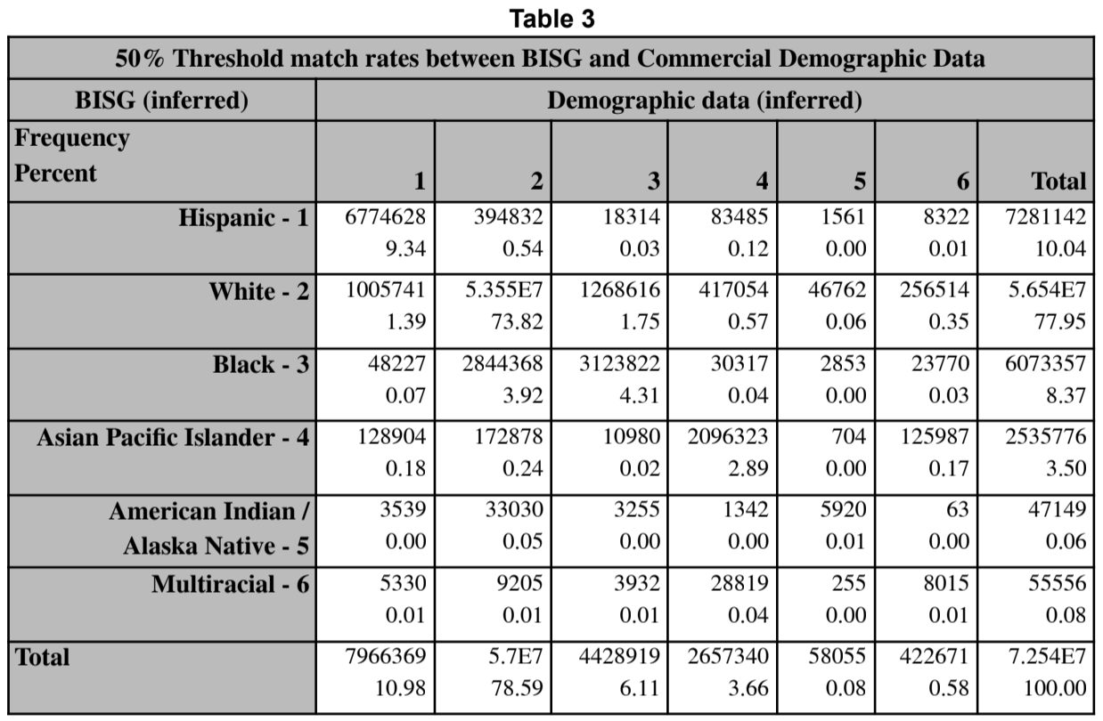

Table 3. If BISG and commercially available demographic data were the same, all the data would lie along the main diagonal. It is clear that significant disagreement occurs when these two measures directly are compared. In this figure, we are comparing BISG to inferred demographic data under the condition that we allow the BISG probability to be quite low: 50 percent. In addition, this table compares these measures for approximately 24% of the credit file. If the entire credit file follows the patterns identified here, the misclassification rates are the same, but the number of affected consumers is four times larger.
In what follows we assume that the inferred demographic data are correct; that is, we assume that commercially available demographic data correctly identify the ethnic identity of consumers on the credit file, where we have valid values for the measure.¹¹ Table 3 plainly shows the mismatch between the two measures at the 50 percent threshold. In particular, focus on the second and third rows of the BISG inference. In the second row, more than 1 million people inferred to be White by BISG are inferred to be Hispanic in the demographic data. 1.2 million BISG-inferred Whites are classified as Black by inferred demographics.
¹¹ One could reverse the assumption and compute misclassifications, false positives and false negatives under the assumption that BISG is correct. The reader can accomplish this directly from the data in the tables.

Table 4 below examines the data sample at the 80 percent BISG threshold. Again, a significant amount of data lies off the main diagonal, implying the BISG measure is misclassifying ethnicity when compared to inferred demographic data. For example, BISG assigned the ethnic value White to about 49 million consumers in our sample. There are 47 million of those jointly classified as White in both samples. This is nearly a 4 percent misclassification rate.
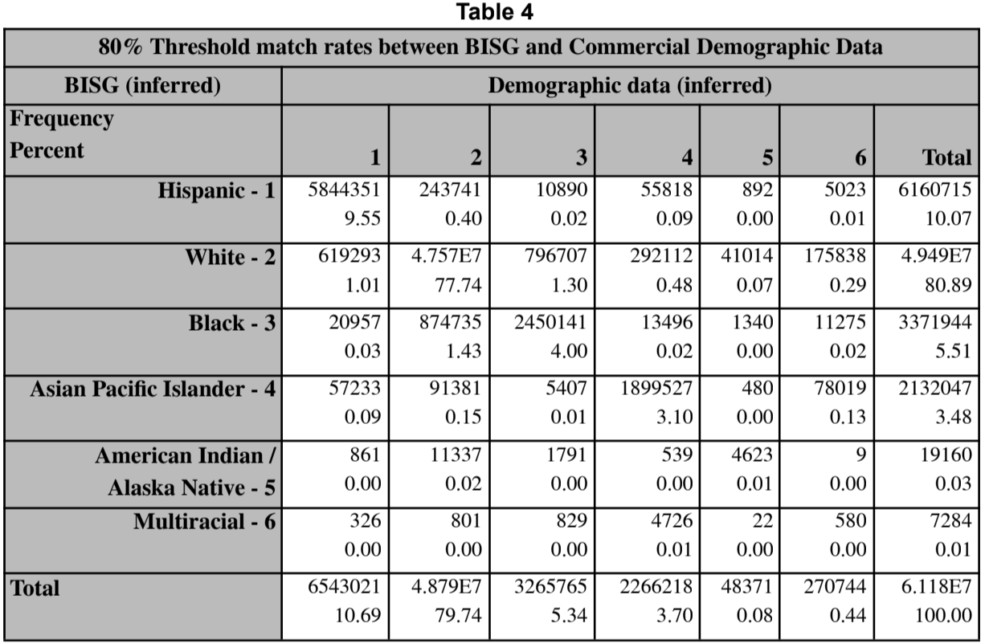

Table 4. If BISG and commercially available demographic data were the same, all the data would lie along the main diagonal. It is clear that significant disagreement remains when these two measures directly are compared at the higher probability threshold for BISG. In this figure, we are comparing BISG to inferred demographic data under the condition that we allow the BISG probability to be high: 80 percent.Extrapolating to the entire credit file, the number of misclassified consumers may be five times larger.
For those BISG classified as Black, the misclassification rate is much higher. Of the nearly 3.4 million consumers identified by BISG as Black, only about 2.5 million are on the main diagonal (cell (3,3)). We delve further into these misclassification, false positive, and false negative rates below. Consider Table 5 below. This table collapses Table 2 into a 2x2 table allowing the false positive and false negative rates to be computed more easily.

A false negative value occurs when the BISG value disagrees with the inferred demographic ethnicity value. Put another way, a false negative is defined as the proportion of consumers that are reported to be White by inferred demographics, but BISG identifies them as non-white. At the 50% threshold on the left in Table 5 we observe a 21.6 percent false negative rate for White consumers. We compute the false negative rate using the ratio of those with inferred White ethnicity (1) divided by the marginal count for all BISG classified as non-white. This is the proportion of the total sample demographics infers are white relative to the fraction of the population BISG identifies as non-white.¹² This ratio is 3,454,313/15,992,980 = 21.6 percent. Similarly, the false positive rate is defined as the ratio of consumers inferred demographics identify as non-white, but which BISG identifies as white. Here that ratio is 2,994,687/56,544,062 = 5.3 percent.
The right side of Table 5 shows the results of the same computations using the 80 percent BISG threshold. As expected, the ratios are smaller, but also the total number of records declines. The more certainty applied to BISG, the smaller the sample size becomes.
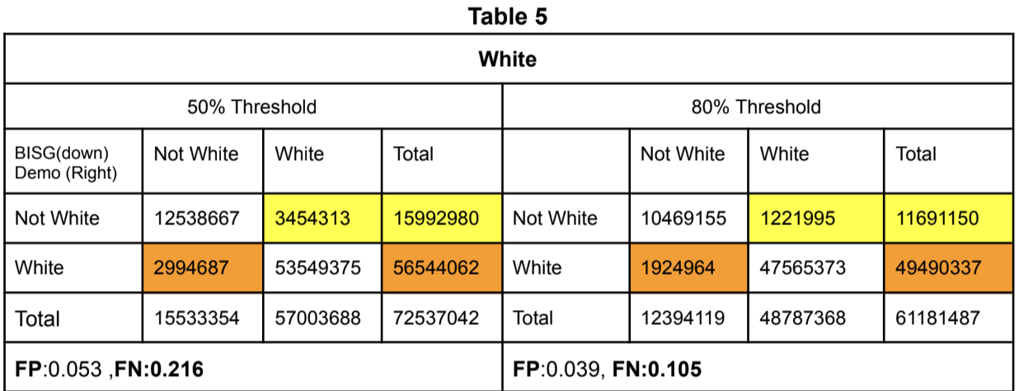

*FP=False Positive Rate,FN =False Negative Rate
In Table 6 below, we conduct the same comparisons for consumers identified as Black in the demographic data. Here the misclassification of ethnicity is highest for false positives. At the fifty percent BISG threshold, forty-eight percent of consumers are falsely classified as Black by BISG compared to demographic data. At the eighty percent BISG threshold, twenty-seven percent of consumers are misclassified by BISG.
¹² The calculations for false positive and false negative are identical to those used by Baines and Courchane , 2014.
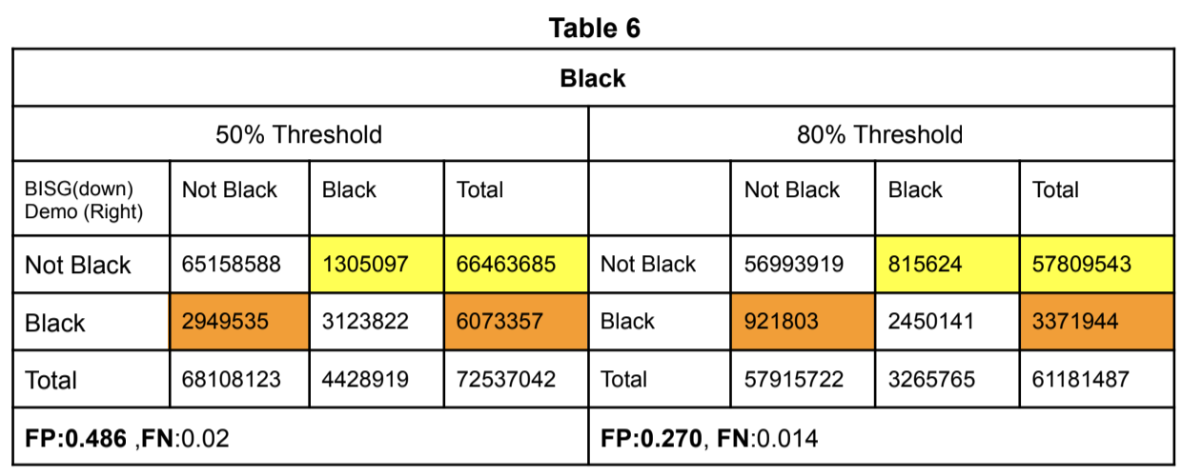

Tables 7-10 below examine the four remaining ethnic groups in the analysis, Hispanic, Asian Pacific Islander, American Indian/Alaska Native, and Mutiracial. In these tables, we emphasize the false positive rates. False negative rates are low for all four groups. Each table is organized identically to tables 5 and 6 above. In Table 7, 0 represents not Hispanic and 1 represents Hispanic as inferred either by BISG (on the left side) or by demographic data (across the top). The logic is similar for tables 8-10.
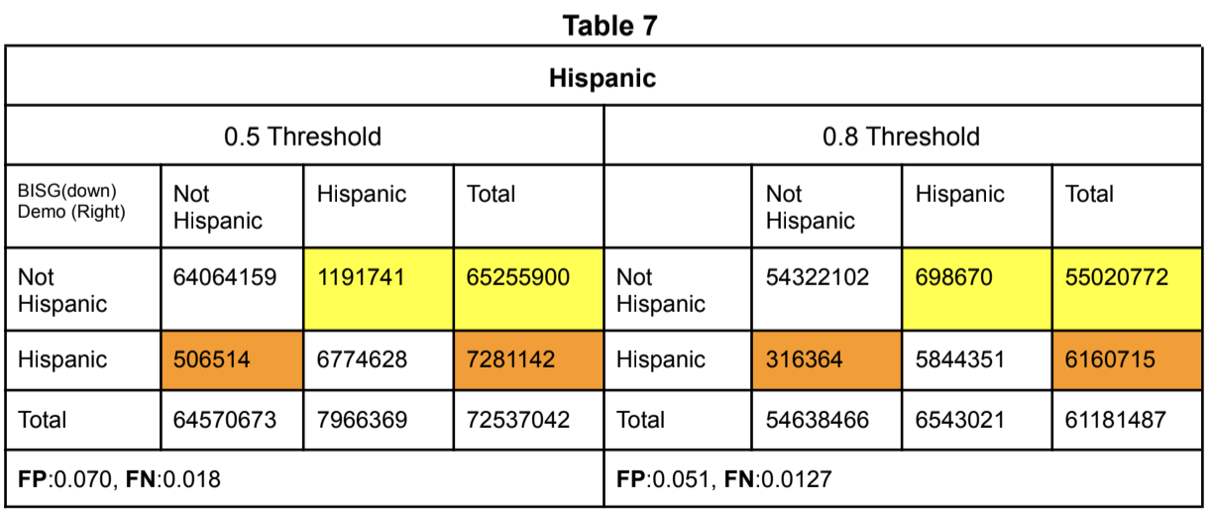

As one observes from the false positive rates in these tables, generally the smaller the proportion of the population the ethnic group comprises, the higher the disagreement between these two measures of demographic identity. This is consistent with smaller groups being more difficult to identify, especially as they disperse through the population.

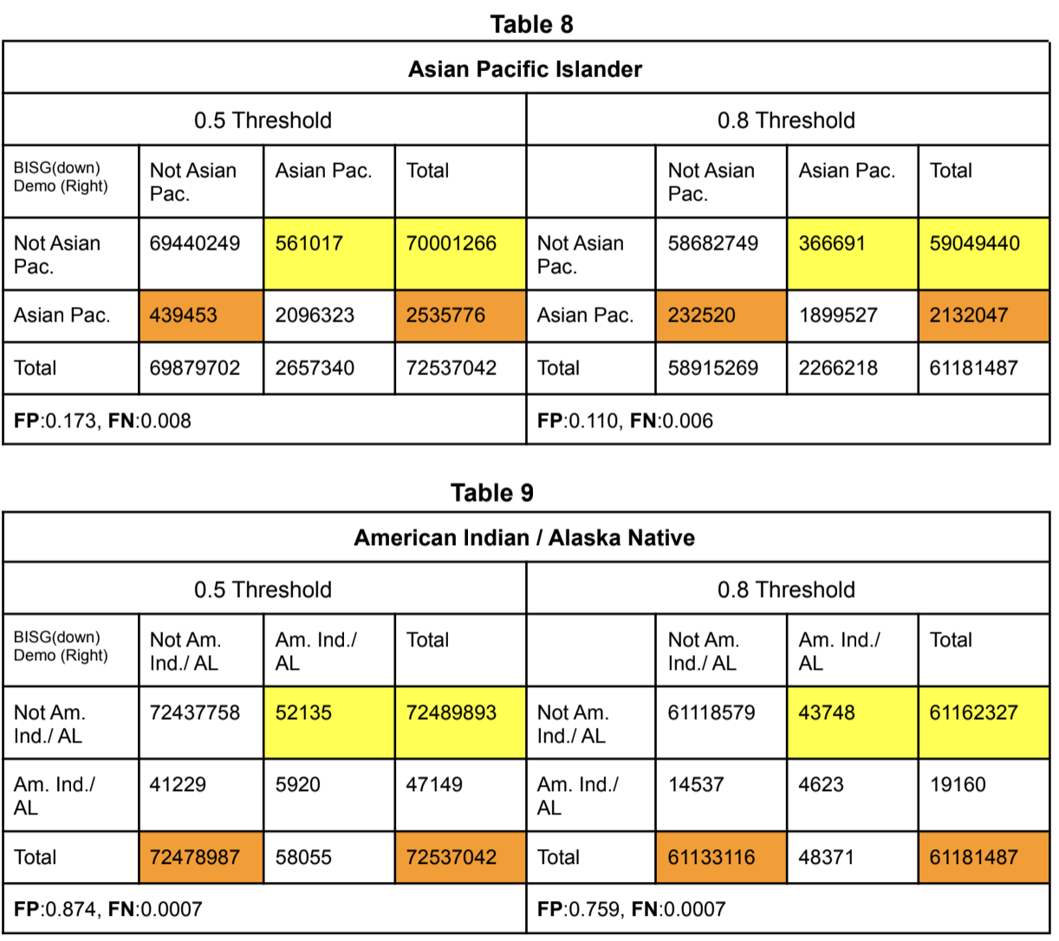

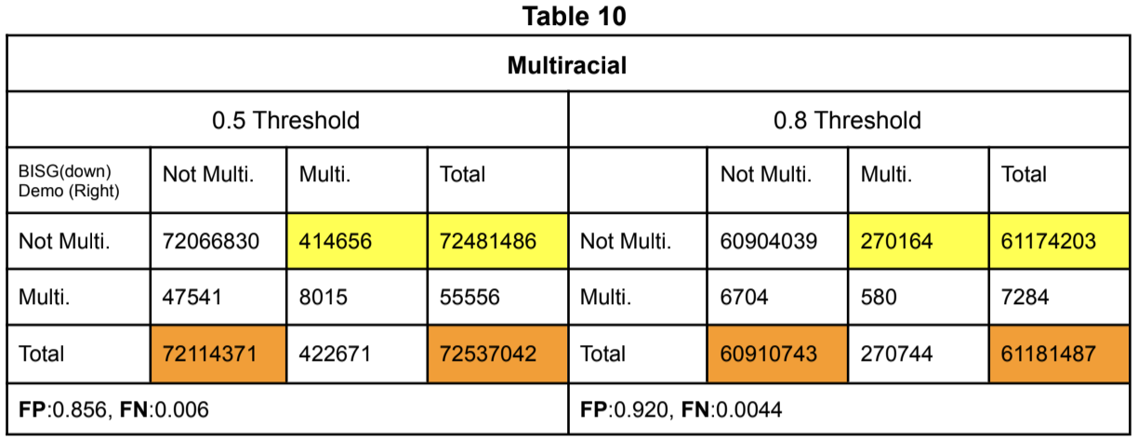

Conclusions
The analysis conducted supports the finding that commercially available demographic data and the Bayesian Improved Surname Geocoding proxy for ethnic identity are incommensurate with one another. The absence of a ground-truth baseline to compare either measure argues against the use of these data for studies of disparate impact.
In the 2007 Report, the authors rejected the use of commercially available demographic data in their disparate impact analyses. Rejection occurred because ethnicity was unavailable in the commercial demographic data sample the FRB used.¹³ We now have access to ethnicity in demographic data. However, we have shown that it may be unreliable for analytical purposes. For the reason exposed in this paper, we believe access to ground truth data, such as used by the Federal Reserve Board in The Report be made available for disparate impact analyses of credit scores.
¹³ The Report to Congress, 2007, p 62.

