ACTIONABLE AND FEASIBLE
CONSUMER CREDIT SCORE
IMPROVEMENT PATHS WITH
OPTIMALITY CONSTRAINTS AND EXPLANATIONS
AUTHORS:
Matthew Turner, Ph.D., Stephen Miller, Ph.D., Lewis Jordan, Ph.D. ¹
Abstract
Credit score simulators have historically been trial and error-based processes, requiring the consumer to experiment with various “What if” scenarios to evaluate the impact a set of actions may have on their credit score. For example: “What if I apply for a new car loan?”, “What if I decrease my credit card balances”, or “What if I remove a bankruptcy?”. However, a consumer may be interested in improving their score to a specific value in order to say reach a minimum approval score threshold, or to qualify for a better pricing offer. In this work, we describe a method for constructing an optimal path that explicitly navigates an individual consumer through the model feature space from their current score to a score of their choosing over monthly intervals. Optimality is achieved by minimizing the distance the consumer must travel within the feature space, subject to a given score constraint. Boundary box constraints are used to ensure the path is constrained within the attribute domain. The algorithm also provides the consumer with explanations of what model features most impacted their score improvement by utilizing integrated gradients.
Introduction
Equifax is on mission to Help Consumers Live Their Financial Best, and credit literacy is a key cornerstone of this mission. Credit reports and credit scores can be a confusing subject for many consumers. A consumer’s credit report not only effects their access to credit, but can also impact job offers, rental leases, utilities, wireless deposits, among others.

¹ Equifax Inc. Correspondence to: matthew.turner@equifax.com
Figure 1: Optimal Path
In the US, regulation requires that the Key Factors, also known as Adverse Action Codes, that impact a credit score must be returned with the credit score. These factors are the items on the credit report that have the largest negative impact to the score. In many instances these key factors are not immediately actionable to the consumer. For example, bankruptcies in the United States remain on a consumer’s credit file for seven years. Thus, while a recent bankruptcy may be the key factor for denying a consumer credit, the consumer cannot take immediate action to improve their score based on this key factor. This gap has traditionally been filled by generic credit education or credit score simulators. Credit education provides generic advice on how to manage credit for improved credit score, e.g. Keep credit card utilization < 10%, Don’t close revolving accounts, or Don’t open new accounts. Simulators require the consumer to experiment with various “What if” scenarios to evaluate the impact a set of actions may have on their credit score. For example: “What if I apply for a new car loan?”, “What if I decrease my credit card balances”, or “What if I remove a bankruptcy?”. These useful credit education tools require a trial and error experimentation process. Instead of only relying on trial and error credit simulations, what if we could instead identify a sequence of feasible monthly actions that the consumer could execute in order to improve their credit score in order to get approved or get better rates? We call this algorithm Optimal Path². Optimal Path (figure 1) is a new prescriptive AI solution from Equifax that guides consumers to a better credit score. Optimal Path goes beyond generic credit education and credit score simulators to provide a feasible sequence of actions a consumer can take to improve their credit standing. Along the way, the impact of each action is conveyed to the consumer.

² US/PCT Patent Application PCT/US2020/046993
Solution
Optimal Path starts by identifying a cluster of consumers that look like you today. We use credit information that the consumer can act on to improve their score, such as account balances, utilizations, number of accounts, delinquencies, recency of delinquencies, income, length of credit history, among others. We first determine a distribution of the monthly changes in these attributes ( δ⃗ = x�⃗₁ − x�⃗₀ ) that consumers who improved their score were able to execute in a 1-month period. Using this distribution _{of δ}⃗, we can introduce a metric on what actions are feasible and which are actions are not very likely. The metric is the Mahalanobis distance (δ⃗ − _{μ}⃗)′S⁻¹_{(δ}⃗ _{− μ}⃗_{) between δ}⃗ _{and the mean μ}⃗ _{= E(δ}⃗_{|X}⃗ = _{x}⃗) _{of δ}⃗ induced by the covariance matrix S = cov(δ⃗_{|X}⃗ = _{x}⃗). The covariance matrix is a key feature that recognizes that features move together instead of independently. Actions that are likely have small Mahalanobis distance, while unlikely actions have large Mahalanobis distance.
Using this metric, we can optimize the most feasible action that achieves a desired score increase C of the score f. This is a constrained optimization problem:
_{min (δ}⃗ − _{μ}⃗)′S⁻¹_{(δ}⃗ _{− μ}⃗₎ (1)
_{s.t. f(x}⃗ _{+ δ}⃗_{) − f(x}⃗_{) = C.} (2)
The optimization problem (1)-(2) is often solved using Sequential Quadratic Programming (SQP). SQP forms a sequence of Quadratic Programming (QP) sub-problems that converge to the solution. Each QP problem is formulated by second-order approximation to equation (1) and a first-order approximation to equation (2). For this specific metric, each QP sub-problem has a closed form solution. Additionally, if one assumes that the credit score f is monotonic (as is usually the case in credit scores), box constraints on the feature are easily incorporated into the closed form solution. This ensures that the recommended actions are valid.
We then project that the consumer will complete this action in 1 month, and repeat the algorithm. This leads to a sequence of monthly actions that should be feasible for the consumer to take in order to improve their credit score by a desired amount within a specified time frame.
Integrated Gradient Explanations
Path integrated gradients³ are defined to additively explain the change in a scoring surface along a given path. The path integrated gradient along a given path y in the i^{tℎ} dimension is defined as
³ Mukund Sundararajan, Ankur Taly, and Qiqi Yan. “Axiomatic attribution for deep networks”. In: Proceedings of the 34th International Conference on Machine Learning-Volume 70. Journal of Machine Learning Research. 2017, pp. 3319–3328.

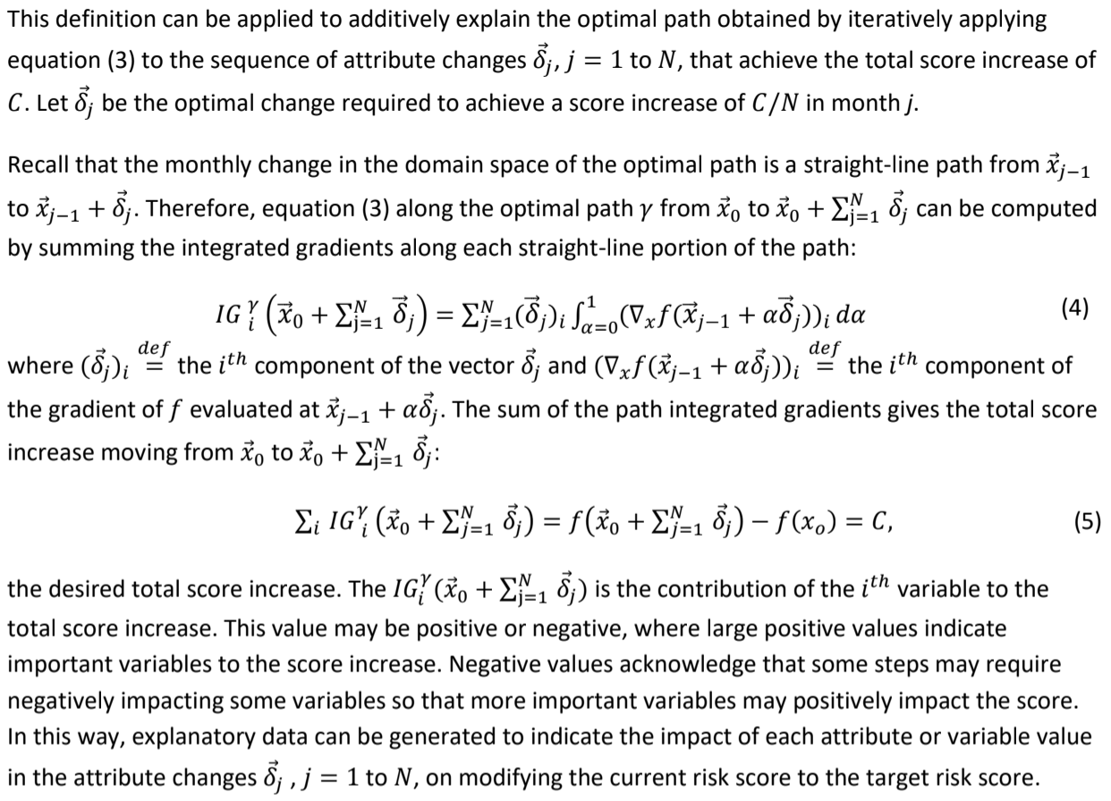
Example
A consumer, currently scoring 672, first went delinquent 9 months ago on an installment loan, and still has an outstanding past due balance. Their revolving account utilization is moderately elevated at 17%. The consumer has been unable to pay off the past due balance in the last 9 months, so they are incurring past due occurrences every month in their payment status grid. It will take years for every occurrence to roll off the credit score computation, even if the past due balance were paid in full today. What is feasible for this consumer to achieve a score increase? What have similar consumers been able to achieve in the past to raise their score?
Figures 2 and 3 show the recommended actions this consumer should take in the first month to raise their score 10 points, and the approximate impact the action would have on their score. For example, similar consumers were able to raise their score by almost 1 point (0.84 points) by lowering utilization
from 17% to 16% (figure 2). In addition, this consumer needs to begin paying down their past due balance by 5%, to raise their score 0.63 points (figure 2). In addition, they should not attempt to open any new accounts so their score is not negatively impacted (figure 3).
Figure 2: Optimal Path Payment Actions
Figure 3: Optimal Path Account Status Actions
Conclusion
We have shown an innovation with the ability to build further upon adverse action key factor notifications to provide significant consumer benefit. It provides logical and actionable guidance tailored to the individual circumstances of a consumer. The optimal path algorithm provides a feasible path, in
one-month increments, to optimize a consumer's credit score. This work innovates by focusing on within-subject month-to-month feasibility to ensure that the recommended path not only produces the desired score increase, but also that the recommended path is reasonable for that particular consumer. This work also has advantages over credit score simulators that rely on trial and error “what if” simulations to determine a feasible move that achieves a desired score increase. The optimal paths algorithm provides feasible, actionable, and impactful recommendations to the consumer.

