OPTIMAL PATH PLANNING FOR CONSUMER CREDIT SCORE IMPROVEMENT
STEPHEN MILLER, PHD, LEWIS JORDAN, PHD, MATTHEW TURNER, PHD, ALLAN JOSHUA, MARK DAY, PHD
Equifax Data Science
Abstract. There is an increasing expectation on financial institutions utilizing consumer data for credit risk modeling to explain how automated systems make decisions. However, explanations of credit risk models do not necessarily translate into the ordered sequence of actions a consumer could take to improve their score to a desired value. Further, the use of machine learning models complicates transforming model explanations into actionable consumer behavior due to the inherent nonlinearity and interactions present in these models. In this work, we describe a patent-pending method for constructing an optimal path that explicitly navigates an individual consumer through the model feature space from their current score to a score of their choosing. Our methodology automatically generates the ordered actions a consumer could take to incrementally reach their desired score.
Contents
- Introduction 1
  - Simple Illustrated Example 2
- Defining a Metric on the Feature Space 3
- Optimal Path in the Feature Space 5
  - Optimal Single Step Algorithm 6
  - Optimal Path Algorithm 7
  - Examples 7
- Conclusion 10
1. Introduction
Credit risk scores can be a confusing and cloudy subject for consumers. Consumers are often shocked to learn that “a” credit score was used in a financial decision instead of “the” credit score. One measure of financial health is a credit risk score. Even though there are many different credit risk scores for different applications, they are each a measure of risk on a financial product and a proxy indication of financial health. Therefore, it can be useful and beneficial to consumers to learn more about the profiles of consumers that are assessed as a safe and sound financial risk. In addition, providing a personalized path to a consumer to reach a certain risk level profile adds transparency and understanding to credit risk models.
Suppose a consumer desires to reach a given credit score threshold. This threshold may be an approval threshold or a threshold that qualifies for a better pricing offer. What actions should

E-mail address: stephen.miller@equifax.com, lewis.jordan@equifax.com, matthew.turner@equifax.com.
Date: August 8, 2019.
All work herein is patent pending. 2019 Equifax Inc., all rights reserved.
a consumer take to reach this threshold? There are many products in the market today that simulate credit score “What if” scenarios, intended to provide the consumer with how their score would change given an action taken by the consumer (e.g. “What if I apply for a new credit card”). However, these products do not provide a path to reach a user specified score, nor do they provide the sequence of actions that are necessarily achievable in monthly increments. There are also products in the market that provide generic advice or guidance to credit scores such as “keep your credit utilization below 30%” or “don’t take out a mortgage more than 3X your income”. Examples could also be profile analysis of consumers around a certain score range such as “typical consumers with a 750 credit score have 4 revolving credit lines with a $1000 balance and 5% utilization”. These products only provide generic guidance and may not be feasible for individual consumers. More importantly, none of the aforementioned solutions provide a path for consumers with little to no credit history to establish a healthy credit report.
Suppose a consumer is currently at a location ~x with credit score f(~x) and is trying to navigate to a new point ~x + ~δ that reaches a score threshold f(~x + ~δ) ≥ C. There are immediate technical and esoteric challenges with this problem. First and foremost, there are likely an infinite number of solutions ~δ that meet this objective (Figure 1). Second, not all solutions are created equal. Consider an attribute in a credit risk model Number of accounts past due in the last 12 months. A consumer that recently had an account go past due will have at minimum 12 months for this delinquency to roll off their 12-month credit file. Therefore, solutions that tell a consumer to reduce the number of past due occurrences are not immediately useful. What are immediate feasible actions that a consumer could take to impact their credit score and financial health while they eventually wait for the past due occurrences to roll off of the credit report? Among these feasible actions, which ones will have the largest impact?
In the US, regulation requires that the “key factors” that impact a credit score must be returned with the credit score. These factors are the items on the credit report that have the largest negative impact to the score. As indicated above, in many instances these key factors are not immediately actionable to the consumer. Therefore, there is a potential big gap between what is causing the biggest negative impact to a credit score versus what is most actionable on a credit score.
The above discussion illustrates important points. It is beneficial to the consumer to provide a path to sound financial risk. The path best serves its purpose if it is immediately actionable to the consumer in monthly increments and if the path is feasible for a particular consumer (Figure 2). The following work illustrates a novel and inventive approach to “Optimal Path Planning For Consumer Credit Score Improvement”. In it, we will detail an algorithm that provides monthly feasible actions tailored to a specific consumer to reach a desired score threshold.
The biggest challenge therefore is to properly define the space of feasible actions for a given consumer so as to overcome the pitfalls of trial-and-error credit score simulators or generic advice based on profile analysis. Applications of this algorithm include defining optimal paths for improvement and in explaining complex scoring surfaces, especially those generated by machine learning algorithms capturing non-linearities and interactions. The algorithm can also work in reverse - what are the actions a consumer should not take that would negatively impact their financial health. This is easily achieved by finding the optimal path to reach a credit score threshold that is below their current credit score.
1.1. Simple Illustrated Example. As an example, Figure (3) represents a hypothetical credit risk model where Score = f(x₁,x₂). The “black” dot indicates the consumer’s current score, and the cutoff score (horizontal plane) at Score = 0.28 represents the minimum score required to be approved for a loan. In traditional risk score models, the reasons for denying this consumers loan would rank order x₁ as the first most important reason, and then x₂ as the second most important reason. No other information outside of this is typically given to the consumer. Thus, the consumer has no way on knowing or determining which actions they should take to improve their score in
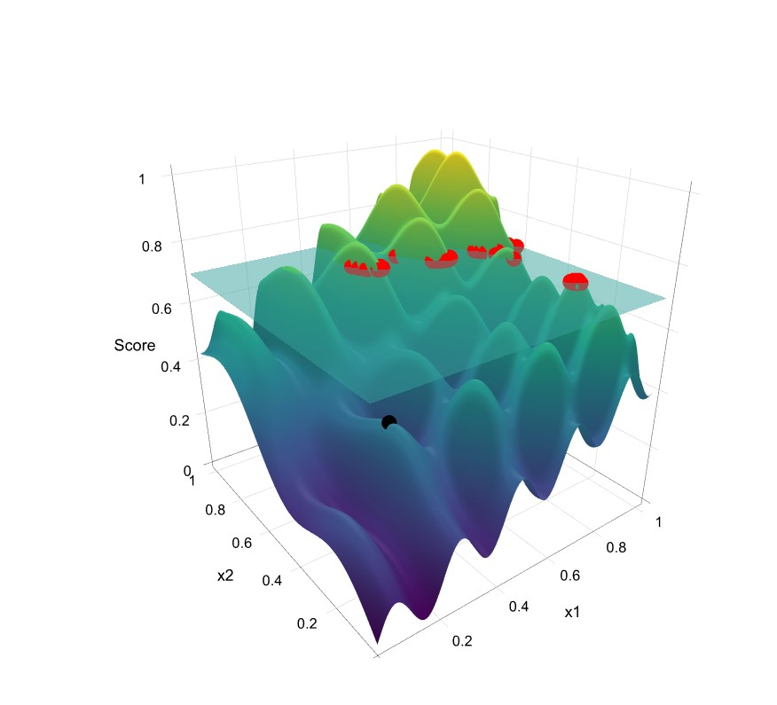
Figure 1. Plot of Score = f(x₁,x₂). The horizontal plane at Score = 0.70 represents the minimum score required to be approved for a loan. The black dot indicates the consumer’s current score. The red dots are examples where the horizontal plane intersects the scoring surface.
the quickest and most efficient manner. The consumer would probably think that x₁ is what they should focus on changing since that was the “primary” reason for rejection. However, upon examination of Figure (3), it can be seen that changing either x₁ or x₂ will lead to a 0.28 score. If it is easier for the consumer to take actions to change x₂, then obviously x₂ should be considered the “primary” feature.
It should be noted, that this same logic holds for credit risk models with p features in the model. As discussed above, except under very strict modeling assumptions, the reason codes provided do not necessarily help the consumer take actions to improve their score in the most efficient way to achieve the minimum approval score for the loan applied for. That is, the way reason codes are typically generated by credit scoring systems in no way guarantees that if the consumer acts first on the “primary” reason code, their score will improve in the quickest and most efficient manner.
2. Defining a Metric on the Feature Space
To have a meaningful definition of shortest path or closest point in the attribute/feature space, we need a metric that captures what movements in the feature space are feasible for a consumer. It is not enough to observe another consumer with an alternative feature vector - that does not necessarily constitute a feasible destination point. For example, the addition of more credit lines to a consumer’s report may not be feasible. Or, the movement could require removal of a bankruptcy, which are not readily removed after first appearing on ones credit report.
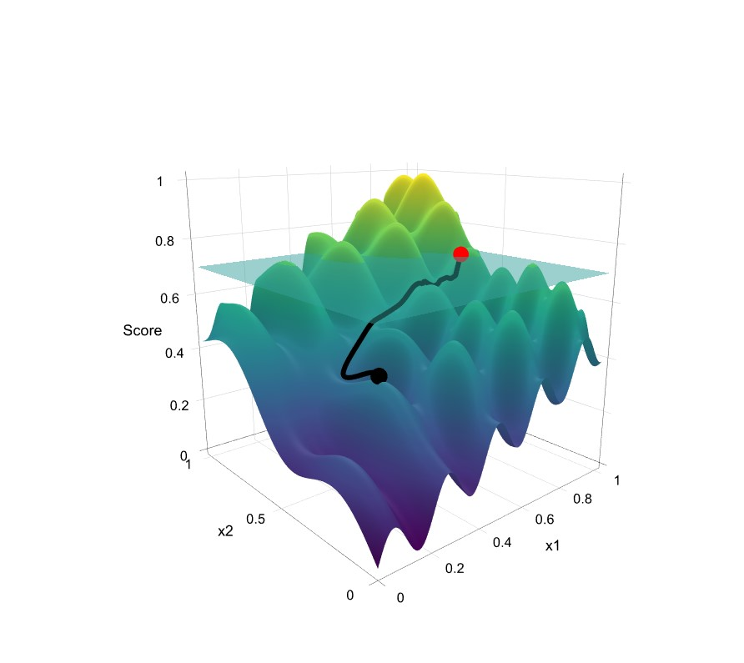
Figure 2. Plot of Score = f(x₁,x₂). The cutoff score (horizontal plane) Score = 0.70 represents the minimum score required to be approved for a loan. The black dot indicates the consumer’s current score. The red dot represent the point where the cutoff surface intersects the scoring surface. The solid black line is the optimal path from the consumer’s score to the cutoff score.
To quantify feasible movements in the feature space, we can use the covariance matrix of withinsubject month-to-month (or quarter-to-quarter etc.) changes in the feature vector:
Σ = Var(Xitj − Xitj−1). (1)
We will call this the longitudinal (co)variance matrix, and its inverse the longitudinal precision matrix. If a feature has high longitudinal variance, then a unit change in that feature is common for a consumer; conversely if a feature has low longitudinal variance then consumers rarely change that feature. This also captures scale: the longitudinal variance of total credit card balance will be higher than credit card utilization. If two features x₁ and x₂ (e.g. balance and utilization) are highly correlated, then their (appropriately weighted) sum (x₁+αx₂) will have a higher longitudinal variance still.
The covariance matrix itself does not give a metric on the feature space. Specifically, covariance is a symmetric bilinear form on the space V of random variables over the feature space. It allows us to compute, for example, Var(X₁), Var(2X₁) and Var(X₁ + X₂) for random variables X₁ and X₂. We will find that Var(2X₁) = 4Var(X₁), implying correctly that a unit increase in 2X₁ is more feasible than a unit increase in X₁. But covariance does not assign a value to a specific value X₁ = x₁. The appropriate way to convert longitudinal covariance to a metric on the feature space is through the longitudinal precision matrix P = Σ⁻¹. The feature space is dual to the variable space, as a specific value X = x provides a linear map V → R by evaluation at x. The precision matrix gives a symmetric bilinear form on the feature space.
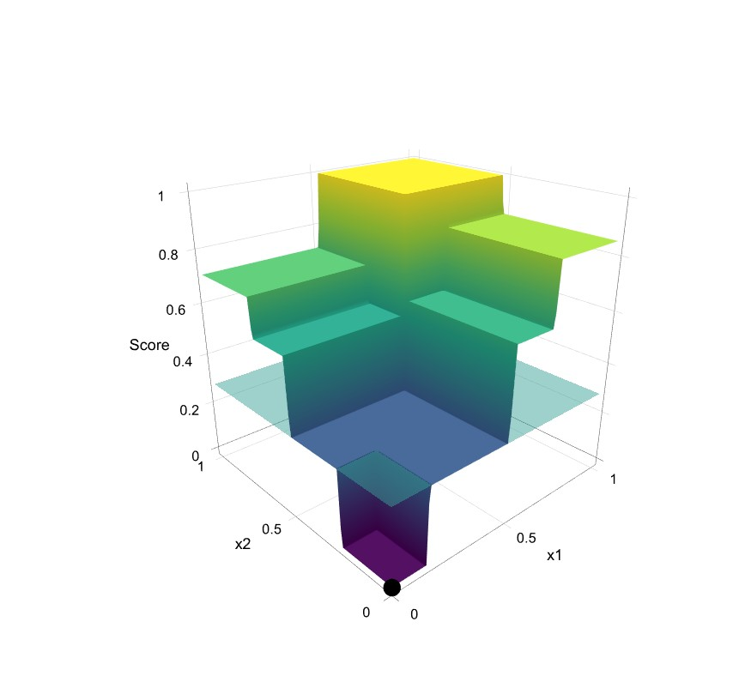
Figure 3. Plot of Score = f(x₁,x₂). The black dot indicates the consumer’s current score. The horizontal plane a Score = 0.28 represents the minimum score required to be approved for a loan.
The precision matrix, like the covariance matrix, is positive definite and symmetric so it produces a valid Riemannian metric. Vectors with high variance have low precision, so a unit change in a common/easy direction in the feature space will be a short path, while a unit change in an uncommon direction will be a long path. A benefit of the precision matrix is that, as its off-diagonal terms represent the negative conditional correlation of features, it captures the fact that certain groups of features usually move together. For example balance and utilization are conditionally positively correlated (almost perfectly), so an increase in balance without a corresponding increase in utilization would be unusual and would have a high precision, whereas an increase in balance with a corresponding increase in utilization would be feasible and have a low precision - a short path. For this reason the precision matrix is commonly referred to as the “surprise” matrix - it quantifies how unusual/surprising an observation is.
When the precision matrix calculated over the whole dataset is used to define a metric, the distance defined by this metric is the Mahalanobis distance. We innovate by calculating Σ over within-subject month-on-month changes, rather than the whole cross-sectional dataset.
3. Optimal Path in the Feature Space
Let 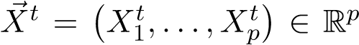 denote the features (attributes) of a particular record at time t.
Our first goal is to take the shortest feasible step ~δ ∈ R^{p} in one time increment that attains a score increase of C units.
We need to define what is “feasible”. Feasibility can be broken into two parts - portfolio level feasibility and consumer level feasibility. Portfolio level ensures that X~ ^{t}+~δ belongs to the manifold of the development sample. One such solution would be to use an autoencoder developed on the training dataset to determine if the new proposed data point X~ ^{t} + ~δ is feasible - that is all the points that are close to the manifold of the development sample. Examples that involve time may be feasible at the portfolio level but not at the consumer level. The autoencoder could allow an action at the portfolio level that is not feasible at the consumer level. Consider a consumer that just filed for bankruptcy. It is not feasible to suggest the consumer ”immediately” remove the bankruptcy from their credit file, as it will take years to fall off the credit file. What is needed then is an algorithm that profiles consumers and determines what is feasible for an ”individual” consumer in a single time increment.
There are many technical details we have solved for that are not detailed in section (2). These include properly handling missing, default, and categorical values and possible inversion problems of singular or nearly singular matrices. In this paper, we will only detail a minimally viable product (MVP). For the MVP, we
- Work only with a small subset of the Advanced Decisioning Attributes (ADA) for those consumers who have at least one open trade and a valid Equifax Risk Score (ERS3).
- Standardize the data using z-score transformations for cluster analysis.
- Choose to approximate the longitudinal covariance matrix by computing the sample longitudinal covariance of sub-samples, where the sub-samples are defined by a cluster analysis detailed below and is comprised of consumers who are similar to one another (as determined by the cluster analysis).
- All features (consumer level attributes) are treated as continuous random variables.
- Default/Missing values are imputed to 0 or 1 as appropriate. This is possible since we are only considering ADA attributes and missing values for each ADA attribute can be logically assigned to 0 or 1 as appropriate.
3.1. Optimal Single Step Algorithm. To develop the the MVP model, a 1% sample of U.S. consumers with at least one open trade and a valid ERS3 score were sourced from January 2018 (t = 0) and February 2018 (t = 1). The attributes that were included in the MVP are
- Number of inquiries in the last month
- Number of inquiries in the last 12 months
- Balance on revolving accounts
- Utilization on revolving accounts
- Percent of accounts always satisfactory
- Number of accounts
- Age of oldest revolving account
- Number of accounts with past due amount > $0
- Total amount past due
- Number of 60+ days past due occurrences in the last 24 months
- Percent of open revolving accounts to all open accounts
First, we developed a very simple linear regression proxy model to ERS3 using the X~ ⁰ data to predict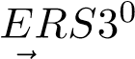. The model has an Rquared of 0.82. Next we conducted a k-means cluster analysis on the X⁰ data. The cluster analysis was constructed to be extremely granular so as to best represent the data. We were not interested in getting the fewest clusters possible. Instead, we only needed to ensure that each cluster had enough data points to reasonably approximate the centroid of cluster k, ~c_{k}, with confidence and that there were enough clusters to adequately capture nuances in the data. Next, for each cluster k, we computed the mean µ~_{k}, covariance Σ_{k}, and precision matrix P = Σ⁻¹ of the distribution of ~δ’s defined by ~δ ^{def}= X^{~ 1} − X^{~ 0}.
Now suppose that a consumer is located at X~ ^{t} at time t. We determine the shortest feasible step δ that produces a desired score increase as follows:
- Classify a given record X~ ^{t} into a cluster based on Euclidean distance to the closest centroid
~c_{k}.
- Using the pre-computed µ~_{k} and P_{k} for that cluster, solve the optimization problem
) (2)
subject to: (3)
We can directly solve the constrained optimization problem (2) and (3) with a constrained optimization routine. Using a constrained optimization routine has the added benefit of adding lower and upper bound constraints on the attributes (for example, number of inquiries on file ≥ 0) and integer constraints on the attributes (for example, number of inquiries on file must be an integer).
3.2. Optimal Path Algorithm. Let us now turn to considering a long term goal. For example, in 12 months, I want to improve my financial health in an optimal manner so that my score increases from 600 to 750. This problem is easily solved by applying the MVP algorithm of section (3.1) to
def ^{~ 12} − X^{~ 0}. This will provide me the optimal 12-month the distribution of delta’s defined by ~γ = X
path to reach my financial goal. However, how can we break this 12-month path into monthly actions to get on a path of “healthy” score improvement? For example, if there are 10 different ways for a certain consumer type to increase their score by 10 points, some paths might yield short-term score improvement before scores deteriorate due to consumers becoming overextended while other paths might yield sustainable score growth.
Let us start by drawing parallels to the gradient descent numerical algorithm. Gradient descent is a first-order algorithm to find the minimum value of a function. The algorithm works by iteratively taking steps (actions) in the direction of steepest descent. The primary benefit of gradient descent is that you generate a sequence of steps (actions) that generate the largest short-term rewards at each step. Even if the gradient descent algorithm gets to the long term goal, the sequence of steps (actions) are not guaranteed to be the optimal sequence of steps (actions). However, if the scoring surface is monotonic, then each step (action) of gradient descent is guaranteed to always produce an action that moves towards the global minimum.
In credit scoring systems, the scoring surface is usually monotonic (or at least monotonic in most every feature). In this regard, we can solve the optimal path problem by iteratively applying the single step algorithm in section (3.1) to generate a sequence of actions δ~₁,...,δ~_{n} that solves the sequence of problems
) (4)
subject to: f(X^{~ t+1}) − f(X^{~ t}) ^{def}= f(X^{~ t} +~δ^{t}) − f(X^{~ t}) = C (5)
Drawing parallels to gradient descent again, we are not guaranteed that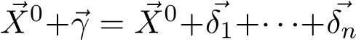.
However, we are guaranteed that f(X^{~ 0}+~γ) = f(X^{~ 0}+δ~₁+···+δ~_{n}). Moreover, if the scoring surface is monotonic, then we can be guaranteed that each action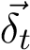 is a financially healthy step.
3.3. Examples. We now turn to some examples of the optimal path algorithm given by equations (4) and (5). We start by simulating a 3-dimensional scoring surface example depicted in Figure (4). The scoring surface f(x₁,x₂) = 1 ∗ x₁ + 0.1 ∗ x₂ + 1 ∗ x₁ ∗ x₂ is a linear regression with interaction term x₁ ∗ x₂. The attributes x₁ and x₂ covary in a parabolic manner as depicted in the top two graphs of Figure (5). Across time (Figure (5) second row), x₁ does not have a lot of variance while x₂ does. Suppose a consumer is located at the red dot on the scoring surface in Figure (4) at time t = 0 and desires to reach the scoring threshold given by the yellow contour line at a future time. If we ignore that x₁ and x₂ covary together and that x₁ has little variance across time, we could apply gradient descent to determine a path to reach the desired scoring threshold. The gradient descent
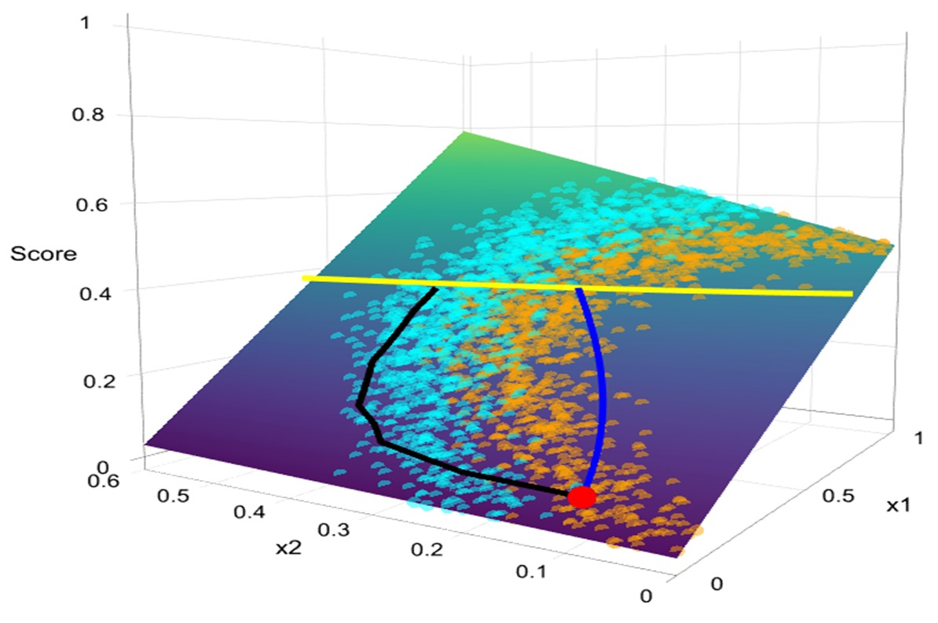
Figure 4. Path of gradient descent (blue) and Mahalanobis metric (black) over time from a consumer’s current score (f(X⁰) at time t = 0, red dot) to a specified score (f(X¹³) = constant at time t = 13, yellow line) with a score increase of 0.025 units in each time period.
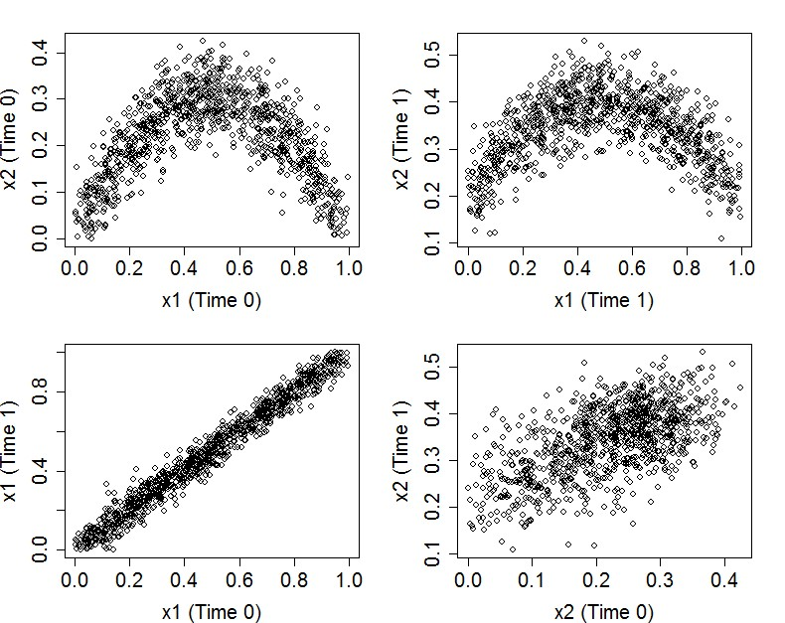
Figure 5. Simulated variables x₁ and x₂ covary in a parabolic manner, while x₁ has little variance across time and x₂ has moderate variance across time.
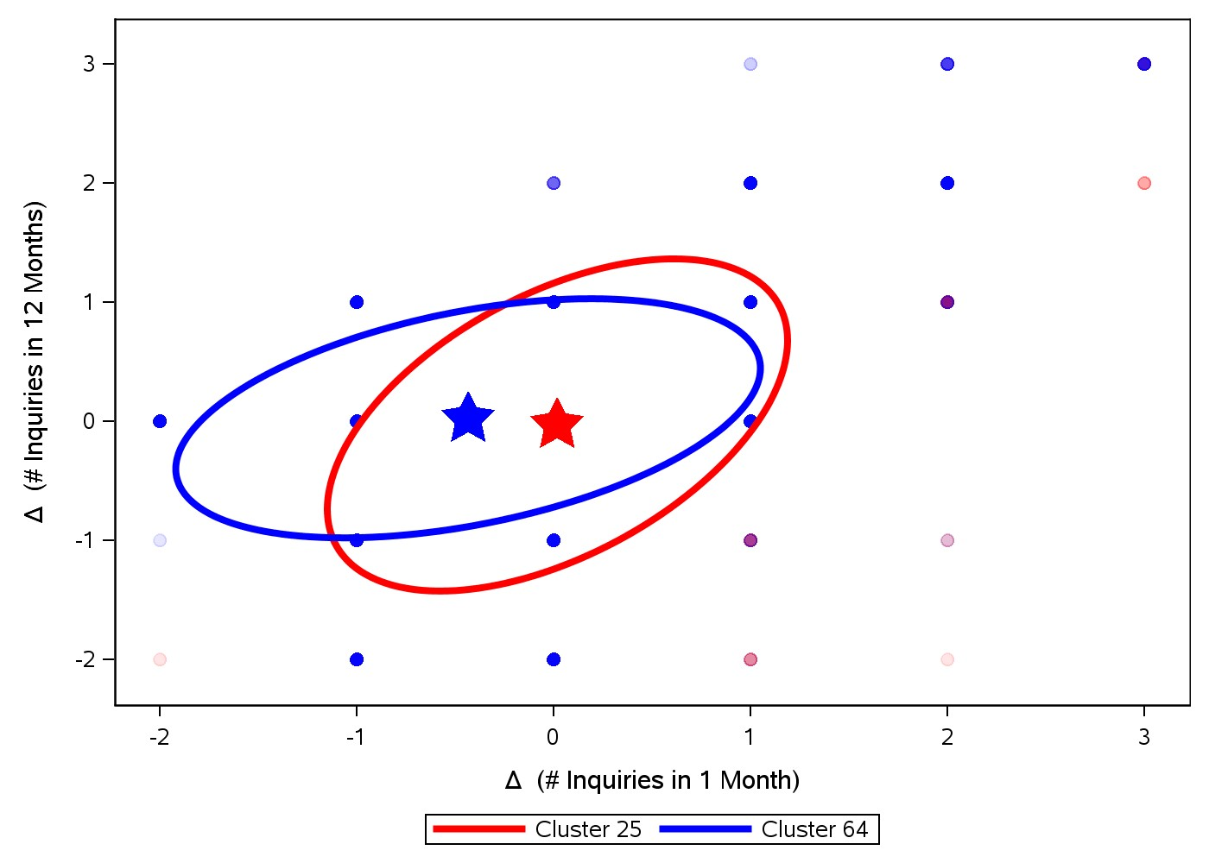
Figure 6. 95% prediction intervals are depicted for the δ’s of two different clusters. In the red cluster, consumers on average do not experience a change in the number of inquiries in 1 month and in 12 months. If a change occurs, the change in each coordinate are very positively correlated. This is typical of consumers that have old inquiries that are about to roll off the 12 month file. In the blue cluster, consumers on average do experience a change in the number of inquiries in 1 month but not in 12 months. This is typical of consumers who have a recent inquiry that rolls off the 1 month file but not the 12 month file.
path is depicted by the blue line in Figure (4). In this example, it converges to a point that is feasible at the portfolio level. This may not always be the case. It could readily converge to a point that is not represented by the data. While one could add a penalization term to the optimization algorithm that penalizes movements away from observed data manifold, we are still missing a very important aspect, and that is consumer level feasibility. The gradient descent algorithm focuses most of the movement on x₁, since the gradient is much steeper in the x₁ direction. However, we know that x₁ has very little variance across time. Since x₂ has higher variance across time, it is more feasible to move in the x₂ dimension. This fact is captured perfectly by the optimal paths algorithm equations (4) and (5) and is depicted by the black line in Figure (4). The algorithm takes 13 steps to reach the scoring threshold in score increments of 0.025 units in each time period. At each step, it correctly favors larger steps in the x₂ dimension over the x₁ dimension. In terms of Euclidean distance, gradient descent certainly converges to the “closest” data point. But this point is highly infeasible to the consumer and represents movement in the x₁ dimension that is not likely and potentially not even possible.
Consider now an example using X₁ = number of inquiries in the last 1 month and X₂ = number of inquiries in the last 12 months. Let’s consider two consumers. The first consumer, consumer A, has 1 inquiry on file made 12 months ago. The second consumer, consumer B, has 1 inquiry on file made within the last month. At time t = 0, consumer A has X~ ⁰ = [0,1] and consumer B has
X~ ⁰ = [1,1]. Figure (6) depicts 95% prediction intervals for the δ’s of the cluster that each consumer belongs. Consumer A belongs to cluster 25 at time t = 0. The mean δ of cluster 25 is depicted by the red star in Figure (6). The mean is approximately the origin, indicating that for this cluster, we do not expect any change in the number of inquiries within the last 1 month and 12 months. However, an inquiry that rolls off the 12-month file falls within the 95% prediction interval of this cluster. Therefore, a change of δ = [0,−1] to the new point X~ ¹ = [0,0], indicating no inquiries on the 12-month file, is feasible for consumer A.
Now, the next consumer, consumer B, belongs to cluster 64. The mean is depicted by the blue star and clearly indicates that for this cluster, the number of inquiries in the last month is expected to decrease. However, consumer B can’t move to the new point X~ ¹ = [0,0], indicating no inquiries on file, since this move corresponds to a delta of δ = [−1,−1], which falls just outside the 95% prediction interval. If consumer B does not make any new inquiries, then the prediction interval correctly tries to move this consumer to the left towards [0,1] with delta δ = [−1,0], which falls well inside the prediction interval. Assuming that this delta gives a score increase, this is obviously where the consumer should walk.
We now turn to a third hypothetical consumer, consumer C. This consumer has 1 inquiry on file made 6 months ago. Therefore X~ ⁰ = [0,1] and, assuming no new inquiries in the next few months, will remain at the point [0,1] for 6 more months until that inquiry rolls off the file. This example illustrates the need to have a more granular cluster analysis on many different feature measurements over time. In this simplified MVP example where we only consider X₁ = number of inquiries in the last 1 month and X₂ = number of inquiries in the last 12 months, we are not able to differentiate consumer A and consumer C. Both start at the point X~ ⁰ = [0,1] and both are walking towards X~ ^{t} = [0,0], assuming no new inquiries on file. However, consumer A will achieve this point in 1 month while consumer C will take 6 months. If we had included additional features in the cluster analysis to measure number of inquiries in the last 6 months, we could differentiate consumer A from C and recommend even better, more feasible, delta’s for each.
As a final example, we turn to balance, X₁ = Balance on revolving accounts, and utilization, X₂ = Utilization on revolving accounts. These features are obviously highly correlated with one another. But across time, some clusters of consumers may have high variance while others very low. We picked a few clusters and depicted the 95% prediction intervals in Figure (7). As expected, most of the clusters show a positive correlation between changes in balance and utilization. Three of these are depicted by the red, brown, and purple ellipsoids. The height of these ellipsoids is tight, indicating the strong correlation. The width of each indicates that only small changes in balance are possible for some clusters while large changes may occur in others. The remaining two blue and green ellipsoids are mostly vertical. These represent clusters that either change credit limits, possibly through opening or closing of accounts, or clusters with small credit limits, so that small changes in balance can greatly affect the change in utilization.
We now apply the optimal path algorithm of section (3.2) equations (4) and (5) to a consumer and examine the features we have been discussing. The path is depicted in Figure (8) and shows the monthly change of each feature. Each new data point X^{~ t+1} minimizes the Mahalanobis distance between X^{~ t+1} and X^{~ t} required to achieve a 5 point score increase over the previous month. Since this consumer started at number of inquiries in the last month = 0, the consumer is recommended to remain at this value for most months. Near the end of the path, once this consumer has reached a certain threshold, the path does indicate that they might inquire for a new account. We recall for this MVP solution that one assumption was every feature was treated as continuous. This is why number of inquiries is not an integer value, nor has the recommendation crossed a threshold to actually recommend an inquiry. This consumer did start with 1 inquiry in the last 12 months and over the course of a few months, this inquiry is expected to roll off the 12-month credit file. We also see that revolving account balance and utilization move together, as expected for most consumers. This consumer obviously has a high credit limit, but can greatly improve their score by reducing the balance in manageable monthly payments.
4. Conclusion
We have detailed an algorithm that provides a feasible path, in one month increments, to optimize a consumer’s credit score. This work innovates by focusing on within-subject month-to-month feasibility to ensure that the recommended path not only produces the desired score increase, but
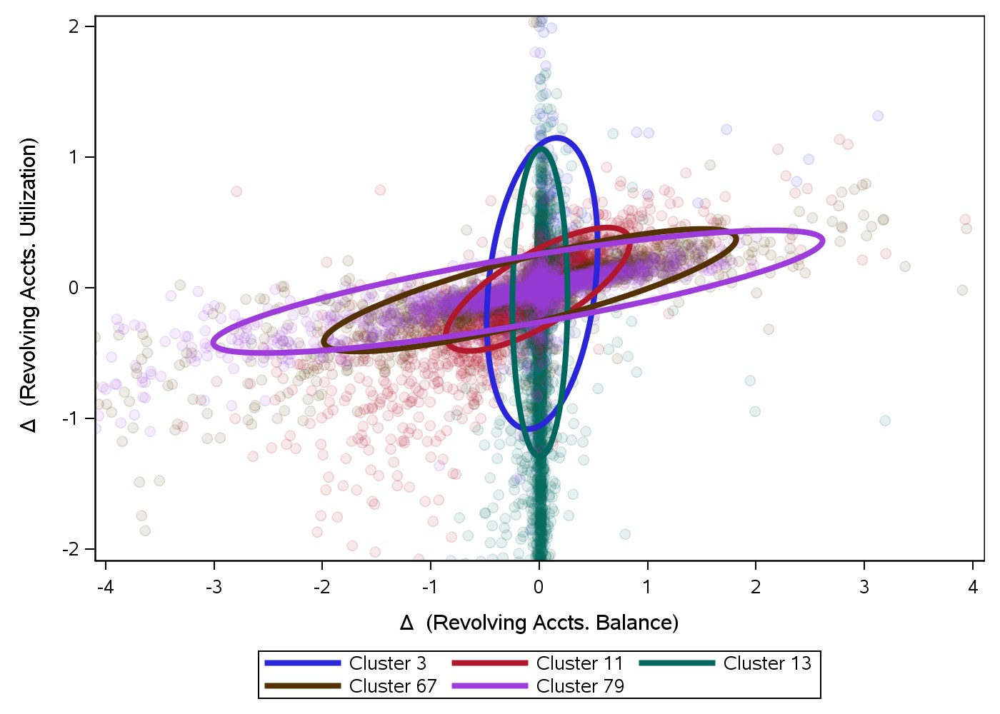
Figure 7. Various clusters are depicted showing the relationship between changes in utilization and balance. For certain clusters, utilization may change without a significant change in balance. This is typical of clusters with newly opened or closed accounts, clusters with credit limit increases or decreases, or clusters with low credit limits where small changes in balance represent significant changes in utilization. For most clusters, we see the expected positive correlation between balance and utilization where an increase or decrease in balance corresponds to an increase or decrease in utilization.
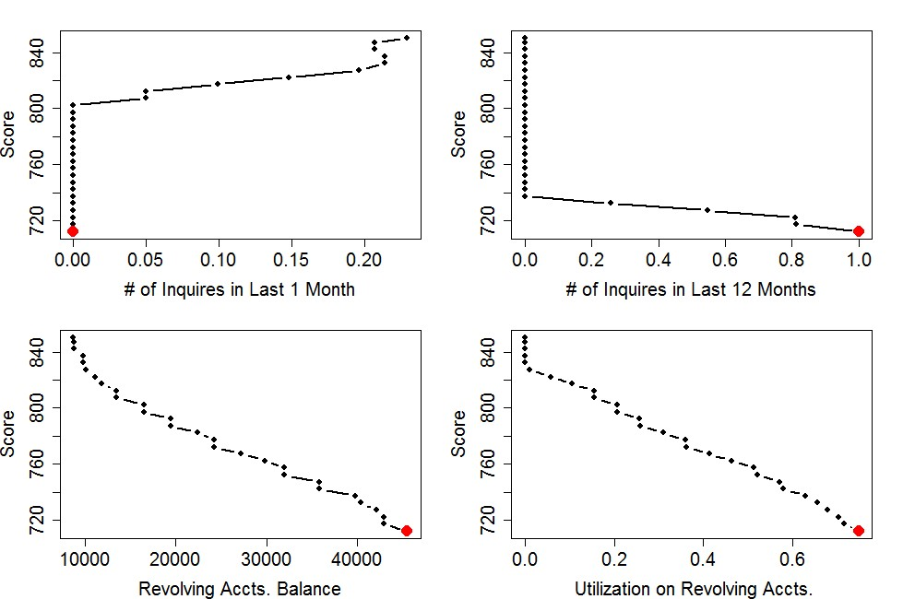
Figure 8. Optimal path for a specific consumer to reach a scoring threshold. The red dot represents this consumer’s starting values at time 0 and each dot is a 1 month increment of changes in the feature space to achieve a 5 point score increase. also that the recommended path is reasonable for that particular consumer. This is in contrast to other “optimal path” algorithms that may only look for the “closest” point in the model development domain that achieves a desired score increase. This work also has advantages over credit score simulators that rely on trial and error “what if” simulations to determine a feasible move that achieves a desired score increase.
Optimal paths provide an additional benefit to the consumer over traditional credit scoring systems. In the U.S., a credit scoring system provides the key factors that negatively impacted a consumer’s score. However, these key factors may not be easily actionable to the consumer. We discussed extreme examples of a recent bankruptcy that can not be removed for years. We also discussed more typical examples such as number of inquiries in the last 12 months. Consumers who have inquiries about to roll off the 12 month file receive the recommended action of not generating new inquiries on file and letting the old inquiries roll off file. The optimal paths algorithm provides feasible, actionable, and impactful recommendations to the consumer.

