Bank-Sourced Credit Transition Matrices
BarboraMakova∗
August 8, 2019

Abstract
This study introduces bank-sourced credit transition matrices based on internal credit risk estimates from twelve global A-IRB banks provided by Credit Benchmark. It provides new insights into applicability of the existing transition matrix estimators on bank data by exploring practicality of their assumptions. Using a unique dataset covering monthly observations on more than 20,000 large corporates from North America and the European Union over the 2015-2018 time period, the study empirically tests the widely used assumptions of Markovian property and time homogeneity. The results show that the internal probability of default estimates do not satisfy the assumptions as they reveal both path-dependency and time-heterogeneity; banks tend to revert their rating actions, contradicting some of the previous findings on rating processes by credit rating agencies. This implies that simple transition matrix estimators including commonly used cohort and hazard rate approaches are not appropriate for bank-sourced data.
Further, bank-sourced data have several unique features that make the estimation more complex. A single entity is commonly a part of a portfolio of multiple banks so data samples from individual banks overlap, which implies three possible approaches to estimation of transition matrices observation based, based on entity aggregated data, and based on average of bank specific transition matrices. We use Monte Carlo simulation to assess impact of banks dataset characteristics including differences in size, coverage, opinion and opinion changes on size of differences between these three methods. The simulation reveals that the impact of these parameters on differences between the three approaches are limited and we conclude that the observation based transition matrices are preferred as they have the most non-zero off-diagonal values.
Finally, we introduce bank-sourced credit transition matrices, compare them to transition matrices produced by credit rating agencies and analyse their industry-specific versions. Our analysis shows that bank-sourced matrices are more dynamic than matrices by credit rating agencies and, as opposed to credit rating agencies matrices, preserve the current credit risk distribution across rating categories. We also illustrate that there are significant differences in industry-specific transition matrices, signalling an existence of industry-specific business cycles.
Keywords: Risk Management, Credit Risk, Transition Matrices
JEL Classification: C12, G12, G21, G32

∗
Institute of Economic Studies, Faculty of Social Science, Charles University, Prague, Czech Republic and Credit Benchmark, London, UK. E-mail: makovab@gmail.com. The analysis and conclusions in this paper are those of the author. Credit Benchmark is not responsible for any statement or conclusion herein, and opinions or theories presented herein do not necessarily reflect the position of the institution.

Introduction
Credit risk, identified by Bank for International Settlements as the potential that a bank borrower or counterparty will fail to meet its obligations in accordance with agreed terms, has been one of the most researched topics in finance (Lando, 2009). The increased interest in credit risk research during the last two decades has been driven by development of portfolio risk measurement, growing credit derivatives trading, regulatory concerns (e.g. Varotto, 2012) and life-time credit losses required by the new IFRS9 and CECL regulations as outlined in several industry papers including Conze (2015), Cziraky and Zink (2017) and Chawla, Forest Jr, and Aguais (2015).
Credit transition matrices (CTMs), estimated using past credit risk data, are essential components in credit risk analysis. Their main publicly available sources are currently credit rating agencies, which use data on firms that they provide credit risk estimates for. The alternative source, banks, also construct transition matrices using internal credit rating data, yet there is no public source for such matrices. At the same time, banks’ internal credit risk estimates, particularly when aggregated, may overcome the issue of data sparsity faced by rating agencies and allow estimation of country- and industry-specific transition matrices, which may lead to improvements in accuracy of forward-looking credit risk models. However, given the limited information on banks’ internal credit assessment systems and their potential heterogeneity, characteristics of banks’ models and credit estimates need to be thoroughly investigated to ensure that bank-sourced transition matrices are unbiased. The two principal questions then link to the choice of methodology: which CTM estimator and approach to aggregation of overlapping portfolios are the most suitable for bank data.
This study aims to provide new empirical evidence in this respect using probability of default estimates from 24 global A-IRB banks covering monthly assessment on more than 20,000 large corporates in North America and EU modelled by banks’ main corporate models. It brings an insight into some of the essential features of banks’ internal credit models and proposes a bank-sourced version of transition matrices. Specifically, we first empirically test the two main assumptions used by transition matrix estimators – the Markovian property and time-homogeneity assumptions – and assess banks’ credit rating behaviour patterns at a larger scale than covered by previous literature.
Secondly, we discuss different methods for aggregating the bank-specific datasets during the estimation process. Three aggregation methods are considered: observation based, entity average based, and based on average of bank-specific credit transition matrices. The magnitude of differences among the CTM estimates is driven by discrepancies in entity overlap among banks, size of data samples, initial distributions, and rating opinion levels and changes. We examine the impact of these factors on the resulting CTMs aggregated using the three methods with the help of extensive Monte Carlo simulations with 11 data-driven parameters.
Finally, we compare bank-sourced CTMs to CTMs produced by three credit rating agencies and highlight differences among industry-specific CTMs.

Credit Transition Matrices
In this section we introduce the notation and the standard estimation methods and review the main assumptions - Markovian property and time homogeneity. We also discuss comparison of transition matrices. Each subsection contains an overview of the relevant literature and technical details.

Notation
When defining a transition matrix, we consider a rating space S = 1,2,...,K where 1 and K − 1 represent the best and the worst credit quality, respectively, and K represents a default. R(t) denotes rating of an entity at time t and takes the values from the rating space S.
p11  p21 Q(t,t + δ) =  ...   | p12 p22  ... | p13 p23  ... | ...  ...  ... | p1K   p2K    ... , | (1)
The (K ×K) transition matrix Q(t,t+δ) describes all possible transitions and their probabilities

over horizon [t,t + δ]:

  pK1 pK2 pK3 ... pKK
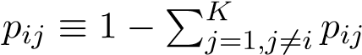
where p_{ij} represents the transition probability from state i to state j within time period (t,t + δ) when i 6= j and the probability of rating being preserved when i = j. The rows represent the rating of the entities at time t while columns represent the rating at time (t + δ). It is often assumed for the sake of simplicity that the last row with defaults is an absorbing state, which means that defaulted entities cannot emerge from default. The transition rates satisfy p_{ij} ≥ 0 for all i,j and
for all i.

Estimation
Transition matrices are estimated based on historically observed data. The two most common approaches to CTM estimation are cohort (discrete time) and duration (continuous time) methods. Both of the approaches are based on time homogenous Markov chain assumption. The straight forward cohort approach has become the industry standard (Schuermann, 2007) and it is used by credit rating agencies. Even though our analysis of banks’ internal credit risk data indicates that the banks’ credit data violate the two main assumptions, we use the cohort method for basic comparisons between different aggregation methods, banks-sourced and credit rating agencies’ CTMs and industry-specific CTMs because the calculation is notably simpler compared to the other methodologies, it is in line with the calculation used by credit rating agencies and it provides valuable insight into the features of banks’ credit risk data.
There are multiple studies providing an alternative for data that are either time-heterogeneous or non-Markovian. Bluhm and Overbeck (2007) calibrate a non-homogeneous time-continuous Markov chain. Frydman and Schuermann (2008) use Markov mixtures and Giampieri, Davis, and Crowder (2005) model the occurrence of defaults within a bond portfolio as a simple hidden Markov process.
Cohort approach Cohort approach looks at the number of entities that migrated from rating i to rating j over a specific period of time (t,t + δ), where δ is a discrete number. N_{i}(t) denotes number of entities with rating i at time t, R(t) = i, and N_{ij}(t,t+δ) is a subset of such entities that migrated to rating j within the period (t,t + δ), R(t) = i and R(t + δ) = j.
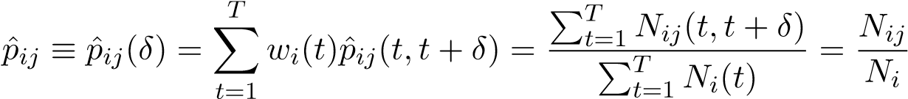
Assuming a time-homogeneous Markov rating process, the maximum likelihood estimator of the credit migration probability is:
, (2)
where 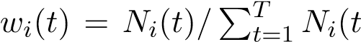) are weights. Therefore, ˆp_{ij} can be simply computed as the total number of migrations over a specific period from grade i to j, divided by the total number of obligors that were in grade i at the start of the sample period.

Main Assumptions
Starting with the works of Jarrow and Turnbull (1995) and Jarrow, Lando, and Turnbull (1997), the industry standard in description of credit rating dynamics has been based on time homogeneous Markov chain models. Consequently, one of the most discussed topics in the field of transition matrices is the Markovian chain assumption, suggesting that the estimated migration probabilities are independent of the previous rating history. In addition, the assumption of time homogeneity suggests that the probabilities are constant over time. Even though the validity of the assumptions has been challenged by number of empirical studies, the assumptions significantly simplify CTM estimation and estimations based on the assumptions provide valuable insight into rating systems of banks.
Markovian Property Definition A stochastic process satisfies the first-order Markovian property if the probability of transition to a future state j depends only on the current state and is independent of the rating history:
P[R(t + δ) = j|R(t),R(t − 1),R(t − 2),...] = P[R(t + δ) = j|R(t)], (3)
where R(t) denotes rating of an entity at time t and takes the values from the rating space S.
Time Homogeneity Definition A Markovian chain is time homogeneous if transition probabilities depend only on the time horizon of interest, δ, and not on the initial date:
Q(δ) ≡ Q(t,t + δ) = Q(t − k,t − k + δ).  Time-homogeneous Markovian chain satisfies | (4)
P[R(t + δ) = j|R(t) = i] = P[R(t − k + δ) = j|R(t − k) = i]. | (5)
Time-homogeneous transition matrices are important tool for measuring credit risk as they can be used for forecasting future.

Comparing Transition Matrices
The simplest approach to transition matrices comparison is using Euclidean distance (based on the average absolute difference) and the average root-mean-square difference between corresponding cells of the matrices. However, Jafry and Schuermann (2004) point out that these methods provide only a relative rather than absolute comparison, and thus only a limited information on magnitude of the difference. As a result, they propose a singular value decomposition (SVD) metric based on a mobility matrix (defined as the original matrix minus an identity matrix) that approximates the average probability of migration and facilitates a meaningful comparison between transition matrices.
The metric is defined as the average of the singular values of the mobility matrix:
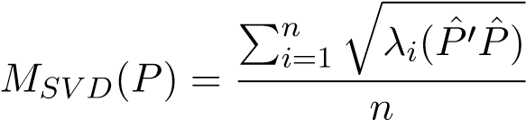, (6)
where Pˆ is the n × n mobility matrix defined as the original transition matrix minus the identity matrix of the same dimension, i.e. Pˆ = P − I, and λ_{i}(...) denotes the i-th largest eigenvalue.
The SVD method captures the probability and size of migration but not the direction of the migration. Hence, we also report the percentage of entities upgrading and downgrading.

Data
Our study is based on a unique dataset provided by Credit Benchmark, containing probability of default estimates (PDs) from 24 global banks covering the 2015-2018 period. Credit Benchmark works with global advanced internal ratings based (A-IRB) banks, pools together their internal estimates of hybrid through the cycle (H-TTC) one year PDs and aggregates them into an entitylevel credit risk benchmark. Data used in this study include both bank-specific data points and aggregated data points. As regulators require an annual review of all credit risk estimates, we focus on annual transition matrices to ensure that all of the entities have been reviewed over the observed period.
The first part of the analysis focused on assessing the time homogeneity and Markovian process assumptions requires longer time series of data and sufficient number of observations per bank which limits the number of eligible banks to 12. The second simulation part as well as the last part focused on specific bank-sourced CTMs are based on aggregated data and do not have as strict requirements for bank specific datasets, data from all 24 banks are utilised.
Transition matrices are based on a set of rating categories. To assign the submitted PDs to a rating category, we use banks’ internal rating scales and the Credit Benchmark eight categories scale. Some banks’ internal rating scales have different number of rating categories or unconventional rating categories. The Credit Benchmark scale is calibrated based on the individual rating scales submitted by banks and ensures comparability between ratings from different banks. Analysis of banks’ internal models through testing time homogeneous Markovian chain assumptions is run using both versions of the rating scales with the same results. Here we present only the results for banks’ internal rating scales, which better represent the banks’ model features. Analyses involving aggregation of banks’ data is based on the Credit Benchmark rating scale. Due to regulatory floor of 3 Bps applied on corporates, there are no corporates rated as aaa and this category is omitted in bank-sourced transition matrices.
Basel II introduced reduced risk weighting for small and medium-sized enterprises (SMEs) in line with their turnover, and some of the banks analysed in this study use two types of corporate models for large companies and SMEs. Similar distinction exists for developed and developing markets and the standard is to produce transition matrices separately for corporates, financials and governments. Hence, in our study we focus on banks’ main corporate models and limit our dataset to large corporates from North America (NA) and the European Union (EU). The entity size and country are determined using information on annual sales, number of employees and family structure from Duns & Bradstreet and FactSet.
The participating banks are based in various countries and they prefer to stay anonymous so we do not name them here. The order of presented results is random and changes for each set of results due to confidentiality of the data.

Analytical Approach to Assumptions Testing
This section describes the applied methodology; we introduce the tests used for detection of the non-Markovian behaviour and time-heterogeneity and review the relevant literature and technical details.

Testing Markovian Property
The Markovian property of rating processes is challenged by multiple studies investigating presence of non-Markovian effects using a variety of methodologies detecting the momentum effect and duration effects defined below. Specifically, Lando and Skødeberg (2002) and Kavvathas (2001) employ a semi-parametric multiplicative hazard model, Fuertes and Kalotychou (2007) and Lu (2012) use logit models, Bangia, Diebold, Kronimus, Schagen, and Schuermann (2002) estimate transition matrices dependent on previous developments and compare them, and Kru¨ger, St¨otzel, and Tru¨ck (2005) test the Markov property based on Likelihood Ratio Test and compare the conditional transition matrices. Most of the studies find a strong support for a downgrade momentum and evidence of duration effect, although Kru¨ger et al. (2005), who, unlike most of other studies, do not use rating agencies data and analyse a rating system based on balance-sheet data of Deustche Bundesbank, conclude that upgrades are more likely to be followed by downgrades and vice versa and identify a second-order Markov behaviour. Significant duration effect is described in e.g. Fuertes and Kalotychou (2007), Lando and Skødeberg (2002), or Kavvathas (2001), but the evidence on direction of the effect is mixed.

Momentum Effect
Rating momentum presupposes that prior changes in credit ratings have a predictive power regarding direction of future rating changes. Specifically, a downgrade momentum suggests that an entity downgraded to a given credit category is more likely to be downgraded than upgraded in the future. There are several approaches to testing momentum effect, we present a panel logit model.
We follow Fuertes and Kalotychou (2007) and Lu (2012) and test the Markovian chain assumption using a logit model to detect momentum effects in the internal rating data from global banks. Lu (2012) examines the rating momentum over nine years and Fuertes and Kalotychou (2007) use 24 months of rating data. Due to the time limitations of our data, we analyse the momentum effect for rating changes over 12 months periods. To do so, we define the following four variables related to the current and historical rating changes:
- U_{it} = 1 if borrower i was upgraded in month t and 0 otherwise;
- D_{it} = 1 if borrower i was downgraded in month t and 0 otherwise;
- M_{it}^{u} = 1 if borrower i was upgraded to the current rating over [t − 13,t − 1] and 0 otherwise;
- M_{it}^{d} = 1 if borrower i was downgraded to the current rating in the period [t − 13,t − 1] and 0 otherwise.
The M^{u} and M^{d} variables are upward and downward momentum indicators.
The logit regression for upgrade momentum estimation is then defined as:
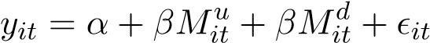, (7)
where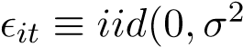) and y_{it} is a continuous latent variable such that U_{it} = 1 for y_{it} ≥ 0 and U_{it} = 0 otherwise.
As the available data cover three years time period, the number of observed upgrades and downgrades is limited and it does not allow us to assess momentum effect for each of the rating categories separately as used by Lando and Skødeberg (2002). Hence, we use panel logit model on all of the observed rating changes without rating differentiation.

Duration Effect
The duration effect refers to a link between time spent in a given rating category and the associated transition probability and, as discussed by Fuertes and Kalotychou (2007), it is another nonMarkovian property. The duration measure d_{it} is defined as the number of months between the last transition and the current state. The effect of d_{it} is measured separately for upgraded and downgraded entities using a similar panel logit model as for detecting momentum effect:
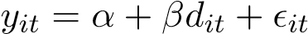, (8)
where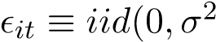) and y_{it} is a continuous latent variable such that U_{it} = 1 for y_{it} ≥ 0 and U_{it} = 0 otherwise. Analogous notation applies to downgrades.

Testing Time Homogeneity
The time homogeneity assumption has been extensively covered in the academic literature; it is mostly tested using eigenvalues or sensitivity of transition rates to the business cycle, yet some studies link transition matrices to specific macro- and microeconomic indicators. Specifically, Bangia et al. (2002), Kavvathas (2001), Fuertes and Kalotychou (2007), and Kru¨ger et al. (2005) investigate time heterogeneity using eigenvalue and eigenvector tests or conditioning the hazard rates on time. Fuertes and Kalotychou (2007) find that eigenvalue and eigenvector tests supports the time homogeneity, while Kavvathas (2001) and Kru¨ger et al. (2005) identify time dependence.
Studies comparing transition matrices across the business cycle include Kavvathas (2001), Nickell, Perraudin, and Varotto (2000), Bangia et al. (2002), Christensen, Hansen, and Lando (2004), Andersson and Vanini (2008), Gavalas and Syriopoulos (2014), Fei, Fuertes, and Kalotychou (2012), Frydman and Schuermann (2008), and Amato and Furfine (2004). Most of the analyses conclude that there are significant differences between transition matrices estimated during recession and expansion periods. Amato and Furfine (2004) then conclude that the ratings vary according to the state of the business cycle, but the fact is driven by cyclical changes to business and financial risks rather than cycle-related changes to rating standards.
Finally, studies measuring dependency of transition probabilities on various economic indicators include Gavalas and Syriopoulos (2014), Kavvathas (2001), Kru¨ger et al. (2005), Figlewski, Frydman, and Liang (2012), who show a correlation between transition probabilities and GDP growth or unemployment; Stefanescu, Tunaru, and Turnbull (2009) who use a Bayesian model to describe the explanatory power of S&P500 returns; and G´omez-Gonz´alez and Hinojosa (2010), who include both macroeconomic and microeconomic variables into their model to obtain conditional time-homogeneity.
Our dataset is too short to apply these methods of testing. Both Centrum for Economic Policy Research (EU) and National Bureau of Economic Research (US) mark the recent years covered in our dataset as a period of expansion so, based on the time homogeneity assumption, the estimated transition matrices should not be significantly different. To test this hypothesis, we construct all available annual matrices, average them and compare the average to the individual matrices using the χ² test developed by Goodman (1958) and more recently applied by Trueck and Rachev (2009) to transition matrices. Note that there are two to three distinct annual transition matrices per bank, depending on the number of observations.
To check whether transition matrices for different sub-samples differ significantly from the aggregate transition matrices for the given period calculated as an average of the individual matrices, we use the following test statistics:
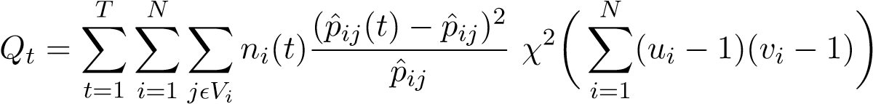, (9)
where ˆp_{ij} denotes the average probability of default representing the transition from rating i to j estimated based on the full sample, ˆp_{ij}(t) is the corresponding transition rate estimated based on a sub-sample t, and n_{i}(t) is the number of observations initially in the i-th rating class within the t-th sub-sample.
The test is based only on transition probabilities that are positive for the entire sample; hence, we define V_{i} = {j : p_{ij} > 0}. Q_{t} has an asymptotic χ² distribution with degrees of freedom equal to the number of summands in Q_{t}, corrected for the number of categories where n_{i}(t) = 0, number of estimated transition probabilities ˆp_{ij} and the number of restrictions (i.e. ^{P}_{j} pˆ_{ij}(t) = 1 and ^{P}j pˆ_{ij} = 1). Consequently, the degrees of freedom can be calculated as
X  (u_{i}(v_{i} − 1) − (v_{i} − 1)) = (u_{i} − 1)(v_{i} − 1),  i=1 | (10)
where v_{i} is the number of positive entries in the i-th row of the matrix for the entire sample (v_{i} = |V_{i}| meaning v_{i} is the number of elements in V_{i}), and u_{i} is the number of sub-samples (t) in which observations for the i-th row are available (u_{i} = |U_{i}|;U_{i} = t : n_{i}(t) > 0).

Results of Assumptions Testing
The following section summarises the results of our analysis, structured according to Section 4. Specifically, first we investigate whether the transition matrices estimated on the full sample of PD estimates from the 12 banks satisfy the Markovian property, looking separately at the momentum effect and duration effect using panel logit regression. Subsequently, we assess the assumption of time homogeneity of the transition matrices using the likelihood ratio test.
The results show that the credit risk assessment behaviour of the examined banks differs from credit rating agencies. Several studies (see e.g. Carty & Fons, 1994; Bangia et al., 2002, Lando & Skødeberg, 2002; and Kavvathas, 2001) describe a downward momentum in data from credit rating agencies, which means that downgrades are more likely to be followed by another downgrade. Our analysis suggests existence of a path dependence but in the opposite direction - upgrades are more likely to be followed by a downgrade than an upgrade and the other way around. Further, the duration appears to have a significant impact on the upgrade and downgrade probability, yet direction of the impact differs across banks. This is in line with the mixed evidence found by Fuertes and Kalotychou (2007), Lando and Skødeberg (2002) and Kavvathas (2001). The time homogeneity tests suggest that bank data based transition matrices are not stable over time.

Testing Markovian Property
Markovian property is one of the main assumptions used in CTM estimation. Transition probabilities following Markovian process depend only on the current state, they are independent of the rating history. We analyse the banks’ rating process using tests based on momentum and duration effects. Momentum effect states that direction of future credit rating changes can be linked to prior changes in ratings, and duration effects connects time spent in a given rating category with the associated transition probability. Specifically, we employ panel logit regression models defined by Equations 7 and 8.

Momentum Effect
We employ panel logit regression to analyse momentum effect tracking changes in ratings over 12
months preceding the given upgrade or downgrade. We divide the entities with at least one change into three groups - upgraded, downgrade or stable during the 12 months preceding the last change.
The stable state is the base group.
The results are summarised in Table 1.
The results summarised in Table 1 show that banks tend to reverse their rating change and that the reversion tendency is stronger for upgrades. In the upgrade model, we conclude that in ten out of twelve bank cases, entities that were downgraded in the last 12 months have significantly higher probability to be upgraded than stable entities. Further, we find out that previous upgrade has significantly negative impact on the upgrade probability for five out of twelve banks, the significance level is much lower than in the case of downgrade dummy with two of the coefficient being significant at 10% level and two at 5% level. Two banks show significantly higher probability of upgrade for previously upgrading entities compared to stable entities. Differences between the impact of previous downgrades/upgrades and stable state are not significant for two banks.
If we want to compare directly the entities previously upgrading and downgrading, we look at the coefficients and their confidence intervals and investigate if they overlap, we use the simple 95% Table 1: Regression Analysis: Impact of Previous Upgrade and Downgrade on Probability of Rating Change

Mitu Mitd Mitu Mitd
U
it
D
it
Bank
1
***
0.166
***
0.445
0.337
***
***
0.228
(0.033)
(0.032)
(0.035)
(0.035)
2
-0.095
.
***
0.190
**
0.074
0.149
(0.051)
(0.046)
(0.044)
(0.049)
0.091
3
-0.031
0.101
-0.056
(0.084)
(0.078)
(0.073)
(0.08)
4
.
-0.622
***
0.607
***
-0.020
0.981
(0.109)
(0.192)
(0.104)
(0.321)
5
*
-0.059
0.186
***
***
0.190
-0.021
(0.024)
(0.028)
(0.027)
(0.025)
6
0.162
.
0.581
***
.
-0.212
***
0.397
(0.118)
(0.084)
(0.075)
(0.086)
7
-0.003
***
0.730
0.676
-0.036
***
(0.024)
(0.024)
(0.036)
(0.032)
8
0.098
0.082
.
0.028
0.134
(0.08)
(0.077)
(0.073)
(0.075)
0.248
-0.005
0.154
9
0.337
(0.186)
(0.256)
(0.51)
(0.267)
10
-0.387
**
0.332
**
**
0.269
0.175
(0.118)
(0.165)
(0.103)
(0.121)
11
0.008
0.628
***
-0.284
0.293
(0.227)
(0.184)
(0.343)
(0.159)
12
*
-0.203
***
0.224
*
-0.177
*
-0.125
(0.061)
(0.056)
(0.083)
(0.069)
. significant at p < 0.1; * significant at p < 0.05; ** significant at p < 0.005; *** significant at p < 0.001 Notes:
U_{it} = 1 if borrower i was upgraded in month t and 0 otherwise, similarly for D_{it} = 1;
M_{it}^{u} = 1 if borrower i was upgraded to the current rating over [t − 13,t − 1] and 0 otherwise, similarly for M_{it}^{d}.
Base group is stable in the previous 12 months.
Wald confidence intervals here and we do not report the limits. We conclude that upgrade is more likely to occur after a previous downgrade than a previous upgrade for eight out of the twelve banks. The differences are not significant for the other banks.
The upgrade model clearly shows that entities downgraded in the last 12 months are more likely to be upgraded than stable entities or entities experiencing upgrade. The difference between stable and upgraded entities is not uniform across the banks.
The results in the downgrade model are less definite, six out of the twelve banks show significantly higher probability of downgrade for entities previously upgraded compared to stable entities, the probability decreases for two banks and the remaining four banks show no significant difference in downgrade probability between stable and upgrading entities. The previous downgrade dummy variable has no clear impact on upgrade probability across the banks, the coefficient is not significant for nine banks, two bank are more likely to downgrade previously downgraded entities than stable entities and one bank is less likely to downgrade the previously downgrading entities.
When we compare the impact of previous downgrade and upgrade based on the Wald confidence intervals, we find that only three banks are significantly more likely to downgrade previously upgraded entity than previously downgraded entity, one bank shows significantly higher probability of downgrade for previously downgrading entities and the differences are not significant for the remaining banks.
Analysis of momentum effect, which assumes that directions of previous and future rating changes are correlated, using panel logit regression model leads to the conclusion that it is more likely to observe an upgrade for previously downgraded entities compared to previously upgraded and stable entities; the impact of previous movements on downgrades is weaker and less definite but we can still conclude that previous upgrades have rather positive impact on downgrade probability compared to previous downgrades and stable periods.

Duration Effect
Duration effect links time spent in a given rating category with the associated transition probability and its existence indicates non-Markovian behaviour. Duration is defined as numbers of months spent in a given rating before upgrade or downgrade. We employ panel logit regression defined in Equation 8. Order of banks reported in Table 2 differs from Table 1 due to confidentiality.
Table 2: Regression Analysis: Impact of Duration on Probability of Rating Change
 | U_{it} | D_{it}
Bank | dit | dit
-0.005
A. 0.001
(0.003) (0.003)
-0.027 | *** | -0.022
B***
(0.001) | (0.001)
- -0.013 -0.021 *
(0.008) | (0.011)
- 0.005 0.011 ***
 | (0.003) | (0.003)
F | -0.004 | -0.004
 | (0.004) | (0.005)
0.006
G** 0.000
(0.002) (0.002)
-0.042 | *** | -0.019
H***
 | (0.006) | (0.005)
I | -0.003 | 0.003
 | (0.005) | (0.005)
-0.014 | *** | -0.013
J***
(0.002) (0.002)
0.012 | *** | -0.014
K***
(0.003) (0.004)
-0.014
L** -0.004
(0.004) (0.005)
-0.004
M 0.000**
(0.001) (0.001)

. significant at p < 0.1; * significant at p < 0.05; ** significant at p < 0.005; *** significant at p < 0.001 Notes:
U_{it} = 1 if borrower i was upgraded in month t and 0 otherwise, similarly for D_{it} = 1; d_{it} is duration measure.
Table 2 shows that the effect of duration is not uniform across the banks but negative impact on
the probability of upgrade or downgrade prevails. Three banks reveal a negative impact of duration on any rating changes, which means that recently upgraded or downgraded entities have higher chance of another rating change than stable entities. The probability of either upgrade or downgrade decreases with duration for another four banks. Two banks show no significant impact of duration on rating changes. The duration has positive impact on either upgrade or downgrade probability of two banks, which means that entities staying in a given rating have higher probability of upgrade or downgrade compared to recently reviewed entities. The results for the last bank are mixed - the probability of upgrade increases with duration and probability of downgrade decreases with duration.
These findings are in line with mixed evidence found by Fuertes and Kalotychou (2007), Lando and Skødeberg (2002) and Kavvathas (2001).

Testing Time Homogeneity
Time homogeneity is the second main assumption used for transition matrices estimation. Timehomogeneous rating process depends only on the time horizon of interest and not on the initial date.
The time homogeneity assumption is tested using likelihood ratio test defined in Equations 9 and 10. We examine the difference between individual annual transition matrices and the average matrix, calculate the observed χ² test statistics and compare the values with the tabulated values for 99% confidence level.
Table 3: Likelihood Ratio Test: Time Homogeneity of Transition Matrices
 | Bank Z | Y | W | V | U | T | S | R | Q | P
Observed χ² | 116 | 1005 | 413 | 573 | 274 | 376 | 72 | 757 | 147 | 103
Tabulated χ²_{99%} | 105 | 739 | 383 | 300 | 274 | 362 | 93 | 557 | 121 | 147
DF | 74 | 652 | 321 | 246 | 222 | 302 | 64 | 482 | 87 | 110
p-value | 0.001 | 0.000 | 0.000 | 0.000 | 0.010 | 0.002 | 0.230 | 0.000 | 0.000 | 0.669
 | ** | *** | *** | *** | * | ** |  | *** | ***
. significant at p < 0.1; * significant at p < 0.05; ** significant at p < 0.005; *** significant at p < 0.001 Note:
Two banks are not included due to insufficient data.
Table 3 summarises the results for ten banks, two banks are not included in the analysis due to insufficient data. The observed χ² values are larger than the tabulated ones for seven out of ten observed banks, which means that we can reject the null hypothesis of time-homogeneous transition matrices at 99% level. For the remaining three clients, we are not able to reject the null hypothesis at this significance level.
It seems that bank data based CTMs are not stable over time even across the recent period of economic expansion. The banks’ PD estimates are hybrid through-the-cycle (H-TTC), which means that the sensitivity of the PD estimates to economic cycle is between the pure through-the-cycle (TTC) PDs (which express the same degree of creditworthiness at any time, regardless of the state of the economy) and point-in-time (PIT) PDs (which are based on all currently available information) but the banks do not specify the level of PITness in their H-TTC PD estimates. Due to the limited history of the analysed data, we cannot draw strong conclusions but we will repeat the analysis when longer history of the data is available.
We show that banks’ credit risk data have non-Markovian features and are time heterogeneous. We detect momentum effect in rating processes of 10 out of the 12 examined banks. Interestingly, we conclude that banks tend to reverse their rating changes and previously downgraded entities are more likely to upgrade than previously upgraded entities, similarly for previously upgraded entities and downgrades but the link is weaker. Studies focusing on rating agencies mostly conclude that downgrades are more likely to be followed be another downgrade. Further, we describe a duration effect in the data as duration has a significant impact on probability of rating change for 10 out of 12 banks but the direction of the effect is not uniform across the banks. The time homogeneity test suggests that the banks’ credit risk estimates are time-heterogeneous. This implies that the commonly used cohort and duration approaches are not appropriate for bank-sourced data and more advanced estimators such as Markov mixture model suggested by Frydman and Schuermann (2008) need to be considered.

Aggregation of Banks’ Credit Estimates
Portfolios of the researched banks overlap and a single entity can be assessed by multiple banks, raising another question related to CTM estimation: how to aggregate them? Banks’ entity contributions are mapped to reference data and entity-specific PD average is defined using a geometric mean to reflect log-normal shape of the PD distribution. The banks’ contributions and the entity-specific PD averages are mapped to eight credit risk categories following the Credit Benchmark (CB) scale. Both observation-level credit notches and entity-level credit notches can be used for estimation of the transition matrices. In what follows, we explore three distinct approaches to aggregation of bank-sourced data for estimation of transition matrices, assess differences in their results and analyse the links between the set of underlying factors, including entity overlap among banks, size of data samples, initial PD distributions, and rating opinion levels and changes. To do so, we use Monte-Carlo simulations with data-derived parameters to create a set of fictitious observations closely following the general patterns in the actual datasets with varying specifications affecting the three CTM estimates. For simplicity, the CTM estimators reported here are derived from cohort methodology described in Equation 2.
The first approach, based on observation-level PDs (”Observation CTM”), captures all observed notch changes but assigns greater weight to entities with observations from multiple banks. It can be defined as:
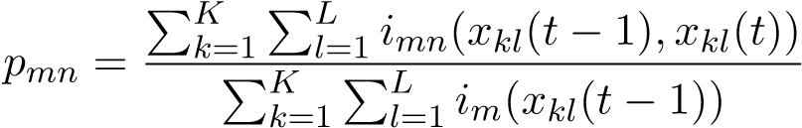, (11)
The second approach uses the estimated entity-level PD (geometric) averages (”Entity CTM”). Here, some notch changes observed at the observation level may not be reflected in a change in the entity-level credit category. On the other hand, all entities have a same weight:
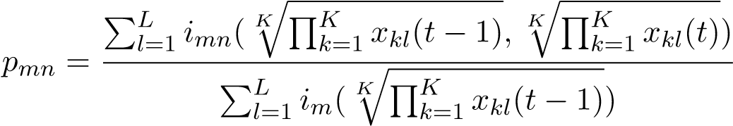, (12)
The last approach is based on the average of bank-specific CTMs and assigns equal weights to all banks, disregarding the size of their portfolios (”Average CTM”). As a result, single observations from some banks have greater impact on the final transition matrices than others.
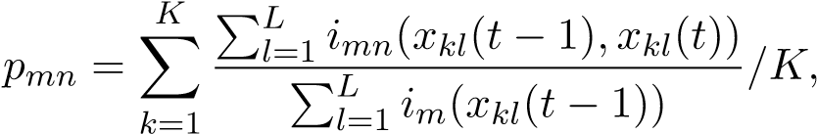 (13)
In the equations, x_{kl}(t) is a PD observation from bank k on entity l at time t; i_{mn}(x_{kl}(t−1),x_{kl}(t)) is an indicator function equal to 1 when g(x_{kl}(t)) = n and g(x_{kl}(t − 1)) = m, and 0 otherwise, with g being a mapping function assigning PD estimates to the eight CB credit risk categories and n and m ratings from the associated rating space S = {1,2,...,8}; and i_{m}(x_{kl}(t − 1),x_{kl}(t)) is an indicator function equal to 1 when g(x_{kl}(t − 1)) = m and 0 otherwise. The entity-PD average equation (12) makes a simplifying assumption that each bank provides a PD estimate on every entity.
Table 4: Stylised Example: Obseervation- and Entity-level PD Estimates in Bps
Entity | Bank |  | Observation-level |  | Entity-level
Entity | Bank |  | PD Notch |  | PD Notch
Entity | Bank | t1 | t2 t1 t2 | t1 | t2 t1 t2
20
1
a
100
1
2
25
58
1
2
2
1
b
40
100
1
1
1
c
20
20
1
2
a
200
200
2
2
200
89
2
2
b
40
2
2
200
1
3
a
40
100
1
2
2
63
100
2
3
c
100
2
2
100
To better appreciate the extent to which the CTM estimates may differ using the three formulas, consider the following stylised example of three entities (1 − 3) with PD observations received from three different banks (a − c) at time t1 and t2 as depicted in Table 4, columns ‘Observation-level’. The estimates are mapped to two rating categories, with values lower than 50 Bps assigned rating 1 and the others rating 2; 50 Bps is on boundary between investment and non-investment entities in banks’ scales. Consequently, we can calculate the geometric average PDs at the entity level forming the CB consensus estimate (see columns ‘Entity-level’ in Table 4).
Using this set of observation- and entity-level PDs and their mapping, we can calculate the resulting CTMs based on Equations 11-13 as shown in Table 5. We can see that the three approaches to CTM estimation can indeed provide significantly different results; in particular, unlike the other two approaches, the entity-based matrix does not show any transitions from notch 2 to notch 1
despite most of the individual observations changing notches.

Observed Version of Bank-Sourced CTMs
Moving away from the simplified example, let us now analyse the actual differences in CTM estimation results for North American and EU corporate based on 30,000 observations from 24 banks covering 23,000 unique entities. Results for three approaches are summarised in Table 6, showing the singular value decomposition metric (M_{SV D}) and percentage of upgrades and downgrades. We can see that the entity CTM approach results in a CTM with the highest probability and size of migration, while the average CTM is the most stable one. The share of upgrades and downgrades reveal that this is Table 5: Example: Derived CTMs

CTM
Type
 |  | 1 | 2
Observation CTM | 1 | 25% | 75%
 | 2 | 33% | 67%
Entity CTM | 1 | 0% | 100%
 | 2 | 0% | 100%
Average CTM | 1 | 33% | 67%
 | 2 | 33% | 67%
driven mainly by downgrades; entity CTM shows 11% downgrades on average in each of the credit categories, whereas the average CTM has only 8% downgrades on average. The average share of upgrades is consistent across the three approaches at 13%.
Table 6: Aggregation Approaches - Comparison of Transition Matrices
 | MSVD | % upgrades | % downgrades
Observation CTM | 0.20893 | 13% | 9%
Entity CTM | 0.21996 | 13% | 11%
Average CTM | 0.18969 | 13% | 8%
To assess the practical implications of such differences, we compare the hypothetical credit rating distributions of three portfolios following the three estimated CTMs over a five-year period, with the initial rating distribution derived from the bank-sourced data. For simplicity, we assume that portfolios satisfy the Markovian chain and time homogeneity assumptions, so the final distribution can be calculated as
d(t + 5) = d(t) ∗ [Q(t,t + 1)]⁵, (14)
where d(t) is the initial rating distribution, d(t+5) is the final rating distribution observed after 5 years, and Q is the transition matrix. The fifth power of the transition matrix is defined as the matrix product of five copies of Q(t,t + 1). The results are summarised in Figure 1.
The data show that the distribution based on the average CTM is more aggressive than the initial distribution, with the share of entities in a categories increasing from 25% to 28% and the share of contributions in high yield categories (bb, b and c) decreasing from 45% to 40%. In contrast, distribution driven by the entity CTM is rather conservative, with entities in aa and a decreasing to 22% of the portfolio and high yield coverage increasing to 46%. The distribution based on observation CTM lies between the two extremes. Transition matrices are used by banks and regulators in forecast models applied in areas including stress testing and the accuracy of the transition rates is crucial.
There are numerous factors driving the differences in the estimated CTMs: entity overlap among banks, size of data samples, initial distributions, and rating opinion levels and changes. It is essential to understand how, and to what extent, each of these parameters affect the CTM estimates in order to make informed decisions regarding the optimal aggregation methodology. In what follows, we simulate the underlying PD datasets for CTM estimation using Monte Carlo simulations with Figure 1: Initial and Final Distribution of Portfolio Across Rating Categories - Aggregation Methods
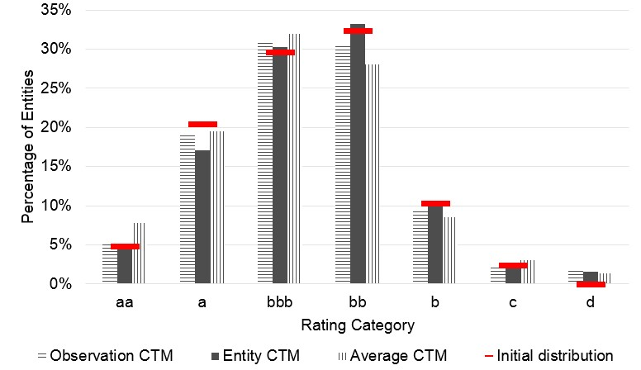
varying parameters, allowing us to identify the independent impact of the individual factors on the resulting CTMs.

Simulation Setting
In essence, the Monte Carlo simulation method uses repeated random sampling from a predefined probability distribution of an input set to generate a large number of random data. Conditional on such datasets being large enough, any two sets will differ in the individual data constituting them but will show approximately the same aggregate characteristics. In our case, Monte Carlo simulation can produce a large number of fictitious PD estimates on any given number of entities from an arbitrary number of banks that will, in their aggregate characteristics, such as rating distributions and CTMs, exactly follow the empirical bank-sourced data presented above. Importantly, the probability distributions used to generate the pseudo-random inputs and/or their subsequent deterministic transformation can be altered to induce an isolated change in the resulting dataset. This way, two datasets otherwise equivalent in their characteristics, such as entity-level rating distribution, can differ in a specific parameter (to a determined extent), such as the entity overlap among banks, allowing us to analyse the impact of such changes on the resulting CTM estimates.
The simulation is done in probabilities of default, i.e. the level of information received from banks. This approach is preferred as probability of default is a continuous measure, whereas notch representation used in the transition matrices does not capture all shifts at the PD level. The mapping between PD and notches is done using the CB 8-point rating scale. Banks’ scales mapping PDs to notches imply that the relationship is logarithmic, i.e. 1 Bps change has a different meaning in the a categories of the scale than in c categories and the probability of default can be normalised using logarithmic transformation. Hence, the simulation is done using logarithms of probabilities of default (log-PDs).
The simulation parameters are estimated using 30,000 observations from 24 banks covering 23,000 unique entities, the region and industry focus is North American and EU corporates.
Having the defined set of data features that drive the difference between the estimators – entity overlap among banks, size of data samples, initial distributions, and rating opinion levels and changes – we need to explicitly define the deterministic process of data transformation and aggregation. The simulations are anchored by entity-level transition matrices based on observed credit risk distribution and transitions, the observation-level data characteristics are altered through a set of parameters without altering the entity level behaviour. We start by simulating entity-level data and subsequently obtain observation-level information through numerical optimisation and entity-level inputs including information on number of observation, their variance and number of contributing banks. Finally, we model the changes in credit risk. This is depicted in Figure 2 in detail.
Figure 2: Flowchart of the Simulation Process
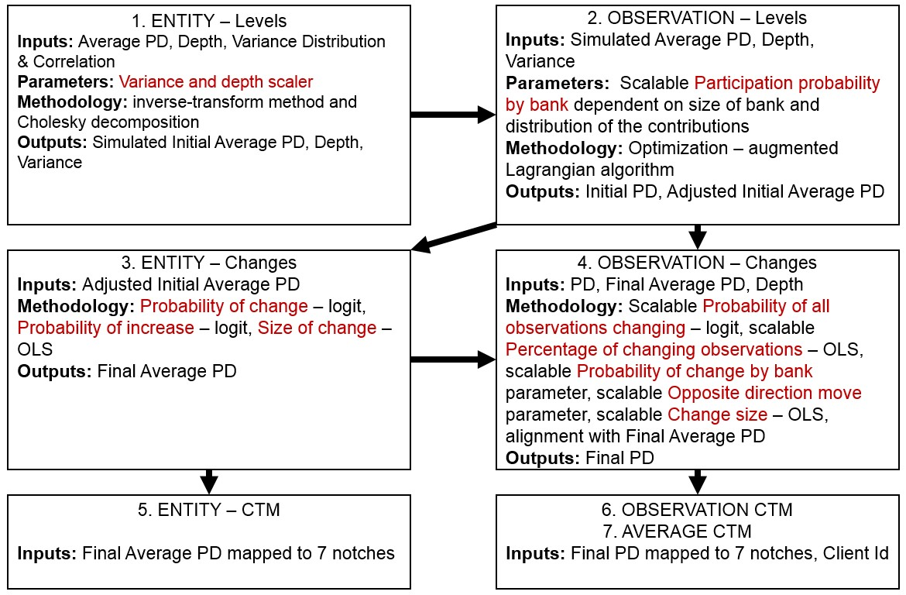
Simulation of data levels
The simulation’s starting point is a set of entity-level parameters: mean, variance and depth of logPDs, i.e. statistics of observation-level PD(s) for a given entity. We obtained the relevant parameters on the initial distribution and correlation among the three variables from the bank-sourced data and simulated new data with the same overall characteristics using the inverse-transform method and Cholesky decomposition (Rubinstein & Kroese, 2016). As we aim for stable entity-level CTMs, the distribution of credit risk, defined by entity-level mean PD, is constant and follows that of the empirical data. On the other hand, the newly generated depth and variance estimates can be further altered using parameters characterising the level of portfolio overlap and agreement among banks. These can be shocked using a set of normally distributed percentage changes with predefined mean and standard deviation. Following is a summary of the three outcome variables at the entity-level stage.
- Mean PD - Entity level PD calculated as a geometric mean of observation-level PDs, defining credit risk of an entity. This variable is fixed in the simulations, i.e. it always follows patterns observed in the empirical data.
- Depth - Number of observations per entity, defining overlap of banks’ portfolios. The variable
is scalable using normally distributed growth rate (mean, standard deviation).
- Variance - Variance of the observations for entities with depth 2+, it captures level opinion similarities among banks. The variable is scalable using normally distributed growth rate (mean, standard deviation).
Having the newly simulated data at the entity level, the next step is to generate data at the observation level for each entity such that the three variables above are preserved. To do so, we must first determine which of the fictitious banks contribute to which entities. This is done through a randomised process to ensure an appropriate distribution of banks’ portfolios across all types of entities, in which probability of a bank contributing to an entity depends on the size and distribution of its portfolio, the baseline is determined by the data and it is described in the next subsection. The two parameters can again be adjusted to analyse impacts of size differences among individual banks.
Knowing the set of bank-entity relationships, the model then proceeds to determine the individual observation-level PDs. This is trivial for entities with a single observation (i.e. with depth of omean PD estimated in the previous step. For other entities we first generate a set of random PDs, one for each bank, and use the augmented Lagrangian optimisation algorithm with the mean PD, variance and depth as binding constraints to adjust the random observation-level PDs so that their aggregate statistics correspond to the entity-level data. Hence, the simulated entity-level mean PD is replaced by the mean of the simulated observaon-level PDs and the baseline cross-sectional set of observations, effectively equivalent to the data received from the bank for one period, is complete.
Simulation of data changes
The next step is to simulate PD changes over time, starting with the entity-level information. This step is simplified to allow for stable entity level output and efficient simulation; we omit correlation between the change variables and depth and variance, which are scalable. We also do not consider monthly changes and path-dependency of the changes and focus only on the full 1 year change, which is again calibrated to correspond to the bank-sourced empirical data. The simplification is acceptable as the overall simulation process is built for analysis of data aggregation at the CTM level and not full description of the transition process. The underlying parameters, which are fixed in the model, are obtained from the empirical data by observe frequency and magnitude of the mean log-PD changes. Given the inherent differences in the nature of the parameters, we use a variety of statistical models for the estimation:
- Probability of change - For any entity-level data point at time t₁, probability of change determines the likelihood that the initial mean log-PD estimate will change over the assumed 1-year time period. We use a logit regression with mean log-PD as the explanatory variable. The statistical model shows that the initial mean log-PD is a significant predictor of the PD change probability; entities with higher log-PD are more likely to have their PD changed.
- Probability of increase - For entities with a log-PD change, the probability that the change is positive. We again use a logit regression on the sample of all changing entities with the mean log-PD as the explanatory variable, which appears highly statistically significant; entities with a higher PD are less likely to see further PD increase.
- Size of change - For entities with a log-PD change, the difference in the initial and subsequent log-PD value. We use an OLS regression with the mean log-PD as explanatory variable and run separate models for entities with increases and decreases. The results show that entities with high PDs see larger log-PD changes when decreasing but smaller when increasing.
Using the three parameters, we can determine, on a random basis, which of the simulated entities will see a PD change, as well as direction and size of such changes. As a next step, we simulate the appropriate observation-level changes corresponding to the entity-level changes. This is done by assessing the number of observations changing for each changing entity, and the direction and size of the changes, with the initial observation-level log-PD, mean entity-level log-PD and depth as exogenous input variables. The dynamics are governed by a set of parameters estimated using statistical models as for the entity-level simulation, which can be scaled to factor in changes to dynamic of observation behaviour over time:
- Probability that all observations change - Logit regression using depth and mean log-PD as explanatory variables.
- Percentage of changing observations - OLS regression with mean log-PD and depth as explanatory variables. Both models show that entities with higher depth and better ratings have lower share of observations changing.
In addition to the two parameters we run three additional regression models at the observation level to estimate the probability of a rating change, direction of the change and size of the change; these are similar to those at the entity-level. With the full set of parameters, we simulate observationlevel log-PD changes for entities with mean log-PD changes such that the individual and aggregate changes are consistent.
This completes the simulation process, resulting in 300,000 observation-level and 200,000 entitylevel data points. The simulated PD values at observation and entity level are then mapped to the 8 CB notches, which are finally used for estimation of CTMs using the three distinct approaches. In the next section we briefly describe some of the data features leveraged in the simulation process.
The simulations are coded in R and take approx. 2 hours to run for a portfolio of 200,000 entities.

Data Observations on Simulation Parameters
The entity level-credit is described using mean log-PD, depth and variance. The data show that around 50% all received observations on North American and EU large corporates cover unique entities, while the remaining 50% overlap; specifically, as shown in Figure 3, Exhibit (a), 80% of entities have only 1 observation (i.e. depth of 1), 13% have depth of 2, and 7% depth of 3 or more. Exhibit (b) shows the entity- and observation-level rating distribution across the 7 CB categories. It highlights that the distribution of credit risk at the observation level is slightly biased towards optimistic view compared to entity level, with 23% of the observation-level data being in a categories compared to 20% for entities. Finally, for entities with depth of 2 or more, Exhibit (c) shows the distribution of coefficient of variation.
The entire dataset covers more than 36,000 observations from 24 banks. On average, each bank contributes 4% of the observations, but the actual share of observation ranges between 0.1% and 30%. We divide the banks into three groups as a simplification of the banks size distribution - 4 large banks contributing at least 50% more than the 4% average, 8 small banks with less than 20% of the average, and the remaining 12 medium banks. In addition, the banks focus on different parts of the rating scales, with 9 banks having more than 60% of observations in investment grade (aaa-bbb, Figure 3: Distribution of Credit Level, Depth and Dispersion
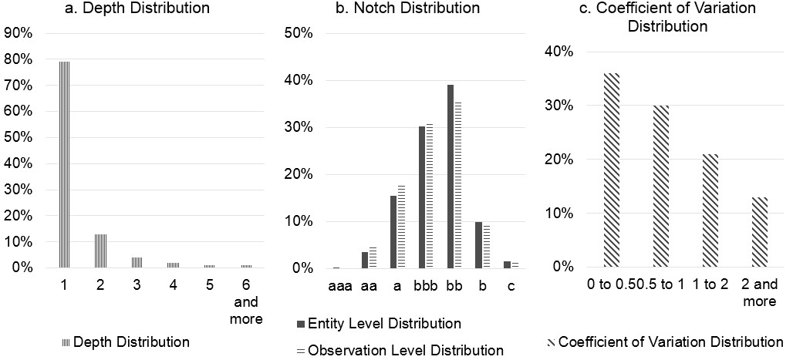
marked as low risk) and 4 banks with less than 40% of observations as in investment grade marked as high risk. There is no correlation between the two measures. The differences between banks impact mainly the average CTM.
The regression analysis around changes at the entity level leads to multiple interesting findings. Firstly, the probability of change analysis shows that 50% of all entities change their PD over the observed 12 months period and that the probability of doing so is correlated with the initial mean PD as the share is only 33% for aa entities but 58% for b entities. Secondly, more entities have decreasing rather than increasing PD; specifically, 48% of the entities with changing PD show an increase in PD over the 12 months, with the share as low as 35% for b entities and increases up to 75% for aa entities.
Further, depth and the probability that all observations changes are interlinked as all observations move for 29% of depth 2 entities with a mean PD change, yet this decreases to only 12% for depth 3 entities and falls further down to approx 3% for entities with depth greater than 3. Interestingly, approx. 17% of observations move in the opposite direction than the entity-level mean PD. There is also a positive correlation between the such probability and the mean entity-level PD; entities in notch b with 33% probability are five more likely to see all observations changing than aa entities. Finally, there are significant differences among banks in terms of the percentage of their portfolios moving over time, ranging from 20% to 80%. This measure does not appear to be correlated with bank size or its portfolio characteristics.
The following section presents the resulting simulated CTMs and their comparison to the banksourced data.

Simulation Results
In order to provide detailed information on the impact of individual factors, we ran nine separate simulations: one baseline (Simulation 1), which is based on the set of parameters obtained from the empirical data and therefore closely follows patterns in the observed data. Simulations 2-9 then differ in one or more simulation parameters described in the previous sections, such as depth, probability and size of change, or share of observations changing PDs. For each simulation, we generated ten distinct randomised datasets with equal underlying simulation parameters, each containing 200,000 entities with 300,000+ observations associated with them. Utilising Equations 11-13, we then use the simulated data for CMT estimation, where each final CMT is an average of the ten individual CMTs based on the generated datasets. That is, the 10 × 9 = 90datasets are initially transformed into 90 CMTs (for each of the three aggregation techniques) and subsequently aggregated back into 9 mean CMTs, one for each simulation.
The baseline (i.e. Simulation 1) average entity-level PD simulation (calculated using the observationlevel PDs produced through the optimisation process described in Figure 2) results in a distribution with similar shape but slightly fatter tails as shown in Figure 4, with the average absolute difference per a notch of approx. 1.5 percentage points. The observation-level distribution differences are analogous, with the average difference per notch of approx. 1 percentage point. The difference is driven by the optimisation process and relatively wide starting points. Equally, the baseline simulated PD changes are in line with the empirical observations as depicted in Figure 5, showing minimal differences in terms of share of entities upgrading and downgrading at the observation, entity and average levels.
Figure 4: Comparison of Observed and Simulated Entity Distributions, Baseline
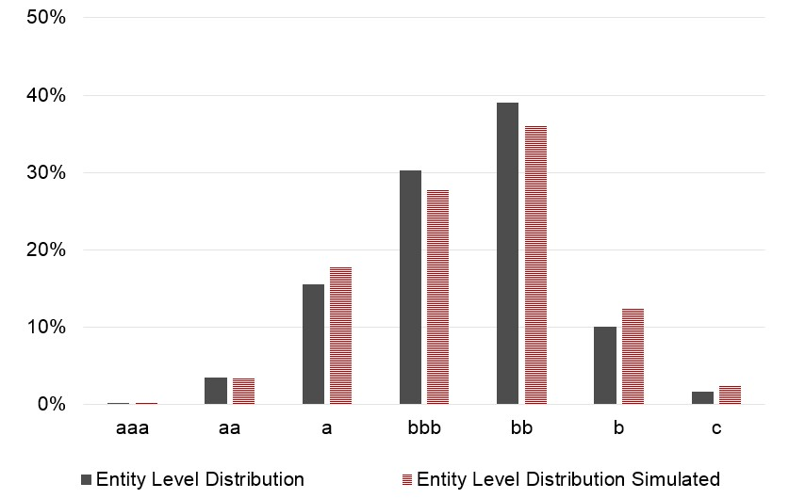
Additional information for comparison – singular value decomposition, upgrade/downgrade shares and average absolute differences – is shown in Table 7, together with a summary of changes to simulation parameters across the nine simulations (zeros corresponds to ‘as observed’ values, i.e. no shock or scaling present). We can see that the baseline simulated entity CTM is very close to the observed one (rows ‘Entity CTM’, columns ‘Observed’ vs ‘Baseline’), whereas the observation CTM and average CTM deviate more due to more significant simulation simplifications on observation and bank specific levels (rows ‘Observation CTM’ and ‘Average CTM’, columns ‘Observed’ vs ‘Baseline’). The average absolute difference between the baseline simulated and observed matrices are 1.1 percentage points for entity CTM, 1.8 for observation CTM and 2.2 for average CTM.
Let us now consider Simulations 2-9 with the changing scaling/shock parameters (Sensitivity Analysis Parameters – SAPs – hereafter). SAP of 0.5 corresponds to a 50% increase in the observed parameter. The SAP values used in our analysis have been chosen arbitrarily and are often beyond the ranges observed in the empirical data; the aim is to show principally results of hypothetical ‘what if’ scenarios using extreme conditions rather than to represent reality. Note, that the Entity CTM remains relatively stable across the different Scenarios thanks to the simulation setting.
Figure 5: Comparison of Observed and Simulated Transition Rates, Baseline
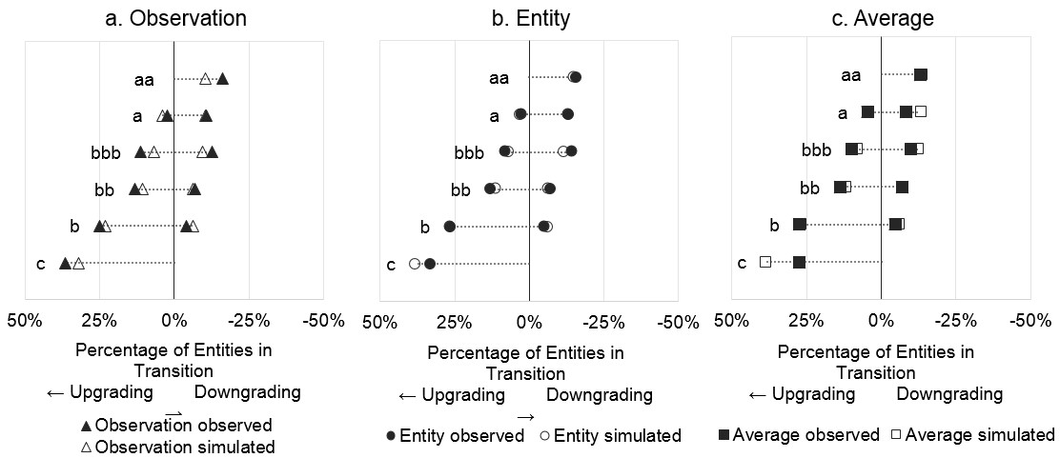
Simulation 6, which focuses on the overlap of banks’ portfolios and increases the mean and standard deviation depth by 80% and 50%, respectively, has the most significant impact on the resulting CTMs. Higher depth means that most of the entities are covered by more than one bank and the ratio of entity to observation count changes from 2:3 to 2:9. As percentage of observations changing for each moving entity is negatively correlated with depth, the increased depth results in lower proportion of observations that change and therefore a much lower percentage of observationlevel upgrades and downgrades, with 25% transitioning entities in the entity CTM compared to 12% in the observation CTM and average CTM. The average absolute difference between the entity CTM and observation/average CTM is 3.7%.
Variance measuring the banks’ agreement at levels and changing size of banks captured in Simulations 5 and 7 have very limited impact on the differences between the different approaches to CTM estimation. The impact of increased probability of change and more significant size of change on observation-level in Simulations 8 and 9 have each a positive impact on the size of transition rates in observation and average CTMs as directly implied by the parameters. Simulation 2, combining the effect of the parameters, shows an increase in transition rate by 2.4 percentage points for observation CTM and 1.5 percentage points for average CTM. Bank size specific probability of change also increases the average absolute difference between observation and average CTM by 0.11 percentage points. Simulation 3 combining shocks to all factors is dominated by the above described depth effect decreasing the transition rates at observation level but it also reveals the combined impact of bank-specific parameters (larger size differences and probability of change correlated with size) to difference between observation and average CTMs, the absolute average difference increases from 0.2% in the observed parameters simulation 1 to 1.2% in Simulation 3.
All SAPs besides depth have a limited impact on the differences between the three CTM aggregation approaches. What is more, given that a significant increase in depth is very unlikely and would likely result in changes in the observed relationships, the simulations implied that there is no superior approach.
Returning back to observed bank data, the limited volume of ratings especially when focusing on industry specific CTMs results in less frequent transitions larger than 1 notch and the further away off-diagonal cells are often left blank. Especially when looking at entity CTMs as movements Table 7: Summary of the simulations
 | Obs | Sim Base | 2 | 3 | 4 | 5 | 6 | 7 | 8 | 9
Parameters  Variance mean |  | 0 | 0 | 1 | 1 | 1 | 0 | 0 | 0 | 0
Variance sd |  | 0 | 0 | 0.5 | 0.5 | 0.5 | 0 | 0 | 0 | 0
Depth mean |  | 0 | 0 | 0.8 | 0.8 | 0 | 0.8 | 0 | 0 | 0
Depth sd |  | 0 | 0 | 0.5 | 0.5 | 0 | 0.5 | 0 | 0 | 0
Participation  Probability by Bank |  | 0 | 0 | large banks larger | large banks larger | 0 | 0 | large banks larger | 0 | 0
All Change Probability |  | 0 | 0.5 | 0.5 | 0 | 0 | 0 | 0 | 0.5 | 0
Percentage of  Observations Changing |  | 0 | 0.5 | 0.5 | 0 | 0 | 0 | 0 | 0.5 | 0
Probability of Change by Bank |  | 0 | large more change | large more change | 0 | 0 | 0 | 0 | large more change | 0
Opposite Direction  Probability |  | 0 | 0.2 | 0.2 | 0 | 0 | 0 | 0 | 0 | 0.2
Size of Change |  | 0 | 0.5 | 0.5 | 0 | 0 | 0 | 0 | 0 | 0.5
CTM Estimates  Entity CTM  - M SVD | 0.2200 | 0.2126 | 0.2126 | 0.2193 | 0.2184 | 0.2104 | 0.2174 | 0.2111 | 0.2126 | 0.2125
- % upgrade | 13% | 13% | 13% | 14% | 14% | 14% | 14% | 14% | 13% | 13%
- % downgrade | 11% | 10% | 10% | 11% | 11% | 10% | 11% | 10% | 10% | 10%
Observation CTM  - M SVD | 0.2089 | 0.1597 | 0.1817 | 0.1486 | 0.0973 | 0.1565 | 0.1036 | 0.1601 | 0.1753 | 0.1651
- % upgrade | 13% | 11% | 13% | 11% | 7% | 11% | 8% | 11% | 12% | 12%
- % downgrade | 9% | 6% | 8% | 6% | 4% | 6% | 4% | 6% | 7% | 7%
Average CTM  - M SVD | 0.1897 | 0.1689 | 0.1817 | 0.1182 | 0.1044 | 0.1652 | 0.1040 | 0.1687 | 0.1768 | 0.1736
- % upgrade | 13% | 12% | 13% | 9% | 8% | 12% | 8% | 12% | 13% | 13%
- % downgrade | 8% | 7% | 8% | 5% | 5% | 7% | 4% | 7% | 7% | 7%
Average Absolute  Difference  Entity to Average | 1.2% | 1.2% | 0.9% | 3.0% | 3.5% | 1.3% | 3.7% | 1.2% | 1.0% | 1.1%
Entity to Observation | 0.4% | 1.3% | 1.0% | 2.3% | 3.6% | 1.5% | 3.7% | 1.3% | 0.9% | 1.2%
Observation to Average | 1.0% | 0.2% | 0.3% | 1.2% | 0.3% | 0.2% | 0.1% | 0.2% | 0.2% | 0.1%
Note: Obs = Observed matrices, Sim = Simulated matrices, Base = Baseline
in entity level average PDs are less pronounced than the individual observation changes, average PD are held back by stable observations. This argument favours observation CTMS and the following sections comparing bank-sourced CTM to CTMs by credit rating agencies and analysing industry specific CTMs use the osbervation CTM.

Bank-Sourced vs CRA Credit Transition Matrices
In this section, we compare the 2017 bank-sourced transition matrix for North American and EU large corporates with the 2017 credit rating agencies’ (CRA) corporates transition matrices. All matrices are annual. The bank-sourced transition matrix is based on 30,000 observation PD estimates and estimated using the cohort approach defined in Equation 2 and observation CTM defined in Equation 11. The CRA matrices are driven by 1,500 to 5,000 corporates rated by one of the three large credit rating agencies and estimated using the cohort approach (the ‘withdrawn column is omitted). The data were extracted from the Ratings Performance in Exhibit 1 of Form NRSRO available in the database of company filings Edgar run by U.S. Securities and Exchange Commission.⁸
Table 8 shows the usual M_{SV D} and upgrades/downgrades statistics. It highlights that the CRA matrices show considerably less transitions with lower magnitude and the upgrades and downgrades results indicate that the CRA data experienced more downgrades than upgrades, the opposite than can be observed with the bank-sourced data.
Table 8: Comparison of Bank-Sourced and CRA Transition Matrices
 | MSVD | % upgrade | % downgrades
Bank-sourced corporates | 0.209 | 13% | 9%
CRA1 corporates | 0.151 | 5% | 10%
CRA2 corporates | 0.112 | 4% | 7%
CRA3 corporates | 0.146 | 5% | 9%
Source of CRA data: SEC Edgar Database, 2018 Form NRSRO
Figure 6 analyses the differences in more detail. It shows that the bank-sourced transition matrix reports more credit activity in all credit categories and directions except of downgrades in b, where the transition rates are very close, and aa, where one of the CRAs has a higher transition rate. The upgrade percentages in the bank-sourced matrix show almost a linear relationship with the rating categories; the pattern for downgrades is weaker for the upper three categories but returns for categories bbb to b.
Figure 6: Comparison of Bank-Sourced and CRA Transition Rates
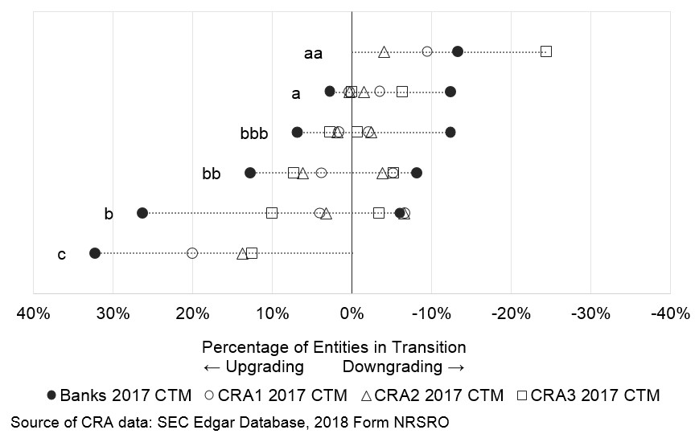
Further, we investigate the cumulative 5-year impact of the transition rates on a fictitious portfolio with the same distribution as currently observed in the bank-sourced data. We assess whether the distribution remains stable or if the transition rates substantially affect the portfolio. The distribution differs between banks and CRA as shown in Figure 7. Banks have less entities in categories b and c, one of the CRAs has more than 35% of their entities rated as b or c. Banks have higher representation in aa and a compared to CRA and their most significant notch is b, two CRAs peak in bbb and on in b.
Figure 8 uses the same approach as described in Equation 14 and illustrates the cumulative 5-year impact of the two sets of transition rates on a portfolio, where the portfolio is individual for each CRA and banks and it is based on the initial distribution in Figure 7. It shows that the bank-sourced and CRA2 transition matrices produce a distribution that is rather close to the initial distribution.
Figure 7: Distribution of Corporates Portfolio by Banks and CRAs
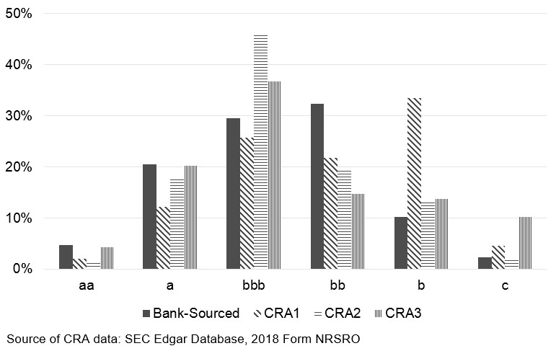
CTMs produced based on data from CRA1 and CRA3 substantially change the initial distribution. This can be caused by the rather high percentage of withdrawn ratings and newly rated entities that impact the shape of CRA1 and CRA3 derived future distribution.
Figure 8: Initial and Final Distribution of Portfolio Across Rating Categories - Banks vs CRAs
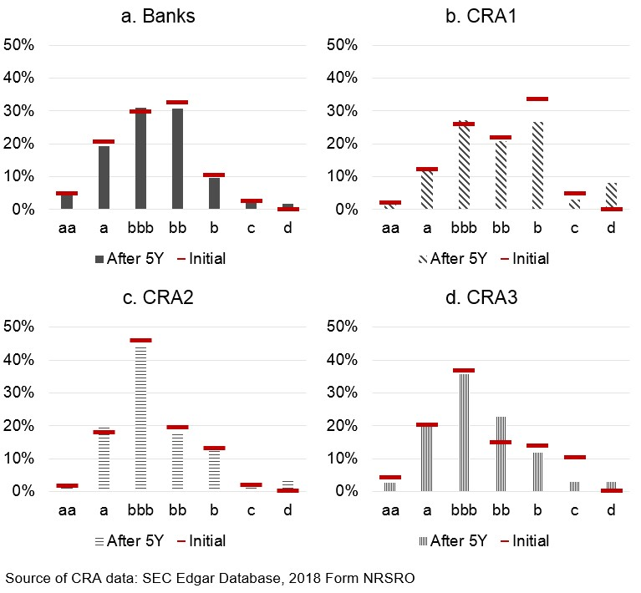
The comparison between bank-sourced CTM and CTMs produced by CRAs shows that the bank data are more dynamic with higher off-diagonal transition rates and the transitions in 2017 are biased towards upgrades, which is in contrary to CRA CTMs showing a downgrades bias. Finally, we check if each of the matrices preserve the initial credit risk distribution using 5 years cumulative CTM, bank CTM and one of the CRA CTM have very limited impact on the distribution shape while the CTMs from the other examined CRAs significantly change the distribution. All the differences might be caused by the significantly different data samples. Bank sourced CTM is based on 30,000 observations for 23,000 large corporates based on sales and employees figures, while the CRAs cover only 1,500-5,000 entities.

Industry-Specific Credit Transition Matrices
The rich dataset of 23,000 North American and EU large corporates and 30,000 underlying observations allows for estimation of industry-specific transition matrices. The reported matrices are estimated using the cohort approach defined in Equation 2 and observation CTM defined in Equation 11 and each of the matrices is driven by at least 1,700 observations. We report transition matrices for eight industries listed in Table 9, which also lists the usual statistics for matrix comparison.
Table 9: Industry Specific Transition Matrices
 | MSVD | % upgrade | % downgrades
All | 0.208932 | 13% | 9%
Basic Materials | 0.220481 | 15% | 8%
Consumer Goods | 0.226149 | 15% | 9%
Consumer Services | 0.216871 | 13% | 11%
Health Care | 0.227993 | 13% | 12%
Industrials | 0.199623 | 13% | 9%
Oil and Gas | 0.201193 | 13% | 9%
Technology | 0.224761 | 15% | 10%
Utilities | 0.244043 | 16% | 8%
Table 9 shows that there are notable differences among the industries, Industrials have the most stable ratings with M_{SV D} of 0.1996, while Utilies show the most and largest movements with M_{SV D} of 0.2440. Further, Utilites are most biased towards upgrades with the difference between average upgrade and downgrade rates of 8 percentage points. Health Care has most balanced upgrade and downgrade rates of 13% and 12% respectively.
The size of the difference can be again magnified using the cumulative five year change driven by the individual transition matrices introduced in Equation 14. Figure 9 shows the differences in the distributions. It shows that the Utilities transition behaviour increases the percentage of a entities by 14 percentage points over the 5 years and the total percentage of investment grade entities goes up from 55% to 72%. On the other hand, application of the Health Care matrix results in a slight increase in all of the high yield categories and the percentage of investment grade entities drops to 48% with most significant decrease in category bbb.
As the collected risk estimates are H-TTC, which means that they are partly impacted by the business cycle, the difference between the industry matrices might reflect industry-specific business cycles. This is further supported by trends constructed through cumulative monthly balance between improving and deteriorating entities defined as
, (15)
where b_{t} is the balance in month t, x_{kl}(t) is a PD observation from bank k on entity l at month t, i_{imp}(x_{kl}(t − 1),x_{kl}(t)) is an indicator function that is equal to 1 when the observation improves, i.e. x_{kl}(t) − x_{kl}(t − 1) < 0 and 0 otherwise, similarly i_{det}(x_{kl}(t − 1),x_{kl}(t)) is equal to 1 when Figure 9: Initial and Final Distribution of Portfolio Across Rating Categories - Health Care vs
Utilities
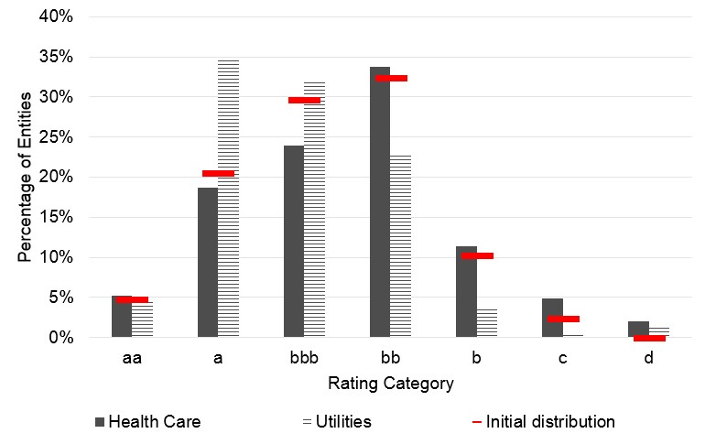
x_{kl}(t) − x_{kl}(t − 1) > 0. We use a simplifying assumption that every bank contributes to every entity and the total number of observations is K ∗ L. The cumulative balance is then defined as
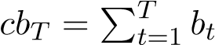.
Figure 10 shows the cumulative balance observed for three different US and UK industries and indicates not only the differences between the industries but also recent divergence across the two regions. Basic Materials and Industrials deteriorated in both countries in 2016 while Consumer Goods were stable with slight bias towards improvements. Beginning of 2017 was a turning point for Basic Materials and Both Basic Materials and Consumer Goods improved dramatically over the year 2017 as suggested by the CTM analysis and bias towards upgrades. US Industrials experienced slight improvement while UK Industrials kept deteriorating. In 2018 and 2019, we can see a diverging trends between the two countries, US BAsic Materials and Industrials show improvement and Consumer Goods slides into deterioration. All described UK industries deteriorated over the time.
Figure 10: Credit Risk Trend Lines - US and UK Basic Materials, Consumer Goods and Industrials
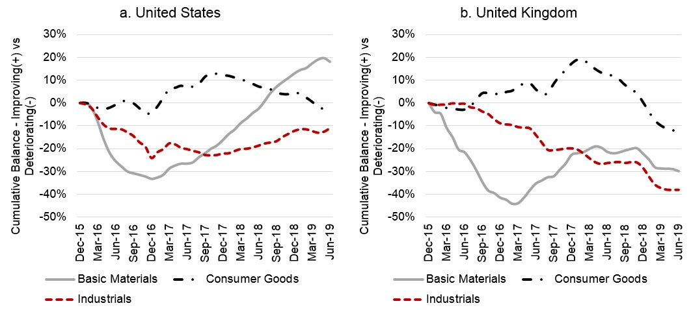
The change in trend can be tracked also in the CTMs, we report North American and EU CTM for 2016 and 2017. As shown in Figure 11 and Table 10, the transitions were dominated by downgrades in 2016 in a ratio 3:2 and the balanced moved to downgrade:upgrade ratio of almost 1:2 in 2017. Figure 11 indicates that the difference in upgrades can be mainly observed in categories c and b, while downgrades were higher in 2016 across all categories.
Figure 11: Basic Materials Transition Matrix
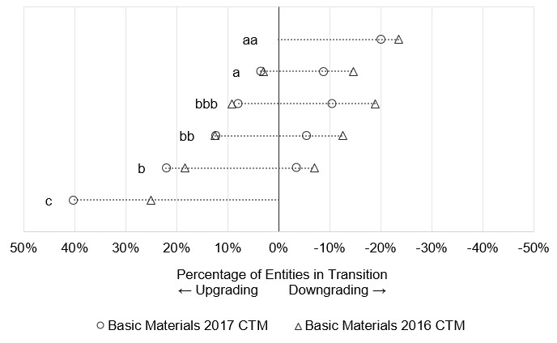
Table 10: Basic Materials Transition Matrices
 | MSVD | % upgrade | % downgrades
Basic Materials 2017 | 0.220481 | 15% | 8%
Basic Materials 2016 | 0.260442 | 11% | 16%
This section highlights differences in industry specific CTMs and suggests that different industries and possibly also regions are in different parts of the credit cycle. The findings support our conclusion on time-heterogeneity of CTMs from Section 5. The time-heterogeneity can caused by the fact that banks’ PD estimates are hybrid through-the-cycle (H-TTC), which means that the sensitivity of the PD estimates to economic cycle is between the pure through-the-cycle (TTC) PDs (which express the same degree of creditworthiness at any time, regardless of the state of the economy) and point-in-time (PIT) PDs (which are based on all currently available information) but the banks do not specify the level of PITness in their H-TTC PD estimates.

Conclusion
Banks’ internal credit risk estimates can be used to create an industry standard for credit transition matrices, overcoming the issue of data sparsity faced by rating agencies, which are currently the main source of CTMs in the field. Indeed, data from banks provide greater detail than data from credit rating agencies and allow estimation of country and industry-specific transition matrices, which may lead to improvements in accuracy of forward-looking credit risk models.
This study builds on a unique dataset of probability of default estimates from 24 global A-IRB banks, bringing insights into some of the essential features of banks’ internal credit models and proposing a bank-sourced version of transition matrices. The dataset of credit risk estimates consists of monthly observations on more than 20,000 large corporates in North America and EU, which are modelled using banks’ main corporate models (SMEs and developing markets are often modelled separately). The analysis explores applicability of the existing CTM estimators at an unprecedented scale and assesses the impact of different bank data aggregation on transition matrices, both of which are crucial to determine the most suitable methodology bank-sourced CTM estimation.
As a first step, we assesses the two main assumptions commonly used for estimation of transition matrices: the Markovian property and time homogeneity of the underlying rating processes. The existing literature, including e.g. Fuertes and Kalotychou (2007) and Bangia et al. (2002), documents extensive testing of these assumptions for credit rating agencies but the coverage of banks’ internal rating processes is sparse and the relevant studies mostly analyse local clusters of banks such as in G´omez-Gonz´alez and Hinojosa (2010) or Lu (2007).
We test the Markovian property assumption using momentum and duration effects hypotheses. Based on panel logit models, we conclude that banks’ credit rating process are not Markovian as previous ratings and time spent in a given rating (i.e. duration) have a significant impact on transition probabilities. The results are in line with previous studies on credit rating processes by major credit rating agencies (e.g. Lando & Skødeberg, 2002; Bangia et al., 2002; or Fuertes & Kalotychou, 2007). At the same time, and in contradiction to the listed studies, our analysis suggests that the probability of an upgrade is higher for previously downgraded entities than for previously upgraded entities and analogously for downgrades. That is, banks tend to revert their rating actions. Even though duration has a significant impact on the transition probability, results on direction of the impact are mixed. The Likelihood ratio test indicates that the transition matrices are time-heterogeneous, supporting results of previous studies (e.g. Nickell et al., 2000; Frydman & Schuermann, 2008; and Gavalas & Syriopoulos, 2014). The findings are vital for estimation of transition matrices based on banks’ internal credit risk estimates as they show that one must employ more complex estimators (see e.g. Frydman & Schuermann, 2008, or Wei, 2003) that, unlike the more simplistic estimators, do not rely on the two assumptions.
Secondly, we analyse appropriateness of three different methods for aggregating bank-specific datasets for CTM estimation: observation based, entity average based, and based on average of bank-specific CTMs. The analysis shows that CTMs calculated using the three approaches have different tendency to downgrade; the entity averaged based matrix is the most conservative one with the highest ratio of downgrades, whereas the average of bank-specific CTMs results in the most aggressive matrix. We proceed with an extensive Monte Carlo simulation utilising millions of fictitious PD estimates created through a model calibrated using 11 data-driven parameters. This allows us to evaluate the impact of the various underlying parameters of bank-sourced datasets, such as overlap of portfolios. Our analysis shows that all of the parameters have a limited impact on the resulting CTM differences and imply that there is no superior approach to CTM aggregation. The limited volume of observed rating transitions especially when focusing on industry specific CTMs results in off-diagonal cells being often left blank. The entity average based CTMs hide some changes through averaging at entity level and the average of bank-specific CTMs overweight small banks, which favours observation based CTMs.
Thirdly, we compare the bank-sourced 2017 corporate matrix estimated using the cohort method (for consistency with the credit rating agencies matrices) and the observations aggregation method to the 2017 corporates CTMs estimated by three credit rating agencies. The bank data show higher propensity to transition; on average, 22% of the bank observations upgrade or downgrade compared to 11-15% in the credit rating agencies data, and the bank transitions are biased towards upgrades, which is in contrary to credit rating agencies CTMs showing a downgrades bias.
Finally, the rich bank-sourced dataset allows for estimation of industry-specific transition matrices and our analysis shows significant differences in both the average upgrade and downgrade percentages across the industries. CTMs of the Utilities sector are the most biased towards upgrades with the difference between average upgrade and downgrade rates of 8 percentage points, whereas the Health Care industry has the most balanced upgrade and downgrade rates of 13% and 12%, respectively. This indicates an existence of industry-specific business cycles and confirms our findings on timeheterogeneity.

References
Altman, E. I., & Sabato, G. (2007). Modelling credit risk for smes: Evidence from the us market. Abacus, 43(3), 332–357.
Amato, J. D., & Furfine, C. H. (2004). Are credit ratings procyclical? Journal of Banking & Finance, 28(11), 2641–2677.
Andersson, A., & Vanini, P. (2008). Credit migration risk modelling (Working Paper No. 539). Zurich, Switzerland: National Centre of Competence in Research: Financial Valuation and Risk Management.
Bangia, A., Diebold, F. X., Kronimus, A., Schagen, C., & Schuermann, T. (2002). Ratings migration and the business cycle, with application to credit portfolio stress testing. Journal of banking & finance, 26(2), 445–474.
Bluhm, C., & Overbeck, L. (2007). Calibration of pd term structures: to be markov or not to be. Risk, 20(11), 98–103.
Carty, L. V., & Fons, J. S. (1994). Measuring changes in corporate credit quality. The Journal of Fixed Income, 4(1), 27–41.
Chawla, G., Forest Jr, L. R., & Aguais, S. D. (2015). Point-in-time (PIT) LGD and EAD models for IFRS9/CECL and stress testing (Industry report). London, UK: Z-Risk Engine.
Christensen, J. H., Hansen, E., & Lando, D. (2004). Confidence sets for continuous-time rating transition probabilities. Journal of Banking & Finance, 28(11), 2575–2602.
Conze, A. (2015). Probabilities of default for impairment under IFRS 9 (Industry report). Paris, France: Hiram Finance.
Cziraky, D., & Zink, D. (2017). Multi-state markov modelling of IFRS9 default probability term structure in OFSAA (Industry report). London, UK: Oracle.
Fei, F., Fuertes, A.-M., & Kalotychou, E. (2012). Credit rating migration risk and business cycles. Journal of Business Finance & Accounting, 39(1-2), 229–263.
Figlewski, S., Frydman, H., & Liang, W. (2012). Modeling the effect of macroeconomic factors on corporate default and credit rating transitions. International Review of Economics & Finance, 21(1), 87–105.
Frydman, H., & Schuermann, T. (2008). Credit rating dynamics and markov mixture models. Journal of Banking & Finance, 32(6), 1062–1075.
Fuertes, A.-M., & Kalotychou, E. (2007). On sovereign credit migration: A study of alternative estimators and rating dynamics. Computational Statistics & Data Analysis, 51(7), 3448–3469.
Gavalas, D., & Syriopoulos, T. (2014). Bank credit risk management and rating migration analysis on the business cycle. International Journal of Financial Studies, 2(1), 122–143.
Giampieri, G., Davis, M., & Crowder, M. (2005). A hidden markov model of default interaction. Quantitative Finance, 5(1), 27–34.
G´omez-Gonz´alez, J. E., & Hinojosa, I. P. O. (2010). Estimation of conditional time-homogeneous credit quality transition matrices. Economic Modelling, 27(1), 89–96.
Goodman, L. A. (1958). Simplified runs tests and likelihood ratio tests for markoff chains. Biometrika, 45(1/2), 181–197.
Jafry, Y., & Schuermann, T. (2004). Measurement, estimation and comparison of credit migration matrices. Journal of Banking & Finance, 28(11), 2603–2639.
Jarrow, R. A., Lando, D., & Turnbull, S. M. (1997). A markov model for the term structure of credit risk spreads. The review of financial studies, 10(2), 481–523.
Jarrow, R. A., & Turnbull, S. M. (1995). Pricing derivatives on financial securities subject to credit risk. The journal of finance, 50(1), 53–85.
Kavvathas, D. (2001). Estimating credit rating transition probabilities for corporate bonds (AFA 2001 New Orleans Meetings). Berkeley, CA: University of California, Haas School of Business.
Kru¨ger, U., St¨otzel, M., & Tru¨ck, S. (2005). Time series properties of a rating system based on financial ratios (Discussion Paper, Series 2: Banking and Financial Supervision). Frankfurt, Germany: Deutsche Bundesbank.
Lando, D. (2009). Credit risk modeling: theory and applications. Princeton University Press.
Lando, D., & Skødeberg, T. M. (2002). Analyzing rating transitions and rating drift with continuous observations. journal of banking & finance, 26(2), 423–444.
Lu, S.-L. (2007). An approach to condition the transition matrix on credit cycle: an empirical investigation of bank loans in taiwan. Asia Pacific Management Review, 12(2), 73–84.
Lu, S.-L. (2012). Assessing the credit risk of bank loans using an extended markov chain model. Journal of Applied Finance and Banking, 2(1), 197.
Nickell, P., Perraudin, W., & Varotto, S. (2000). Stability of rating transitions. Journal of Banking & Finance, 24(1), 203–227.
Rubinstein, R. Y., & Kroese, D. P. (2016). Simulation and the monte carlo method (Vol. 10). John Wiley & Sons.
Schuermann, T. (2007). Credit migration matrices. forthcoming in Encyclopedia of Quantitative Risk Assessment, Melnick E. and B. Everitt (eds). New York: John Wiley & Sons.
Stefanescu, C., Tunaru, R., & Turnbull, S. (2009). The credit rating process and estimation of transition probabilities: A bayesian approach. Journal of Empirical Finance, 16(2), 216–234.
Trueck, S., & Rachev, S. T. (2009). Rating based modeling of credit risk: theory and application of migration matrices. Academic press.
Varotto, S. (2012). Stress testing credit risk: The great depression scenario. Journal of Banking & Finance, 36(12), 3133–3149.
Wei, J. Z. (2003). A multi-factor, credit migration model for sovereign and corporate debts. Journal of International Money and Finance, 22(5), 709–735.

The actual time frame for individual banks varies between one to three years.
A-IRB banks are allowed to use internal credit risk model to estimate credit risk parameters for calculation of regulatory capital. Banks need an approval from the national regulator to use the A-IRB approach and their models are regularly assessed by regulators to ensure quality.
The aggregation methodology was determined by the contributing banks, which prefer to use an arithmetic average of all PD observations on the given entity.
Basel II: International Convergence of Capital Measurement and Capital Standards
Altman and Sabato (2007) argue that a SME-specific credit risk models are needed to minimise the expected and unexpected losses as they find that SMEs are riskier than large corporates.
According to the European Commission (OJ L 124, 20.5.2003, pp. 3641), SMEs are companies with staff headcount lower than 250 and turnover below 50 million or balance sheet total below 43 million. Companies that are a part of a larger family should be assessed based on the group data.
The 30,000 observations cover 23,000 unique entities. ⁸Retrieved from https://sec.report/ on June 3, 2019.
The downgrades in c are not depicted in the figure as they are represented only by defaults and we have confidentiality restrictions on publishing default rates.

